AUTOSECAI: AUTONOMOUS PULL REQUEST ANALYSIS FOR SECURITY, VULNERABILITY DETECTION, AND CODE QUALITY USING MULTI-AGENT LLMS
(AutoSecAI)
A project report submitted in partial fulfilment of the requirements for the award of the degree of
BACHELOR OF TECHNOLOGY
in
COMPUTER SCIENCE AND ENGINEERING
Submitted by
CHEPURI RISHIVARDHAN | 23K91A0553
BODA SANDEEP | 23K91A0539
DHARAVATH SEETHARAM | 23K91A0562
NARISIMHA REDDY | 24K95A0501
Batch A11 (CSE, Section A)
Under the esteemed guidance of
P. KISHORE
[DESIGNATION]
[COLLEGE LOGO]
DEPARTMENT OF COMPUTER SCIENCE AND ENGINEERING
TKR COLLEGE OF ENGINEERING & TECHNOLOGY (AUTONOMOUS)
[COLLEGE ADDRESS / AFFILIATING UNIVERSITY]
[ACADEMIC YEAR]

[COLLEGE LOGO]
TKR COLLEGE OF ENGINEERING & TECHNOLOGY (AUTONOMOUS)
DEPARTMENT OF COMPUTER SCIENCE AND ENGINEERING
CERTIFICATE
This is to certify that the project report entitled "AutoSecAI: Autonomous Pull Request Analysis for Security, Vulnerability Detection, and Code Quality using Multi-Agent LLMs (AutoSecAI)" is a bonafide record of the work carried out by CHEPURI RISHIVARDHAN (23K91A0553), BODA SANDEEP (23K91A0539), DHARAVATH SEETHARAM (23K91A0562), NARISIMHA REDDY (24K95A0501), in partial fulfilment of the requirements for the award of the degree of Bachelor of Technology in Computer Science and Engineering, during the academic year [ACADEMIC YEAR], under my supervision.

Project Guide  P. KISHORE  [DESIGNATION] | Head of the Department  [HOD NAME]  Department of Computer Science and Engineering | External Examiner  [NAME AND SIGNATURE]
DECLARATION
We hereby declare that the project report entitled "AutoSecAI: Autonomous Pull Request Analysis for Security, Vulnerability Detection, and Code Quality using Multi-Agent LLMs (AutoSecAI)", submitted to the Department of Computer Science and Engineering, TKR College of Engineering & Technology (Autonomous), in partial fulfilment of the requirements for the award of the degree of Bachelor of Technology in Computer Science and Engineering, is a record of original work carried out by us under the guidance of P. KISHORE, [DESIGNATION]. The results embodied in this report have not been submitted to any other university or institution for the award of any degree or diploma.

CHEPURI RISHIVARDHAN | 23K91A0553
BODA SANDEEP | 23K91A0539
DHARAVATH SEETHARAM | 23K91A0562
NARISIMHA REDDY | 24K95A0501
Place: [PLACE]
Date: [DATE]
ACKNOWLEDGEMENT
We express our sincere gratitude to our project guide, P. KISHORE, [DESIGNATION], for valuable guidance, encouragement and constructive suggestions throughout this project.
We thank [HOD NAME], Head of the Department of Computer Science and Engineering, for providing the facilities and support needed to complete this work, and [PRINCIPAL NAME], Principal, TKR College of Engineering & Technology (Autonomous), for the encouragement given to us.
We thank the project coordinators and all faculty and staff members of the department for their help, and our families and friends for their constant support.
We also acknowledge the authors of the base paper, Behzad Khalaji Emamzadeh Abbasi and Alireza Shameli-Sendi, whose work on source-code metrics for vulnerability prediction is the starting point of this project, and the authors and maintainers of the open-source software on which AutoSecAI is built, in particular Python, FastAPI, scikit-learn, XGBoost, NetworkX, React, Vite and Tailwind CSS.

CHEPURI RISHIVARDHAN
BODA SANDEEP
DHARAVATH SEETHARAM
NARISIMHA REDDY
ABSTRACT
Modern software teams merge many pull requests every week, and each one can introduce a vulnerability such as SQL injection or cross-site scripting. Manual review is slow, its security coverage depends on who happens to review, static analysers return long lists of warnings that are mostly noise, and a reviewer judging a small change rarely has the context of a large codebase. The base paper by Abbasi and Shameli-Sendi (IEEE Access, 2026) shows that 14 source-code metrics can predict which C or C++ functions are vulnerable, but it works offline on whole projects and does not explain findings or propose fixes.
This project builds AutoSecAI, an autonomous pull-request analyser. The changed files are extracted from a pasted diff, two file versions, a GitHub pull-request link or uploaded files. Seven cooperating agents then run: ingestion, an AST and taint static analysis, a machine-learning risk agent that scores each changed function with the metric model of the base paper (adapted to Python), a reasoner that explains each finding with its CWE and OWASP class, impact and source-to-sink flow, a remediation agent whose patches are re-scanned before they are offered, a quality reviewer and a judge that de-duplicates findings and issues a risk score and a merge verdict. A codebase assistant answers natural-language questions about a repository with evidence, and a Model Lab shows how the model was built. A FastAPI service with login and background jobs and a React web application deliver all of this; an optional large-language-model layer for the wording is off by default.
Because real labelled Python vulnerability data was not available, the model is trained on a generated corpus of 6,000 functions of which 501 are vulnerable. On 1,500 held-out functions the stored XGBoost model reaches F1 0.851 (precision 0.942, recall 0.776); over five independently generated corpora its mean F1 is 0.842. The rule engine and the model are complementary: flagging a function when either reports it gives F1 0.891. The built-in demo pull request is reviewed in a median of 0.38 s and receives the verdict BLOCK with 15 security findings. The codebase assistant ranks the expected file first for 8 of 12 test questions. Seventeen automated tests, a sixteen-step API smoke test and twenty-two browser flows pass. The corpus is synthetic, no labelled set of real pull requests was available so precision on real reviews is unknown, the optional language-model layer was not evaluated and no numeric comparison with the base paper is valid.
Keywords: multi-agent review, pull request, automated vulnerability detection, code quality, AST static analysis, codebase intelligence, graph-based retrieval, software security.
TABLE OF CONTENTS
CHAPTER 1 INTRODUCTION 1
1.1 Introduction to the Project Domain 1
1.2 Background and Motivation 1
1.3 Problem Statement 2
1.4 Need for the Proposed System 3
1.5 Objectives 3
1.6 Scope of the Project 4
1.7 Key Contributions 5
1.8 Limitations and Assumptions 7
1.9 Organisation of the Report 7
CHAPTER 2 LITERATURE SURVEY 9
2.1 Overview of the Literature Survey 9
2.2 Base Paper Analysis 9
2.3 Related Work 11
2.4 Datasets and Algorithms Used in the Field 12
2.5 Strengths and Limitations of Existing Approaches 13
2.6 Research Gap 14
CHAPTER 3 FEASIBILITY STUDY 15
3.1 Technical Feasibility 15
3.2 Economic Feasibility 15
3.3 Operational Feasibility 16
3.4 Schedule Feasibility 17
3.5 Advantages and Constraints 17
CHAPTER 4 SYSTEM REQUIREMENTS AND ANALYSIS 18
4.1 Existing System and its Limitations 18
4.2 Proposed System and its Advantages 18
4.3 Functional Requirements 19
4.4 Non-Functional Requirements 20
4.5 Hardware and Software Requirements 20
4.6 User Roles and Constraints 21
CHAPTER 5 SYSTEM DESIGN 22
5.1 System Architecture 22
5.2 High-Level Workflow 23
5.3 Data-Flow Diagrams 24
5.4 UML Diagrams 26
5.5 Database Design 28
5.6 Module Design 30
5.7 User Interface Design 31
CHAPTER 6 METHODOLOGY AND SOFTWARE IMPLEMENTATION 33
6.1 Overall Methodology 33
6.2 Dataset 34
6.3 Data Preprocessing 35
6.4 Algorithm Choice and Justification 36
6.5 Mathematical Formulation 37
6.6 Model Architecture and Training 39
6.7 Application Architecture 41
6.8 Key Code Walkthroughs 41
6.9 Implementation Decisions and Reasoning 42
6.10 API Design 43
6.11 Security and Error Handling 44
6.12 Installation and Execution 45
CHAPTER 7 SYSTEM TESTING 46
7.1 Testing Strategy 46
7.2 Unit Testing 46
7.3 Integration Testing 47
7.4 Functional Testing 48
7.5 Security Testing 49
7.6 Validation and Edge Cases 49
7.7 Performance Testing 51
7.8 User Acceptance Testing 52
7.9 Limits of the Testing Done 52
CHAPTER 8 RESULTS AND OUTPUT SCREENS 54
8.1 Output Screens 54
8.2 Model Performance 56
8.3 Product-Level Results 62
8.4 Comparison with the Base Paper 65
8.5 Sample Inputs and Outputs 66
8.6 Success and Failure Analysis 67
8.7 Limits of the Results 68
8.8 Objectives Against Outcomes 69
CHAPTER 9 CONCLUSION 70
9.1 Summary of the Work 70
9.2 Objectives Achieved 70
9.3 Key Findings 70
9.4 Practical Applications 71
9.5 Known Limitations 71
CHAPTER 10 FUTURE SCOPE 73
10.1 Improvements 73
10.2 Additional Features 73
10.3 Scalability and Deployment 73
10.4 Further Research 74
REFERENCES 75
APPENDIX A IMPORTANT CODE 77
A.1 Risk Score and Verdict (Judge Agent) 77
A.2 Patch Verification (Remediation Agent) 77
A.3 Taint Level of an Expression 78
A.4 SQL Injection Rule 78
A.5 SMOTE and Tomek Links 78
A.6 Scoring One Function with the Metric Model 79
A.7 Codebase Retrieval 79
A.8 Review Storage 80
A.9 Background Jobs 80
A.10 Passwords and Tokens 81
A.11 SARIF Export 81
APPENDIX B INSTALLATION AND USER GUIDE 82
B.1 Installation Guide 82
B.2 User Guide 83
APPENDIX C ADDITIONAL SCREENS 84

LIST OF FIGURES
Fig. 5.1: System architecture of AutoSecAI 22
Fig. 5.2: High-level workflow 23
Fig. 5.3: Data-flow diagram, level 0 (context) 24
Fig. 5.4: Data-flow diagram, level 1 25
Fig. 5.5: Data-flow diagram, level 2: the seven-agent review (process 3.0) 25
Fig. 5.6: Use-case diagram 26
Fig. 5.7: Sequence diagram: running a review and opening the result 27
Fig. 5.8: UML class diagram 28
Fig. 5.9: Database design: two SQLite files 29
Fig. 5.10: Overview screen: three entry cards and the seven agents 31
Fig. 5.11: New review screen with the five input modes 31
Fig. 5.12: Review result: verdict banner, gauge and four counters 32
Fig. 5.13: Codebase assistant: suggested questions and a cited answer 32
Fig. 8.1: Overview page 54
Fig. 8.2: New review: Demo PR input 54
Fig. 8.3: Review result: verdict, gauge and key figures 54
Fig. 8.4: Findings tab with the first finding opened 54
Fig. 8.5: Function risk (ML) tab 55
Fig. 8.6: Agent trace tab 55
Fig. 8.7: Export tab 55
Fig. 8.8: Codebase assistant: question and cited answer 55
Fig. 8.9: Codebase assistant: repository map 55
Fig. 8.10: Model Lab: nine models 55
Fig. 8.11: Model Lab: ROC curves and confusion matrix 56
Fig. 8.12: Model Lab: Try it 56
Fig. 8.13: History 56
Fig. 8.14: Precision, recall and F1 of the nine classifiers 57
Fig. 8.15: Confusion matrices of XGBoost and Random Forest 58
Fig. 8.16: ROC curves of the nine classifiers 58
Fig. 8.17: Random Forest importance of the 13 selected metrics 59
Fig. 8.18: Validation F1 against the number of metrics kept 59
Fig. 8.19: Ablation: precision, recall and F1 of three Random Forest configurations 59
Fig. 8.20: F1 of the vulnerability-type classifier by type 60
Fig. 8.21: F1 of XGBoost and Random Forest on five generated corpora 61
Fig. 8.22: Precision, recall and F1 of the rule engine, the metric model and their combinations 61
Fig. 8.23: Findings of the demonstration pull request by severity 62
Fig. 8.24: Median time per agent 63
Fig. 8.25: Median latency of the API endpoints (logarithmic axis) 64
Fig. C.1: Sign in 84
Fig. C.2: New review: Paste diff 84
Fig. C.3: Files tab 84
Fig. C.4: Codebase assistant: onboarding guide 84
Fig. C.5: Model Lab: pipeline and data 85
Fig. C.6: Model Lab: feature selection 85
Fig. C.7: Model Lab: vulnerability types 85
Fig. C.8: Model Lab: ablation 85
Fig. C.9: Settings 85
Fig. C.10: About 85
Fig. C.11: Review result in light mode 86
Fig. C.12: Landing page, light theme (full page) 87
Fig. C.13: Landing page, dark theme (full page) 87

LIST OF TABLES
Table 1.1: Objectives and the modules that address them 4
Table 1.2: Limitations of the system and of the evidence 7
Table 1.3: Chapters of this report 7
Table 2.1: Summary of the main related works 12
Table 2.2: Algorithms and standards used 13
Table 2.3: Strengths and limitations of the approaches 13
Table 2.4: Research gaps and how they are addressed 14
Table 3.1: Cost elements of the project 16
Table 3.2: Project schedule from the repository history 17
Table 3.3: Advantages and constraints of the project 17
Table 4.1: Limitations of the existing system 18
Table 4.2: Features of AutoSecAI 18
Table 4.3: Functional requirements 19
Table 4.4: Non-functional requirements 20
Table 4.5: Hardware requirements 20
Table 4.6: Software requirements 20
Table 4.7: User roles 21
Table 5.1: Database tables and columns 29
Table 5.2: Modules of AutoSecAI (non-blank lines) 30
Table 6.1: Pipeline of AutoSecAI 33
Table 6.2: The eight vulnerability types of the generated corpus 34
Table 6.3: Dataset summary 34
Table 6.4: The fourteen source-code metrics 35
Listing: SMOTE as implemented in autosecai/mlmodel.py 36
Table 6.5: Consensus of the seven feature-selection methods (training data) 37
Table 6.6: Model configuration 39
Table 6.7: Results of the nine classifiers on the 1,500 held-out functions 39
Table 6.8: Ablation of the random forest 40
Table 6.9: Five independently generated corpora 40
Table 6.10: Implementation decisions 42
Table 6.11: HTTP endpoints of AutoSecAI 43
Table 6.12: Installation and verification commands 45
Table 7.1: Test levels and results 46
Table 7.2: Engine tests 46
Table 7.3: API tests 47
Table 7.4: Browser flows of scripts/ui_flows.py 48
Table 7.5: Security checks 49
Table 7.6: Rule engine and ML model on the same 1,500 functions 50
Table 7.7: Retrieval check on the demo repository 50
Table 7.8: Median time per agent on the demo pull request 51
Table 7.9: HTTP latency measured on localhost 51
Table 8.1: Headline model results (generated Python corpus, 1,500 held-out functions) 57
Table 8.2: Nine classifiers on the held-out test set 57
Table 8.3: Confusion matrices of four models (rows: truth, 1,375 safe and 125 vulnerable) 58
Table 8.4: The six most important of the 13 selected metrics 58
Table 8.5: Ablation of balancing and feature count 59
Table 8.6: Vulnerability-type classifier (accuracy 0.651) 60
Table 8.7: Models retrained on five independently generated corpora (k fixed at 13) 60
Table 8.8: Rule engine and metric model on the same held-out functions 61
Table 8.9: Median time per agent over 20 runs of the demonstration review (engine only) 62
Table 8.10: Latency of the HTTP API on localhost (one client) 63
Table 8.11: Retrieval check on the demo repository 64
Table 8.12: Automated checks run on 18 October 2026 65
Table 8.13: AutoSecAI and the base paper 65
Listing: Excerpt of the demonstration diff (added lines of app/users.py) 66
Table 8.14: Findings returned for the demonstration pull request (risk 99, BLOCK) 66
Listing: Verified patch for the SQL injection at line 24 67
Table 8.15: Further sample inputs and outputs (run on 18 October 2026) 67
Table 8.16: Failure and weakness analysis 68
Table 8.17: Objectives against outcomes 69
Listing: Scoring and verdict in review_changes(), autosecai/agents.py 77
Listing: Verification by re-scan in review_changes(), autosecai/agents.py 77
Listing: _level_of() in PyAnalyzer, autosecai/rules.py 78
Listing: SQL injection check in PyAnalyzer._check_call(), autosecai/rules.py 78
Listing: smote() in autosecai/mlmodel.py 78
Listing: tomek_clean() in autosecai/mlmodel.py 79
Listing: predict_metrics() in autosecai/mlmodel.py 79
Listing: Scoring in RepoIndex.ask(), autosecai/codeintel.py 79
Listing: autosecai/store.py 80
Listing: start_job() in backend/main.py 80
Listing: Password hashing and token functions in backend/auth.py 81
Listing: to_sarif() in autosecai/report.py 81
Listing: Manual start 82
Listing: Checks 82
Table B.1: User guide 83

LIST OF ABBREVIATIONS
Abbreviation | Expansion
AI | Artificial Intelligence
API | Application Programming Interface
AST | Abstract Syntax Tree
AUC | Area Under the ROC Curve
CPU | Central Processing Unit
CSV | Comma-Separated Values
CWE | Common Weakness Enumeration
DFD | Data-Flow Diagram
ER | Entity-Relationship
FN / FP | False Negative / False Positive
FR | Functional Requirement
HTTP | Hypertext Transfer Protocol
JSON | JavaScript Object Notation
JWT | JSON Web Token
KNN | k-Nearest Neighbours
LLM | Large Language Model
ML | Machine Learning
NFR | Non-Functional Requirement
OWASP | Open Worldwide Application Security Project
PR | Pull Request
RF | Random Forest
REST | Representational State Transfer
ROC | Receiver Operating Characteristic
SARIF | Static Analysis Results Interchange Format
SMOTE | Synthetic Minority Over-sampling Technique
SQL | Structured Query Language
SVM | Support Vector Machine
TF-IDF | Term Frequency - Inverse Document Frequency
TP / TN | True Positive / True Negative
UI | User Interface
UML | Unified Modeling Language
XGBoost | Extreme Gradient Boosting
XSS | Cross-Site Scripting

CHAPTER 1
INTRODUCTION

1.1 Introduction to the Project Domain
Modern software is built by teams that change the same code base many times a day. In most teams every change arrives as a pull request (PR): a proposed set of modified files, shown as a diff, that another engineer must read and approve before it is merged. The PR is the last point at which a flaw can be stopped cheaply. A SQL query built by string concatenation, a password in a source file or a call to os.system with user input is only a few lines long, yet can open the whole application to an attacker. Such flaws are catalogued in the Common Weakness Enumeration [25] and ranked by the OWASP Top 10 [24].
The domain of this project is therefore artificial intelligence for software engineering and cybersecurity, and more precisely automated security and quality review of code changes, together with code-base comprehension for engineers who must work in a repository they did not write. It draws on static analysis (abstract syntax trees and taint tracking that follow untrusted data from source to sink), software metrics [21] that relate to the likelihood of a vulnerability [1], [8], machine learning with balancing techniques [15]-[17], information retrieval with TF-IDF [22] and graph ranking [23], and large language models (LLMs) that can write the explanations that make a warning actionable.
AutoSecAI, the system built in this project, combines these ideas in one application. A developer gives it a pull request in one of five forms (a diff, two versions of a file, a GitHub PR link, uploaded files or a zip, or a local folder). Seven cooperating software agents then ingest the change, analyse it statically, score every changed function with a trained model, explain each finding, propose a patch verified by re-scanning, summarise maintainability issues and weigh the evidence into a risk score and a verdict of approve, request changes or block. A second module indexes a repository so that a new team member can ask where authentication, routing or configuration lives. The "multi-agent LLM" of the title should be read in that sense: specialised agents hand evidence to one another, an optional language-model layer can rewrite their explanations, but every finding is produced and verified by deterministic components that run on the user's machine.

1.2 Background and Motivation
Three observations motivated the project. First, review effort does not scale with the pace of development. A reviewer who reads many diffs a week cannot give each the attention of a security audit, and flaws such as injection, path traversal and unsafe deserialisation look harmless in a diff because the untrusted value may enter in a different function. Whether a reviewer notices them depends on that person's security expertise.
Second, the usual automatic help is noisy. Static analysers report every pattern that resembles a weakness, so developers learn to ignore long lists of warnings that are mostly false alarms, and a warning such as "possible injection" does not say why the code is dangerous, what an attacker could do, or what safe code would look like. The literature on vulnerability prediction offers a complementary signal: measurable properties of a function, such as its complexity, its number of risky calls and its use of untrusted input, correlate with the presence of a vulnerability [1], [8]. The base paper [1] shows that a small set of such metrics, selected by seven methods and used with a balanced training set, lets a random forest separate vulnerable from safe C and C++ functions with an F1-score of 0.961 on its data. That work is offline, classifying functions of finished projects rather than live pull requests, and the authors name Python and Java as future work.
Third, a change cannot be judged without its context. A reviewer who is new to a repository does not know which module handles authentication, where requests are routed or how the database is reached, and so cannot tell whether a changed line bypasses a control that exists elsewhere. Recent LLM-based review work, such as the Sphinx framework [2], argues that review comments must be grounded in the code change and judged by structured checklists rather than text overlap, so evaluation is as hard as generation. These observations suggest a reviewer that combines static evidence, a learned risk signal and repository context and explains its findings; this project builds one.

1.3 Problem Statement
Manual pull request review does not scale with the pace of modern development. Security review depends on whether the reviewer happens to have security expertise. Static analysers overwhelm developers with warnings that are mostly false positives. Reviewers lack the context of a large code base when judging a small diff.
Formal statement. Given a code change (a unified diff, a pair of file versions, a pull request fetched from GitHub, or a set of files), produce (i) a list of security findings, each tied to a file and line, classified by weakness (CWE) and severity, explained in terms of the flow from untrusted source to dangerous sink, and accompanied, where a safe rewrite is possible, by a patch that has been checked by re-analysing the patched code; (ii) a maintainability summary; (iii) for every changed function, a learned probability that it is vulnerable and the code metrics that drive that probability; and (iv) a single risk score and a merge verdict. Given a repository, answer natural-language questions about where a feature is implemented, citing the code that supports the answer. The system must state how it was measured and where it has not been.
Need. An autonomous reviewer that analyses each pull request for security and quality using code-base-aware, multi-agent reasoning.

1.4 Need for the Proposed System
- Scalable first-pass review. A tool that reads every change in seconds frees reviewers for design and logic.
- Fewer, better warnings. Evidence from independent detectors (rules, taint tracking, a learned model) is combined, de-duplicated and ranked.
- Explanations and fixes, not raw warnings. Each finding needs what is wrong, the impact, the data flow, a safe example and, where possible, a patch known to remove it.
- A measurable risk signal. Metrics are interpretable [1]; a model that shows which metrics drive a function's score gives reviewers a reason to look closer.
- Context for reviewers and newcomers. A repository assistant that locates authentication, routing and database code shortens onboarding.
- Standard outputs. Results should be exportable as a Markdown PR comment and as SARIF 2.1.0 [26], so that they fit existing code-hosting and security tooling.
- Low cost and privacy. The reviewer should run on an ordinary laptop, keep source code on the user's machine, and use an external language model only if the user explicitly turns it on.

1.5 Objectives
1. Extract changed files and diff context automatically when a pull request is opened.
2. Compute source-code metrics for changed files and use them to rank vulnerability likelihood.
3. Perform AST-based static analysis to detect injection, access-control and validation flaws.
4. Deploy multiple LLM agents covering security, code quality and maintainability concerns.
5. Retrieve related code from the repository so review comments reflect the wider code base.
6. Post consolidated review comments and evaluate precision against manually reviewed pull requests.
These are the six objectives of the project as defined at its start. The table shows which part of the system addresses each one; Chapter 8 measures each of them against the results and states plainly where the evidence is incomplete.
Table 1.1: Objectives and the modules that address them
No. | Objective (short form) | Addressed by
1 | Extract changed files and diff context | diffutil.py: unified-diff parser, before/after comparison, GitHub PR and zip/folder readers; Ingestion Agent
2 | Source-code metrics rank vulnerability likelihood | metrics.py (14 AST metrics), mlmodel.py (feature selection, SMOTE-Tomek, nine models); ML Risk Agent
3 | AST-based static analysis for injection, access-control and validation flaws | rules.py (AST and taint engine) and knowledge.py (rule entries with CWE and OWASP); Static Analysis Agent
4 | Multiple agents for security, quality and maintainability | agents.py: seven agents with a trace; optional LLM text layer in llm.py
5 | Retrieve related code from the repository | codeintel.py: repository index, concept scores, call graph, cited answers
6 | Consolidated review comments; precision against manually reviewed pull requests | Judge Agent and report.py produce the comment; the manual-review precision study was not carried out (no labelled set exists)

1.6 Scope of the Project

1.6.1 In scope
- Review of code changes in five input forms: a built-in demo pull request, a pasted or uploaded unified diff, two versions of one file, a GitHub PR URL (public API, optional token), and uploaded files, a zip or a local folder.
- Deep AST and taint analysis of Python, and regex rules for JavaScript, PHP and Java; 43 rule-knowledge entries (30 security, 12 quality and one ML-derived), each with CWE, OWASP category, severity, explanation, impact, remediation and a safe pattern.
- Computation of 14 source-code metrics per function and scoring with a trained classifier, with the three metrics that drive each score.
- Automatic patches for the weakness classes that have a safe rewrite, each verified by re-scanning; a 0 to 100 risk score and a verdict (approve, request changes, block).
- A repository assistant (demo shop, this project, zip, local folder or GitHub repository) with cited answers, a repository map and an onboarding guide.
- Exports as Markdown, SARIF 2.1.0, JSON and CSV, patched files, and a review history with a risk trend.
- A Model Lab that reproduces the base-paper pipeline on Python code, with charts and a single-function scorer.
- A web application with accounts (bcrypt, JWT) and a demo account, a landing page with real model figures, light and dark themes, reduced-motion support and a layout that works from 360 px wide.

1.6.2 Out of scope
- Merging, approving or commenting on a pull request on the code host automatically: a person decides.
- Dynamic analysis, fuzzing, and dependency, container or commit-history scanning.
- Deep taint analysis of languages other than Python; JavaScript, PHP and Java are covered by simpler pattern rules only.
- Proof that a finding is exploitable: a finding is evidence for a reviewer.
- Training a language model; the optional LLM layer only rewrites text and is off by default.
- Multi-tenant production deployment: HTTPS termination, rate limiting by address, per-user separation of stored reviews and distributed job execution.
- Precision and recall of the whole system on real, manually reviewed pull requests (no labelled set was available).

1.6.3 Assumptions
- The submitted change or repository is source text that the user is entitled to analyse; Python files are syntactically valid (otherwise they are scanned with generic rules).
- The base-paper technique, source-code metrics with a balanced classifier, transfers in spirit from C/C++ to Python, although the metrics are Python analogues and the training data are generated.
- One developer uses the application on one machine; the data folder stays on that machine.
- The optional Anthropic key and GitHub token are supplied by the user; without them everything except GitHub fetching works offline.

1.7 Key Contributions
1. A seven-agent pull-request reviewer with an auditable trace. Ingestion, Static Analysis, ML Risk, Security Reasoner, Remediation, Quality Reviewer and Judge agents run in sequence; each records its role, duration, summary and details, and the interface shows them live as the job runs. The built-in demo pull request (1 file, +67/-1 lines) is reviewed in a median of 0.375 s and yields 17 findings, a risk score of 99 and a BLOCK verdict.
2. An AST and taint engine for Python with a rule knowledge base. 30 security rules and 12 quality rules, each mapped to a CWE and an OWASP category with an explanation, impact, remediation and safe pattern. On the 1,500 held-out functions the engine alone reached precision 0.926, recall 0.704 and F1 0.800.
3. Verified auto-fixes. For SQL injection, shell commands and similar classes the Remediation Agent rewrites the code, re-analyses the result and keeps the patch only if the finding has disappeared; on the demo pull request 7 of 7 patches were verified.
4. A Python adaptation of the base-paper metric model. Fourteen AST metrics (M1 to M11 follow the paper's families; M12 to M14 for risky calls, string-built sinks and untrusted sources were added for Python injection flaws), seven feature selectors, SMOTE-Tomek implemented from scratch, and nine classifiers. XGBoost gave F1 0.851 (mean 0.842 over five corpus seeds) on a generated corpus.
5. Evidence that the two detectors complement each other. Flagging a function when either the rule engine or the model flags it raised F1 to 0.891 (recall 0.880) from 0.851 for the model and 0.800 for the rules alone, on the same held-out functions.
6. A repository assistant for code comprehension. TF-IDF similarity, concept scores for authentication, routing, database and other themes, and personalised PageRank over an import and call graph; on twelve hand-written questions about the demo repository the expected file ranked first for 8 and in the first three for 11.
7. Standard outputs and a complete application. Markdown, SARIF 2.1.0, JSON and CSV exports; a FastAPI service of 25 routes, JWT authentication and a React 19 interface with every state designed.
8. A repeatable test and measurement suite. 17 automated tests, a 16-check API smoke test, 22 browser flows, and a measurement script that re-computes the engine, seed, latency and retrieval figures quoted in this report.
Contributions 1, 3, 7 and 8 are engineering contributions; contributions 2, 4, 5 and 6 are the elements whose quality was measured. Compared with the base paper [1], this project moves the technique into the pull-request workflow, adapts it to Python and adds taint-oriented metrics, rule-based analysis, explanation, patching and repository context. The ML measurements are made on a generated corpus, so they show that the pipeline works, not how well it would score on real vulnerabilities.

1.8 Limitations and Assumptions
The limitations below qualify every number in this report; Chapter 8 returns to them with the evidence.
Table 1.2: Limitations of the system and of the evidence
Limitation | Consequence for the reader
The classifier is trained on a generated Python corpus of 6,000 functions (501 vulnerable, 8.35 %). The base paper's C/C++ data are not bundled. | Scores show that the pipeline works; they are a prioritisation signal, not proof of exploitability, and are not comparable with the paper's F1 of 0.961.
The corpus generator and the rules were written by the same team around the same eight weakness patterns, and 1 % of labels are deliberately noisy. | The rule-engine figures are optimistic for real code; a few positives contain no vulnerable code and no detector can find them.
The headline F1 of 0.851 is the best of five corpus seeds (mean 0.842 +/- 0.006 for XGBoost). | Quote the mean when comparing; the number of metrics kept (k = 13) was not re-selected for each seed.
The ablation changes the number of metrics and the balancing at the same time. | The separate effect of SMOTE-Tomek was not isolated; recall was identical with and without it.
No labelled set of real, manually reviewed pull requests exists, so objective 6 (precision against manual review) was not measured. No comparison with Bandit, Semgrep or CodeQL was run. | The real-world precision of the review is unknown.
The 'multi-agent' design is seven deterministic software agents plus an optional LLM text layer. The LLM layer was not measured (no API key was available). | All reported results describe the offline pipeline.
Deep analysis is Python-only; JavaScript, PHP and Java use regex rules. Whole-file fixes exist only when a full file is supplied, not for a bare diff hunk. | Findings in other languages are less precise; some diff-only findings have no patch.
The review history is shared by all accounts (the reviews table has no user column), and jobs live in memory. | Not suitable for several users on one deployment; running jobs are lost on restart.
Fetching a real GitHub pull request was tested only with an invalid URL (readable error); the Streamlit interface could not be run on the build machine. | The GitHub path rests on the code and its error handling, not on a live fetch.

Assumptions are listed in the section on scope. The most important is that source-code metrics carry a vulnerability signal in Python as in C and C++ [1]; this project does not test that on real Python vulnerabilities.

1.9 Organisation of the Report
Table 1.3: Chapters of this report
Chapter | Title | Content
1 | Introduction | Domain, motivation, problem statement, need, objectives, scope, contributions, limitations
2 | Literature Survey | The base paper, related work on vulnerability prediction and pull-request review, the algorithms used, strengths, limitations and the research gap
3 | Feasibility Study | Technical, economic, operational and schedule feasibility; advantages and constraints
4 | System Requirements and Analysis | Existing and proposed system, functional and non-functional requirements, hardware, software, user roles
5 | System Design | Architecture, workflow, data-flow diagrams, UML, database, modules and user interface
6 | Methodology and Software Implementation | Method, corpus, preprocessing, algorithms, formulation, training, application, API, security, installation
7 | System Testing | Strategy, unit, integration, functional, security, validation, performance, acceptance and the limits of testing
8 | Results and Output Screens | Output screens, model and engine results, comparison with the base paper, success and failure analysis, objectives against outcomes
9 | Conclusion | Summary, objectives achieved, findings, applications, limitations
10 | Future Scope | Improvements, features, deployment and research directions

The report ends with the references, Appendix A (important code), Appendix B (installation and user guide) and Appendix C (additional screens). Every figure is taken from the project's own artefacts: the trained-model report, the measurement script, the test runs and the recorded screens.

CHAPTER 2
LITERATURE SURVEY

2.1 Overview of the Literature Survey
The survey covers four groups of work. The first is the base paper [1], which predicts software vulnerabilities from source-code metrics with machine learning. The second is work on automating pull-request review and on vulnerability detection and repair with learned models: the Sphinx framework for LLM-driven pull-request review [2] and four recent papers listed in the batch survey [3]-[6]. The third is earlier research on vulnerability prediction and detection [7]-[14]. The fourth is the techniques from which the system is built: class balancing by SMOTE and Tomek links [15]-[17], tree-ensemble classifiers [18], [19], the scikit-learn toolkit [20], cyclomatic complexity [21], TF-IDF weighting [22], graph ranking [23] and the vocabularies and formats used to report findings [24]-[26].
The base paper [1] and the Sphinx paper [2] were read in full or in large part. The papers [3]-[6] are listed in the batch survey but were not retrieved, so they are described by title and year only. The works [7]-[14] are cited from the base paper's reference list, and only what their titles and the base paper's summary state is repeated here.

2.2 Base Paper Analysis
Base paper. B. K. E. Abbasi and A. Shameli-Sendi, "Leveraging key source code metrics for predicting software vulnerabilities with machine learning," IEEE Access, vol. 14, pp. 52610-52625, 2026, doi: 10.1109/ACCESS.2026.3679930.
Problem and data. Abbasi and Shameli-Sendi ask which properties of source code make a function vulnerable, and whether the same properties reveal the type of vulnerability. They collected 21,759 functions from ten open-source C and C++ projects (including SQLite, FreeType, LibTIFF, Libxslt, Binutils, FFmpeg, ImageMagick, OpenSC and rdesktop, and OpenSSL according to the abstract). Only 275 of them, about 1.26 %, are vulnerable. Six projects were used for training and testing and four (FFmpeg, ImageMagick, OpenSC and rdesktop) only for testing. Vulnerable functions are labelled with eight types, taken from the CVE and NVD databases: denial of service, buffer overflow, memory corruption, SQL injection, code execution, bypass, gain of sensitive information and gain of privilege.
Method. The source code is parsed by a fuzzy parser (ANTLR grammar, Joern tool) into a code property graph that combines the abstract syntax tree, the control-flow graph and the program-dependence graph. Fourteen metrics, M1 to M14, are computed from the graph, among them cyclomatic complexity (M1), the number of variables in the arguments of the caller (M5), pointer-arithmetic counts (M6, M7), nested control structures (M9) and control dependency (M11). Seven feature-selection techniques (Pearson correlation, a support vector machine, Lasso, chi-squared, RFE with logistic regression, RFE with a random forest and a variance threshold) each rank the metrics, and the five that recur are kept. The classes are balanced with SmoteTomek [17], the metrics are scaled with Min-Max normalisation, and nine machine-learning models are trained, with their hyper-parameters set by grid search and evaluated with repeated k-fold cross-validation. The same procedure is applied to eight smaller datasets, one per vulnerability type.
Reported results. The five metrics found most important for predicting vulnerability were M5, M6, M1, M9 and M11. The Random Forest was the best of the nine models, with an accuracy of 0.96, a precision of 0.948, a recall of 0.974 and an F1-score of 0.961. Across all projects the model found 261 of the 275 vulnerable functions, compared with 244 in the authors' earlier work. For denial-of-service vulnerabilities, the Random Forest reached an accuracy of 0.972 and an F1-score of 0.972, against an accuracy of 0.89 in the earlier work.
Limitations stated by the authors. Code property graphs rest on static analysis, so conservative approximations can add false edges, and macros and compiler extensions can disturb the syntax tree. The grammar is limited to C and C++; the authors propose extending the framework to Python and Java and combining the models with autonomous security systems.
What AutoSecAI adopts. The central idea, that a small set of interpretable source-code metrics, chosen by several selectors and used with a balanced training set, separates vulnerable from safe functions, and that the metrics also hint at the vulnerability type. The Model Lab reproduces the full pipeline: fourteen metrics, the same seven selectors with a vote-and-rank consensus, SMOTE and Tomek-link cleaning, Min-Max scaling, nine classifiers and a type classifier. The paper's Python-and-Java future work is the starting point of the adaptation.
What AutoSecAI changes. The data (generated Python functions instead of real C and C++ projects), the metric source (the Python ast module and an analogue of control dependency instead of a code property graph), three added metrics (M12 risky API calls, M13 string-built sinks, M14 untrusted sources) that capture how Python injection flaws arise, the number of metrics kept (chosen by a validation sweep from 5 to 14 rather than fixed at five), and above all the setting: the model is one agent of a pull-request pipeline that also runs rule-based taint analysis, explains each finding, proposes verified patches and gives a merge verdict. The paper evaluates a classifier; this project builds a reviewer around one.
Why the results cannot be compared directly. The evaluations differ in language, in the origin of the data (real projects labelled from CVE records against generated code with injected patterns), in class balance (1.26 % against 8.35 % vulnerable) and in test protocol; Chapter 8 repeats this caution beside the numbers.

2.3 Related Work

2.3.1 Automated pull-request review
Zhang et al. [2] present Sphinx, a framework for LLM-based pull-request review. They argue that existing review data are noisy because they come from human-written comments, that many methods treat a pull request as an isolated diff and ignore its context, and that BLEU and ROUGE scores do not show whether a review finds the substantive issues. Sphinx therefore (i) generates review comments by comparing a pseudo-modified solution, synthesised from the pull request's intent, with the code that was actually merged, (ii) evaluates a review with a checklist of verification points derived from the structured diff, and (iii) trains models with Checklist Reward Policy Optimization, a reinforcement-style method whose rewards come from the checklist. The abstract reports that models trained with Sphinx outperform proprietary and open-source baselines by up to 40 % in checklist coverage. The paper supports two design choices here: reviews should be grounded in the changed code and its context, and evaluation should count issues found, not words that overlap. It differs in method (Sphinx trains an LLM; this project analyses code with rules and metrics) and in evaluation data, which this project does not have.
Four further papers in the batch survey concern learned vulnerability detection and repair: a CNN-LSTM hybrid model for vulnerability detection (2025) [3]; real-time AI code-security auditing with automated detection and remediation (2025) [4]; a multi-modal framework that combines code simplification and meta-learning (2025) [5]; and DcodeBERT for automatic vulnerability detection and repair (2024) [6]. Their titles show a move towards deep and transformer models and towards joining detection with repair; their methods and results were not read and are not summarised.

2.3.2 Vulnerability prediction from metrics and text
Shin and Williams [8] ask whether models designed for fault prediction can predict vulnerabilities, and use complexity metrics for the purpose; the base paper summarises their JavaScript study as having a low false-positive rate but a relatively high false-negative rate [1]. The base paper also reviews work that combined code complexity, code reduction and development metrics (about 80 % recall with a 52 % false-positive rate), that adapted fault predictors to Firefox versions (about 70 % accuracy), and that applied logistic regression to Windows Vista code (about 60 % accuracy) [1]. Generic metric models thus carry a real but modest signal, which is why the base paper selects its metrics systematically and balances the classes.
Shahriar and Zulkernine [7] and Hanif et al. [14] survey approaches and taxonomies for vulnerability detection and prediction; Chernis and Verma [9] study machine-learning methods for the task. Yamaguchi et al. [10] use abstract syntax trees to extrapolate known vulnerabilities to similar code, which is close in spirit to the AST analysis used here.

2.3.3 Deep-learning detectors
Russell et al. [11] learn representations of source code for vulnerability detection, VulDeePecker [12] is a deep-learning system for the same purpose, and VUDENC [13] applies deep learning to a natural code base for Python. The base paper adds a summary of statement-level neural detectors, recurrent networks for C and C++, and SecureQwen, a decoder-only LLM trained on about 1.9 million Python function snippets that classifies fourteen weakness types with F1-scores between 84 % and 99 % [1]. These detectors need large labelled corpora and much computation and explain little; the cheaper, interpretable metric approach of the base paper is the basis of the ML agent here.
Table 2.1: Summary of the main related works
Work | Approach | Data | Reported result | Limitation relevant here
Abbasi and Shameli-Sendi [1] (base) | 14 code-property-graph metrics, 7 selectors, SmoteTomek, 9 classifiers | 21,759 C/C++ functions, 275 vulnerable | Random Forest: accuracy 0.96, F1 0.961 | C/C++ only; offline; no explanation or fix
Zhang et al. [2] (Sphinx) | Pseudo-modified vs merged code to make review comments; checklist evaluation; CRPO training | Pull-request data (not detailed here) | Up to 40 % higher checklist coverage than baselines (abstract) | Trains an LLM; no static analysis of security flaws
Shin and Williams [8], as summarised in [1] | Complexity metrics to predict vulnerabilities | JavaScript projects | Low false-positive, relatively high false-negative rate | Generic metrics, small signal
SecureQwen, as summarised in [1] | Decoder-only LLM, 64K context | About 1.9 million Python function snippets | F1 84 % to 99 % over 14 CWEs | Needs large data and compute; opaque
CNN-LSTM hybrid [3]; AI code auditing [4]; multi-modal meta-learning [5]; DcodeBERT [6] | Learned detection and repair | Not retrieved | Not read | Not read

2.4 Datasets and Algorithms Used in the Field
Datasets. Vulnerability research uses labelled functions from open-source projects and public vulnerability databases. The base paper [1] labels functions from ten C and C++ projects with CVE and NVD records; such data are extremely imbalanced (1.26 % vulnerable) and unsuitable for training a Python reviewer. No equivalent labelled set of Python functions was available, so a generator that injects eight vulnerability patterns into random Python functions, with look-alike safe code, supplies the training data (Chapter 6).
Algorithms. The table lists the algorithms that recur in the surveyed work, the role they play, and where this project uses them.
Table 2.2: Algorithms and standards used
Algorithm | Role | Source | Used in this project
Cyclomatic complexity | Counts independent paths through a function | McCabe [21] | Metric M1 and the complexity quality rule
Feature selection by seven methods | Ranks metrics; consensus keeps the most useful | Base paper [1]; scikit-learn [20] | Model Lab and the ML agent's metric set
SMOTE | Creates synthetic minority samples between neighbours | Chawla et al. [15] | Implemented in mlmodel.py
Tomek links | Removes majority samples that form a boundary pair with a minority sample | Tomek [16]; Batista et al. [17] | Applied after SMOTE
Random Forest | Ensemble of decision trees, robust to noisy metrics | Breiman [18] | Stored for importances; best AUC of the single models
Gradient boosting, XGBoost | Boosted trees | Chen and Guestrin [19] | XGBoost is the stored model
AST and taint analysis | Follows untrusted data from sources to sinks | Yamaguchi et al. [10] (AST use) | rules.py: 30 security rules
TF-IDF | Weights terms by informativeness | Salton and Buckley [22] | Repository retrieval
Personalised PageRank | Spreads relevance over a graph from seed nodes | Page et al. [23] | Boosts code related to the best matches
CWE, OWASP Top 10, SARIF | Names, groups and exchanges findings | [24]-[26] | Every finding and the SARIF export

2.5 Strengths and Limitations of Existing Approaches
Table 2.3: Strengths and limitations of the approaches
Approach | Strengths | Limitations
Manual review | Understands design intent and context | Slow, inconsistent, depends on the reviewer's security expertise
Rule-based static analysers | Precise on known patterns; fast; explainable | Many warnings with little context; blind to patterns not in the rules
Metric-based machine learning [1], [8] | Interpretable, cheap, finds risky functions without a rule for each flaw | Needs labelled data; reported only offline and for C/C++; gives no explanation of its own
Deep and transformer detectors [3], [5], [6], [11]-[13] | Learn features automatically; can reach high scores on large data | Large data and compute; opaque; the surveyed papers were evaluated on their own corpora
LLM review generation [2] | Fluent, contextual comments | Evaluation by text overlap is misleading; comments can be shallow or unsupported; training needs reward design
Combined, agentic pipelines (this project) | Independent evidence that can be cross-checked; explanations and verified patches | More components to test; the quality of the learned part depends on the data; real-world precision unmeasured here

No single approach covers detection, explanation, repair and context. Interpretable metrics carry a signal [1] and automatic reviews need structured evaluation [2]; both point to a pipeline that combines several kinds of evidence and reports how each was measured.

2.6 Research Gap
The surveyed work predicts vulnerabilities from code metrics offline. The gap is applying that signal inside the live pull-request workflow, combined with agentic review that explains each finding. Five more specific gaps follow from the survey.
Table 2.4: Research gaps and how they are addressed
Gap found in the literature | How this project addresses it | Evidence in this report
Metric-based prediction is evaluated offline on finished projects, not on pull requests [1] | The ML Risk Agent scores the functions touched by a diff and feeds its evidence to the Reasoner and the Judge | Review of the demo pull request; Chapter 8
The metric method is limited to C and C++ and names Python and Java as future work [1] | 14 Python AST metrics, three of them new, and a Model Lab that reproduces the pipeline | Model results on the generated corpus; Chapter 6
A learned score alone gives no explanation, impact or fix | A rule knowledge base, taint evidence, impact text and patches that are re-scanned | Verified patches on the demo pull request
Warning lists lack context and prioritisation | De-duplication, severity-and-confidence scoring, and a verdict | Risk-score formula and verdicts, Chapter 6
Review automation is hard to evaluate; text-overlap scores mislead [2] | Detection measured by counts of true and false positives against labelled functions; stated limits of the evidence | Engine against model against both, Chapter 8
Reviewers lack code-base context when judging a small diff | A repository assistant with cited answers, a map and an onboarding guide | Twelve-question retrieval check, Chapter 8

The gaps are addressed to different degrees: the pipeline, the metric set and the detectors are built and measured on generated data, while a labelled set of real pull requests remains future work.

CHAPTER 3
FEASIBILITY STUDY

3.1 Technical Feasibility
The project needs six capabilities: reading changes in several forms, static analysis of Python, measuring and scoring functions, training classifiers, answering repository questions and a web application. Each was available as open-source software; none needs a graphics processor or a paid service.
Reading changes. Unified diffs are parsed with the Python standard library and a small hunk parser; two versions of a file are compared with difflib; GitHub pull requests and repositories are fetched through the public REST API with requests; zip files and folders are read with zipfile and pathlib. Limits (300 files per review; 1,500 files and 800 KB per file for zips and folders) bound memory use.
Static analysis and metrics. Python's ast module gives a full syntax tree, from which the analyser builds taint maps, counts the fourteen metrics and proposes source-range rewrites. Analysing one function takes about 1.23 ms on average, so a large pull request is scanned in well under a second.
Machine learning. scikit-learn [20] and XGBoost [19] train all nine classifiers on 4,500 functions in about 32 seconds on a CPU, including feature selection and the sweep over the number of metrics. SMOTE and Tomek links [15]-[17] are implemented in a few dozen lines of NumPy and scikit-learn code, so no extra dependency is needed.
Repository questions. TF-IDF [22] with scikit-learn, a NetworkX graph and personalised PageRank [23] index a small repository in 14 ms and answer a question in about 2 ms.
Web application. FastAPI and uvicorn serve 25 routes, SQLite stores accounts and reviews, and a React 19 and TypeScript interface built with Vite renders every state. All of this was demonstrated in the built system: 17 automated tests, a 16-check API smoke test and 22 browser flows pass, and the interface builds without type errors.
The technical risks are small. Detection quality depends on the training data, which here are generated; the optional language-model layer depends on an external service but is not needed; and the in-memory job table does not survive a restart. The first risk matters most and is stated wherever a model result is quoted.

3.2 Economic Feasibility
Every component of the system is free and open-source software, and the system runs on an ordinary computer. The cost is therefore mainly the team's time. It was not converted into a currency amount, because no wages, purchases or hosting contracts were involved and any figure would be invented; the table states what each element needs and its fee.
Table 3.1: Cost elements of the project
Item | Choice | Fee
Programming and ML libraries | Python 3.11, scikit-learn, XGBoost, pandas, NumPy, NetworkX (open source) | None
Web back and front end | FastAPI, uvicorn, SQLite, bcrypt, PyJWT; React 19, TypeScript, Vite, Tailwind CSS (open source) | None
Hardware | The development PC: Intel Core i5-12500 (12 threads), 15.7 GB of memory, no GPU | Existing machine
Training data | Generated by dataset.py; no third-party data and no licence | None
Optional LLM layer | Anthropic API; off by default; no key was used in the build or in the measurements | Usage-based fee only if a user enables it; not quantified
Hosting | Runs locally; a server deployment was not costed | Not measured

The effort can be gauged from the size of the product: 2,881 non-blank lines of Python in the engine, 502 in the API layer, 133 in the tests and 69 TypeScript source files (6,525 lines) in the interface. The running cost is the electricity of the machine. Any saving would come from a first pass that takes a fraction of a second instead of a person's minutes, but it was not measured and is not claimed.

3.3 Operational Feasibility
- Users. A developer needs only a browser. Registration is by e-mail and password; the demo account demo@autosecai.dev lets a new user see every screen with a single button.
- Setup. run.bat installs the Python and npm dependencies on the first run, starts the API on port 8311 and the web application on port 5311 and opens the browser; the trained model is created automatically in about thirty seconds if it is missing.
- Everyday use. A pull request is submitted with one button. The built-in demo change (67 added lines, 7 functions) is reviewed in a median of 0.375 s inside the engine and 0.44 s through the API including job polling.
- Maintenance. All ports and the signing secret are in a documented .env file; new rules are added to the knowledge base with a CWE, a severity and a safe pattern; the model is re-trained from the Model Lab with one confirmation, and the measurement scripts re-compute the quoted figures.
- Privacy. Source code is analysed on the user's machine; it leaves only if the user enables the LLM option or fetches a GitHub pull request.

3.4 Schedule Feasibility
The repository and the file system record the phases below. The dates are taken from the modification times of the source files and from the commit log of the project repository; no earlier planning documents with dates were kept.
Table 3.2: Project schedule from the repository history
Phase | Date (2026) | Outcome
Preparation | 21 September | Batch folders and the project brief prepared (repository commit)
Engine | 29 September to 14 October | Metric extractor, rule engine and knowledge base, base-paper model pipeline, seven-agent review, repository index, report exporters, history store, Streamlit interface and 10 engine tests (file times)
API and new interface | 18 October | FastAPI layer with accounts and jobs, React interface rebuilt from the shared kit, 7 API tests, smoke test, browser flows and 26 screenshots (commit 752d0521)
Measurement | 18 October | Held-out comparison of rules and model, five-seed re-run, latency and retrieval measurements (scripts/measure_facts.py)
Documentation | 18 October | Diagrams, decks, chapter documents, this report and the IEEE-style paper

The schedule was feasible because every heavy component was an existing library and the engine was a plain Python package with tests before any interface existed, so the Streamlit and web applications call the same code.

3.5 Advantages and Constraints
Table 3.3: Advantages and constraints of the project
Advantages | Constraints
Runs on one laptop, offline, with no GPU and no licence fee | ML model trained on a generated Python corpus; not validated on real Python vulnerabilities
Several independent detectors (rules, taint, learned model) that can be cross-checked | Deep analysis for Python only; other languages use regex rules
Every finding explained, mapped to a CWE and, where possible, patched and re-scanned | Whole-file patches need the full file; a bare diff hunk gets fewer patches
Standard exports (Markdown, SARIF 2.1.0, JSON, CSV) | No labelled real-PR benchmark; precision on manually reviewed PRs not measured
Source code stays on the user's machine; the LLM layer is optional and off by default | The optional LLM layer was not measured; GitHub fetch was tested only with an invalid URL
Repeatable tests and measurements | Single-machine design: in-memory jobs, SQLite, a review history shared across accounts

CHAPTER 4
SYSTEM REQUIREMENTS AND ANALYSIS

4.1 Existing System and its Limitations
Today a team reviews a pull request in three ways, usually combined: a colleague reads the diff; a static analyser or linter reports pattern matches; and, increasingly, a general-purpose chat assistant is asked about pasted code. A new engineer searches the repository by hand or asks a colleague.
Each has a limit. The colleague's review depends on time and security expertise. The analyser produces long lists of mostly false alarms and rarely explains impact or gives a safe replacement. The chat assistant sees only what is pasted, may state flaws that are not in the code and gives no repeatable evidence. Keyword search finds words, not features.
Table 4.1: Limitations of the existing system
Limitation of the existing system | Consequence
Manual review is slow and uneven | Injection and access-control flaws are missed when the reviewer lacks security expertise
Static analysers flag many patterns without ranking | Developers ignore warnings that are mostly false positives
Warnings carry no explanation, impact or fix | Each warning needs extra investigation before anyone can act on it
No learned signal about which changed function is risky | Reviewers cannot prioritise their attention within a large diff
A diff is reviewed without the context of the repository | A change that bypasses a control elsewhere is not noticed
General chat assistants are not grounded or repeatable | Output can be unsupported and differs from run to run

4.2 Proposed System and its Advantages
AutoSecAI reviews a code change with seven cooperating agents and answers questions about a repository. A developer submits a diff, two file versions, a GitHub pull-request link or a set of files; the agents ingest the change, analyse it, score every changed function, explain and patch each finding, summarise quality issues and issue a verdict; the developer reads, filters and exports the result.
Table 4.2: Features of AutoSecAI
Feature | What it does | Advantage over the existing system
F1 Change ingestion | Parses diffs, file pairs, GitHub PRs, zips and folders into changed files, hunks and line ranges | Only the changed lines are judged as new; older issues are marked pre-existing
F2 AST and taint analysis | 30 security rules for Python, regex rules for JS, PHP and Java; sanitisers stop taint | Precise findings with the source-to-sink flow
F3 Metric-based ML risk | 14 metrics per function, XGBoost probability, vulnerability type, top three drivers | Prioritises functions; independent of the rules
F4 Security Reasoner | CWE and OWASP mapping, explanation, impact, exploit sketch, remediation, safe pattern; ML corroboration | Explains why, not only what
F5 Remediation Agent | Generates a patch and re-scans it; keeps it only if the finding disappears | Fixes that are known to work
F6 Quality Reviewer | 12 quality rules (complexity, nesting, size, exceptions, unused imports) | One review covers security and maintainability
F7 Judge Agent | De-duplicates, scores risk 0-100, issues APPROVE, REQUEST_CHANGES or BLOCK | A clear merge signal
F8 Exports and history | Markdown PR comment, SARIF 2.1.0, JSON, CSV, patched files; history with trend | Fits existing tooling
F9 Repository assistant | Cited answers, repository map, onboarding guide | Gives the reviewer code-base context
F10 Model Lab | Pipeline charts, per-model results, ablation, try-a-function, retrain | Makes the learned part inspectable
F11 Accounts and demo | Registration, bcrypt hashes, JWT, a seeded demo account | Usable immediately, with protected data

4.3 Functional Requirements
Table 4.3: Functional requirements
ID | Requirement | Satisfied by
FR1 | The user shall register, sign in, use a demo account and sign out; protected routes shall refuse missing or invalid tokens | backend/auth.py; /api/auth/*
FR2 | The user shall submit a change as a demo, a pasted or uploaded diff, two versions of a file, a GitHub PR URL, or files, a zip or a folder; invalid input shall give a readable error | POST /api/reviews, /api/reviews/upload; diffutil.py
FR3 | The system shall run the review as a background job and show each agent's progress | start_job, GET /api/jobs/{id}
FR4 | The system shall detect security weaknesses with AST and taint analysis and pattern rules, and quality issues | rules.py, knowledge.py
FR5 | The system shall compute 14 metrics per changed function and score each with the trained model, giving probability, type and drivers | metrics.py, mlmodel.py
FR6 | Each finding shall carry CWE, OWASP category, severity, confidence, explanation, impact, remediation and a safe pattern | agents.py (Security Reasoner)
FR7 | The system shall generate a patch where a safe rewrite exists and verify it by re-scanning | Remediation Agent; diffutil.apply_fixes
FR8 | The system shall de-duplicate findings, compute a 0 to 100 risk score and issue a verdict | Judge Agent
FR9 | The user shall filter findings by severity, category, changed lines and text, and see charts by severity, CWE and file | Review result page
FR10 | The user shall export a review as Markdown, SARIF, JSON and CSV and download patched files | report.py; /api/reviews/{id}/export/{fmt}
FR11 | The user shall list, reopen and delete past reviews and see a risk trend | store.py; History page
FR12 | The user shall index a repository (demo, this project, zip, folder, GitHub) and ask questions with cited answers; see a repository map and onboarding guide | codeintel.py; /api/codebase/*
FR13 | The user shall inspect the model results, score a pasted function and re-train the models | /api/lab/*; Model Lab page
FR14 | The user shall set the minimum severity, switch the ML agent, supply an optional LLM key and GitHub token, and choose light or dark theme; settings shall persist | Settings page (browser storage)

4.4 Non-Functional Requirements
Table 4.4: Non-functional requirements
ID | Requirement | Measure or evidence
NFR1 Performance | A typical review shall finish in seconds | Demo PR: median 0.375 s in the engine (p95 0.471 s, 20 runs); 0.44 s through the API
NFR2 Responsiveness | Ordinary calls shall answer within tens of milliseconds | Median 3.2 ms (history), 5.2 ms (analyse a function), 4.8 ms (repository question); login 60.1 ms by design (bcrypt)
NFR3 Security | Passwords hashed; tokens signed and expiring; protected routes closed | bcrypt (10 rounds), HS256 JWT valid for 12 h, 401 on missing or bad tokens (API tests)
NFR4 Privacy | Code analysed locally; external calls only on request | LLM layer off by default; GitHub only for PR URLs
NFR5 Reliability | Errors shall be readable and the interface shall not crash | 422 messages for bad input, error boundary, API-down state (UI flow)
NFR6 Usability | Every state designed; keyboard access; dark mode; reduced motion; 360 px layout | 22 browser flows pass with no console errors; no horizontal overflow at 360 and 768 px
NFR7 Portability | Runs on a standard Windows or Linux PC without a GPU | One-command start (run.bat); ports fixed in .env
NFR8 Maintainability | Rules and model replaceable without touching the interface | Engine package separate from API and interface; knowledge base in one file
NFR9 Testability | Automated tests and repeatable measurements | 17 pytest tests, 16 smoke checks, 22 browser flows, measure_facts.py
NFR10 Interoperability | Standard report formats | SARIF 2.1.0, Markdown, JSON, CSV

4.5 Hardware and Software Requirements

4.5.1 Hardware
Table 4.5: Hardware requirements
Component | Used for development and measurement | Suggested minimum (not tested)
Processor | Intel Core i5-12500, 12 threads | A recent dual-core CPU
Memory | 15.7 GB | 4 GB (8 GB to re-train the models comfortably)
Storage | A few hundred MB for code, models and dependencies (node modules excluded) | 1 GB free
Graphics processor | None used | Not required
Network | Needed only for installation, GitHub fetches and the optional LLM | Not required for use

4.5.2 Software
Table 4.6: Software requirements
Layer | Software | Version used
Operating system | Windows 11 Pro (the manual commands are platform independent but were run only on Windows) | 10.0.26200
Language and runtime | Python; Node.js with npm for the interface | Python 3.11.9; Node 24
Machine learning | scikit-learn, XGBoost, pandas, NumPy, NetworkX, joblib | 1.5.0, 2.0.3, 2.2.1, 1.26.4
Back end | FastAPI, uvicorn, python-multipart, PyJWT, bcrypt, python-dotenv, requests, httpx | FastAPI 0.143.3
Front end | React, TypeScript, Vite, Tailwind CSS, TanStack Query, axios, recharts, react-markdown | React 19, Vite 8, Tailwind 4
Original interface | Streamlit and Plotly (not installed on the measurement machine) | n/a
Testing | pytest, Playwright | pytest 8.2.0; Playwright 1.44.0
Browser | Any current Chrome, Edge or Firefox | Chrome used for screenshots

4.5.3 Constraints
- Up to 300 changed files per review; zips and folders read at most 1,500 files and 800 KB per file.
- Six repository indexes are kept in memory at a time; finished jobs are forgotten after an hour.
- Passwords must have at least 8 characters; sessions last 12 hours.
- XGBoost is the stored classifier and is loaded from bundle.joblib; loading the file with a different scikit-learn or XGBoost version prints a persistence warning.

4.6 User Roles and Constraints
Table 4.7: User roles
Role | Can do | Cannot do
Visitor (not signed in) | See the landing page with the real model figures and one live example finding; register or sign in | Run a review, open a repository or use any protected route
Developer (signed in, including the demo account) | Submit reviews, read and export results, delete reviews, index repositories and ask questions, use the Model Lab and re-train, change settings | See other accounts' details; there are no further privilege levels
External services | GitHub (public API) supplies diffs and repositories; the Anthropic API rewrites explanations if the user enables it | Receive code unless the user submits a GitHub link or enables the LLM option

The system has one privilege level. The review history is not separated by account: every signed-in user can see every stored review, because the reviews table has no owner column. This suits a single-machine tool and is listed as a limitation and as future work. For orientation: the stored XGBoost reaches F1 0.851 on the generated test set, and the demo pull request, which contains seven deliberately vulnerable functions, scores 99.

CHAPTER 5
SYSTEM DESIGN

5.1 System Architecture
AutoSecAI is a single-machine application with two front doors and one engine. The engine is a Python package of 2,881 non-blank lines in fourteen modules that already existed when the project began: it parses changes, analyses them, scores functions, explains and patches findings, indexes repositories and writes reports. The first front door was a Streamlit page, which was left unchanged; in the final phase a thin FastAPI layer (502 lines), accounts and a React application (6,525 lines in 69 files) were added. The figure below shows the layers.
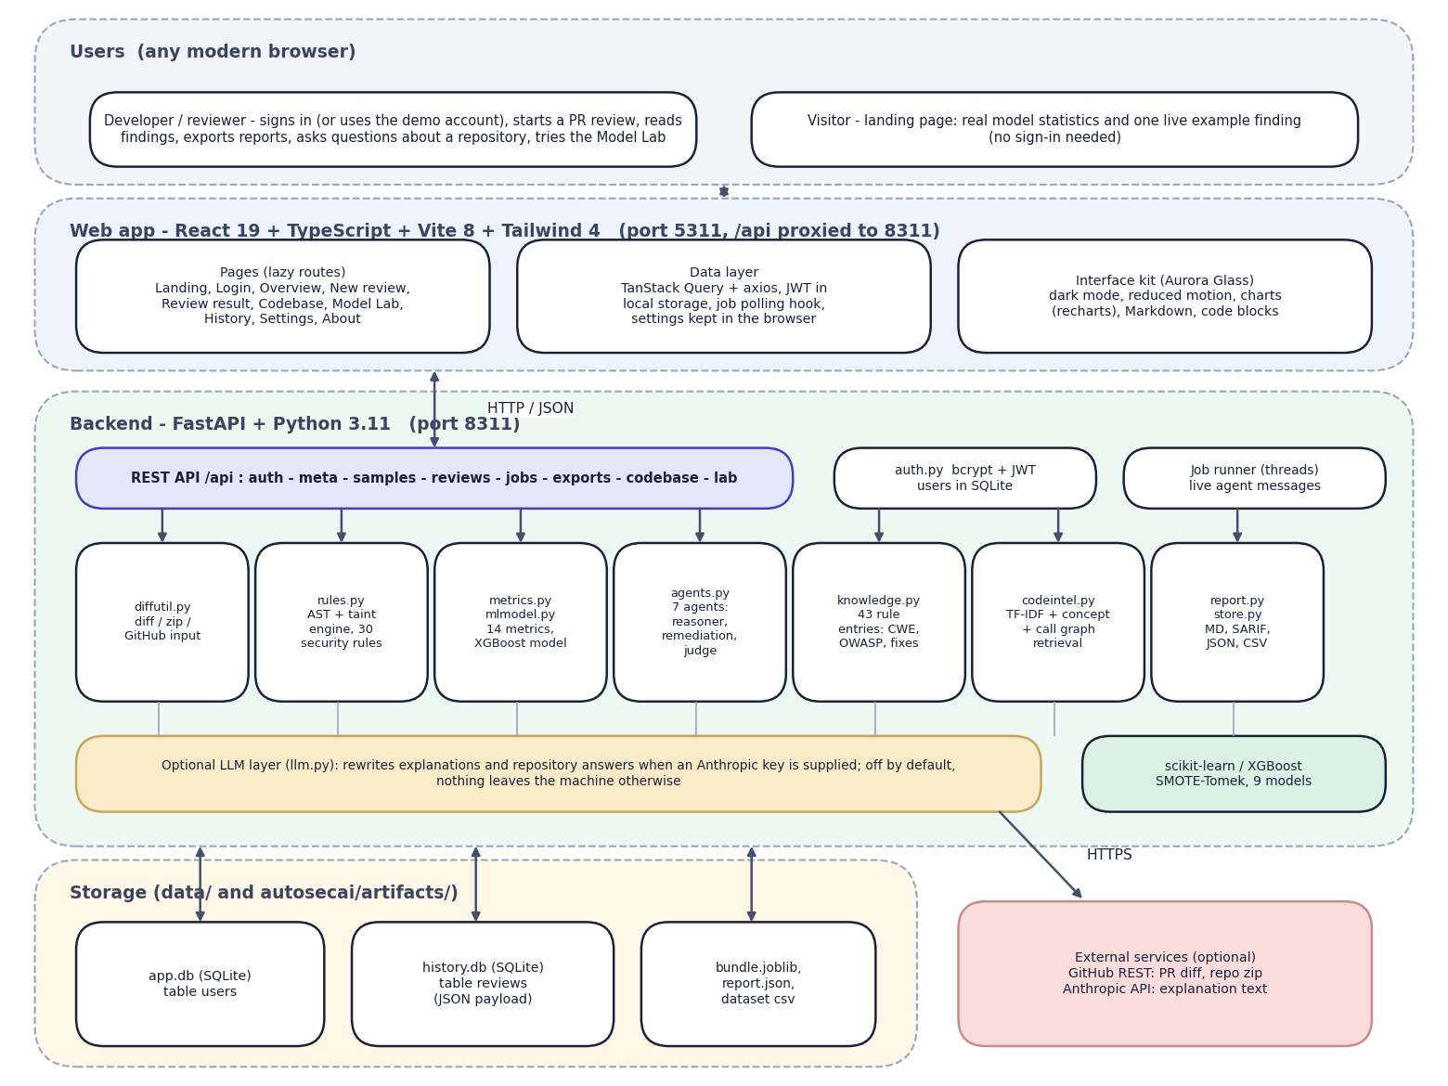
Fig. 5.1: System architecture of AutoSecAI
The diagram shows five bands. At the top are the users: a developer who signs in (or uses the seeded demo account) and a visitor who sees only the public landing page. Below is the React 19, TypeScript, Vite 8 and Tailwind 4 web application on port 5311, with lazily loaded pages, a data layer (TanStack Query and axios) that attaches the JWT and polls background jobs, and the Aurora Glass interface kit.
The backend band is a FastAPI application on port 8311. A REST layer exposes authentication, metadata, reviews, jobs, exports, the codebase assistant and the Model Lab; beside it sit auth.py (bcrypt and JWT) and the thread-based job runner. Beneath it are the seven engine modules that already existed: input handling (diffutil.py), the AST and taint rule engine (rules.py), metrics and model (metrics.py, mlmodel.py), the seven-agent pipeline (agents.py), the rule knowledge base (knowledge.py), repository retrieval (codeintel.py) and exporters and history (report.py, store.py).
The optional language-model layer (llm.py) is used only when an Anthropic key is supplied. Storage is local (app.db, history.db and the trained artefacts); the only external services are GitHub and, optionally, the Anthropic API.
Four principles shaped the design. Evidence before opinion: every finding is tied to a rule, a line and, where possible, an independent signal from the metric model, so that a reviewer can see why it was raised. Verify every fix: a patch is offered only after it has been applied to a copy of the source and the analysis has been run again. Keep the work local: parsing, analysis, model scoring and retrieval run on the user's machine, and the optional language-model layer is off by default. Say what is missing: when an input cannot support a result (for example a bare diff cannot yield a whole-file fix), the interface says so instead of hiding it.
The seven agents are deterministic software components that pass results through a shared trace; they are not language-model processes. The optional language-model text layer was not measured, and every result in this document was obtained without it.

5.2 High-Level Workflow
The workflow below is the path of a single review, from sign-in to the stored result.
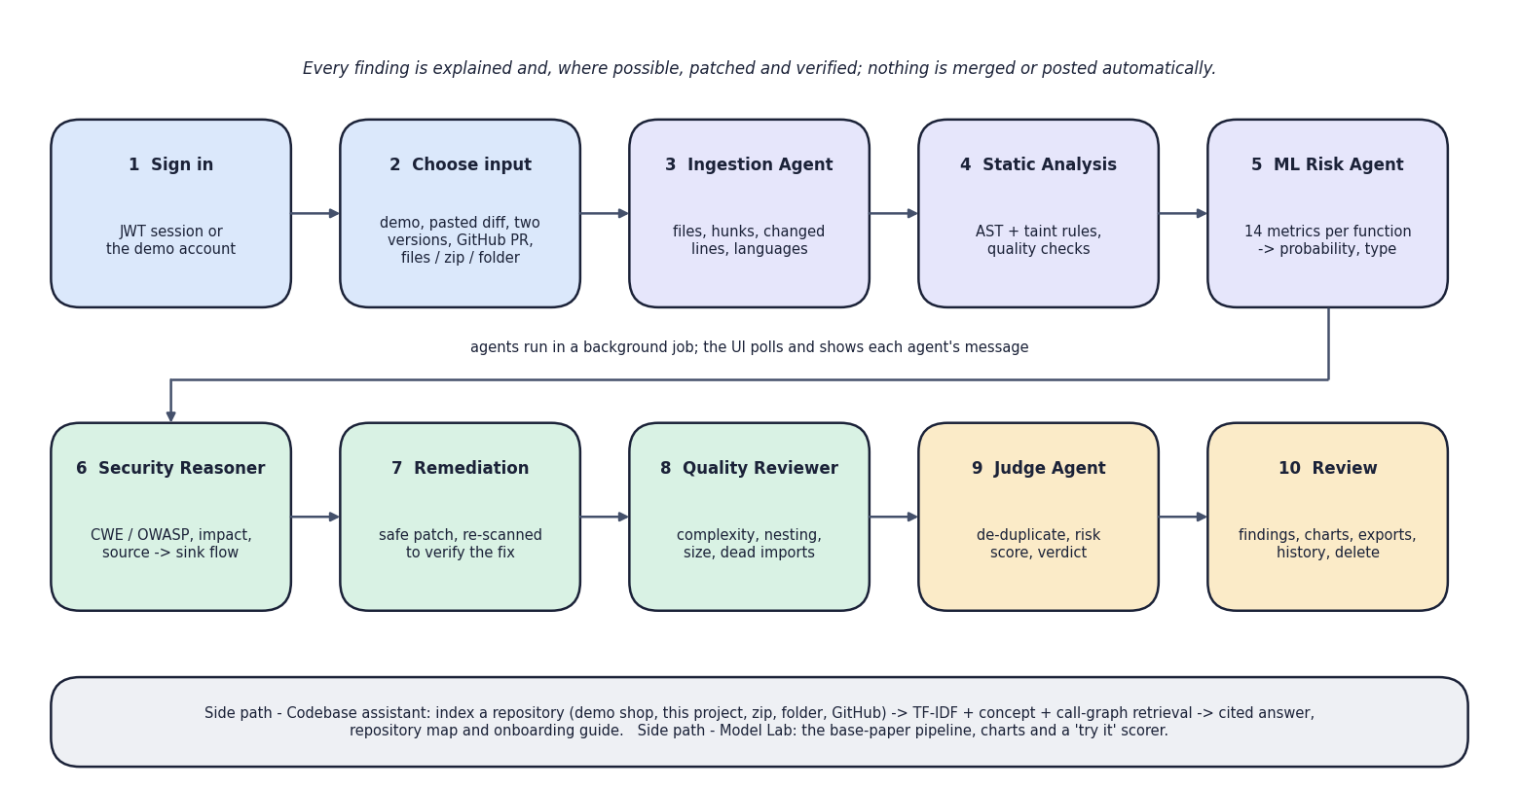
Fig. 5.2: High-level workflow
The ten steps run in two rows. Steps 1 and 2 are the user's: sign in and choose one of five inputs (the demo, a pasted diff, two versions of a file, a GitHub pull-request link, or files, a zip or a folder). Steps 3 to 9 are the seven agents: Ingestion, Static Analysis, ML Risk, Security Reasoner, Remediation, Quality Reviewer and Judge, run in a background job whose progress the interface polls. Step 10 is the review screen. The grey strip names the two side paths, the codebase assistant and the Model Lab, and the top line states the design rule that nothing is merged or posted automatically.

5.3 Data-Flow Diagrams
The data-flow diagrams describe how data moves through AutoSecAI at three levels of detail: the context, the six main processes, and the expansion of the review process into its seven agents.
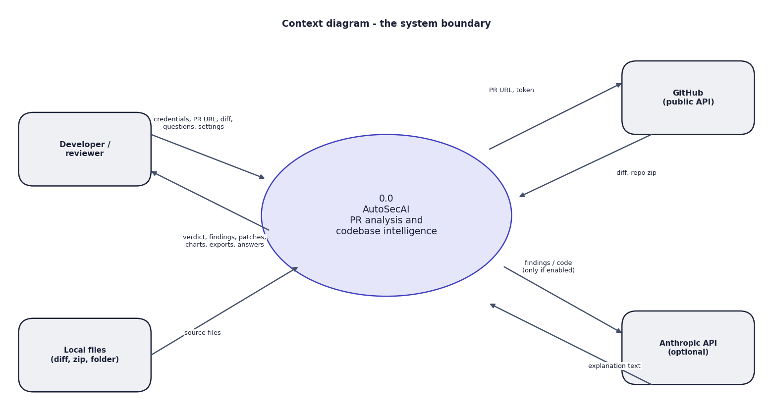
Fig. 5.3: Data-flow diagram, level 0 (context)
AutoSecAI is one process with four external entities. The developer sends credentials, pull-request URLs, diffs, files, questions and settings and receives a verdict, findings, patches, charts, exports and answers. Local files supply source code. GitHub returns a diff or a repository archive for a URL. The Anthropic API receives text only when the optional language-model mode is on.
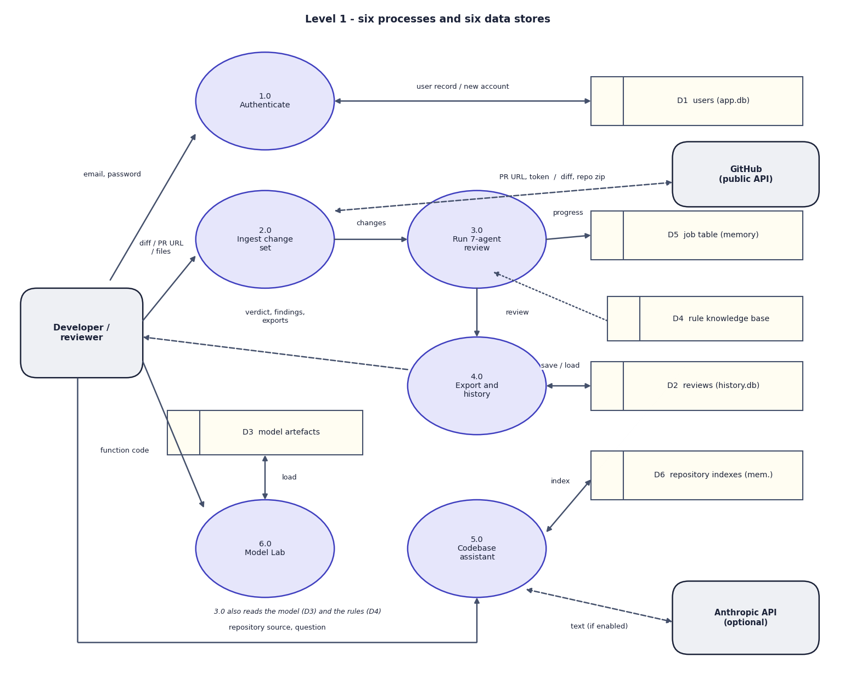
Fig. 5.4: Data-flow diagram, level 1
Level 1 has six processes: authentication (1.0), ingestion (2.0), the seven-agent review (3.0), export and history (4.0), the codebase assistant (5.0) and the Model Lab (6.0), and six stores: users (D1), reviews (D2), model artefacts (D3), rule knowledge base (D4), job table (D5) and repository indexes (D6). Every result that must survive a restart goes through 4.0 into D2, while jobs and indexes stay in memory; the Model Lab only reads the artefacts and never writes to the history.
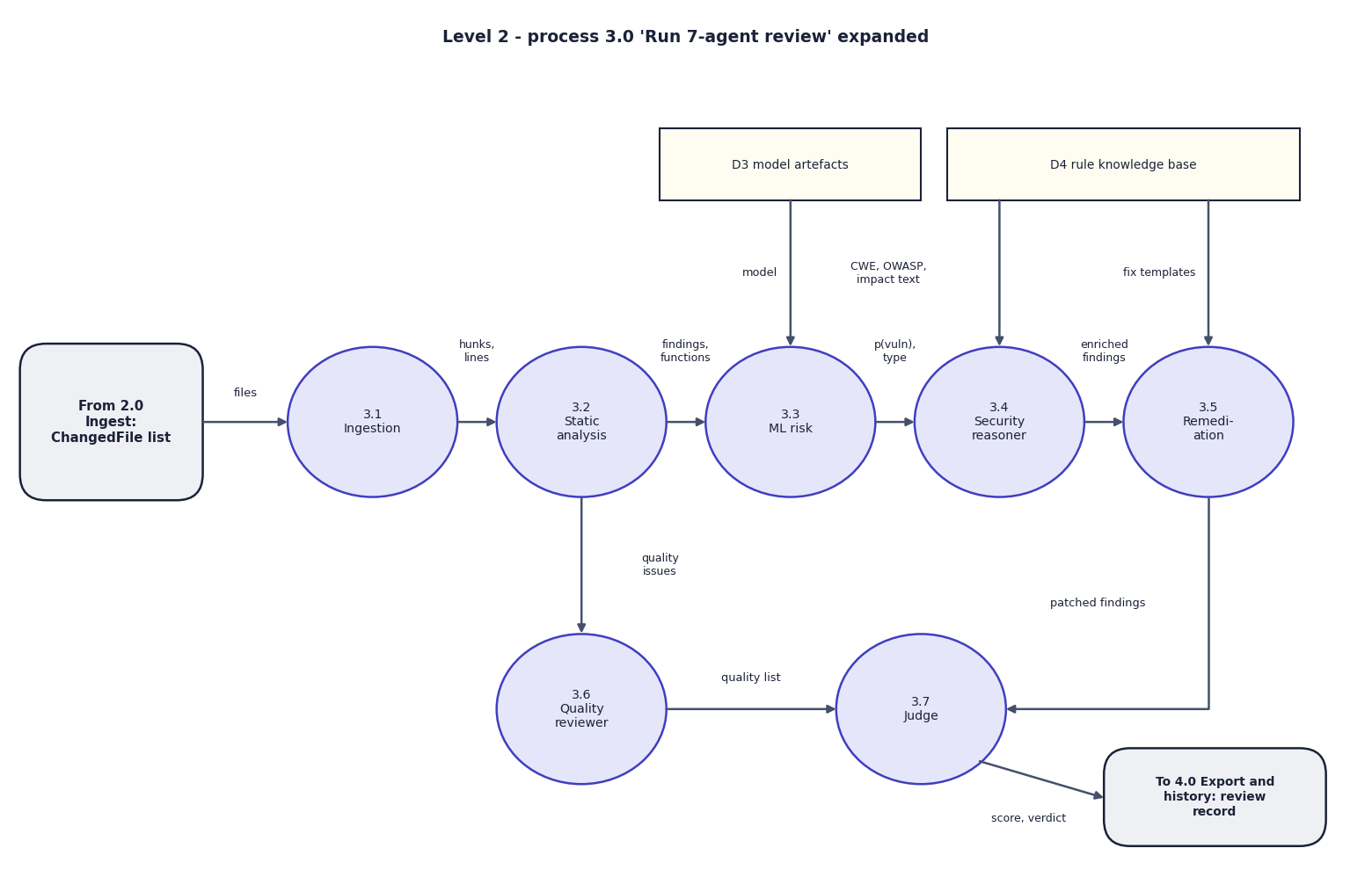
Fig. 5.5: Data-flow diagram, level 2: the seven-agent review (process 3.0)
Process 3.0 is expanded into its seven agents, following review_changes(). The change set enters ingestion (3.1); hunks and line numbers go to static analysis (3.2); findings and functions go to ML risk (3.3), which reads the model artefacts. The reasoner (3.4) reads the knowledge base for CWE, OWASP, impact and flow text, and remediation (3.5) reads the fix templates. Quality issues pass from 3.2 to the quality reviewer (3.6). The judge (3.7) de-duplicates, computes the score and verdict and hands the review record to process 4.0.

5.4 UML Diagrams
Three UML views describe the design: the use-case diagram shows who can do what, the sequence diagram shows how the main flow runs, and the class diagram shows what the code contains. The algorithm itself is shown as a flowchart in the methodology chapter and in the collection of diagrams.
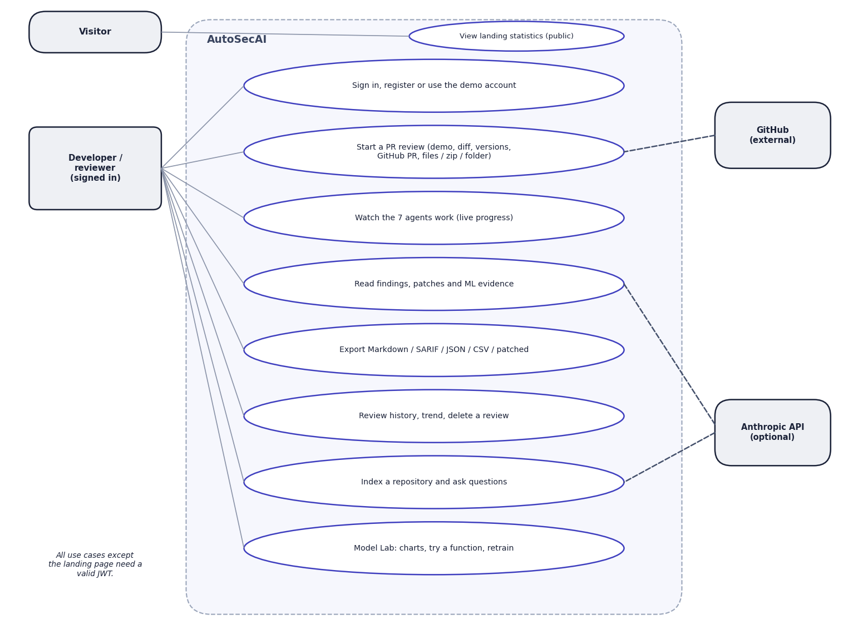
Fig. 5.6: Use-case diagram
The signed-in developer has eight use cases: sign in, register or use the demo account; start a review through any of five inputs; watch the agents work; read findings, patches and ML evidence; export Markdown, SARIF, JSON, CSV or patched files; use the history; index a repository and ask questions; and use the Model Lab. A visitor can only view the landing statistics. GitHub attaches to starting a review and the optional Anthropic API to reading findings and repository questions.
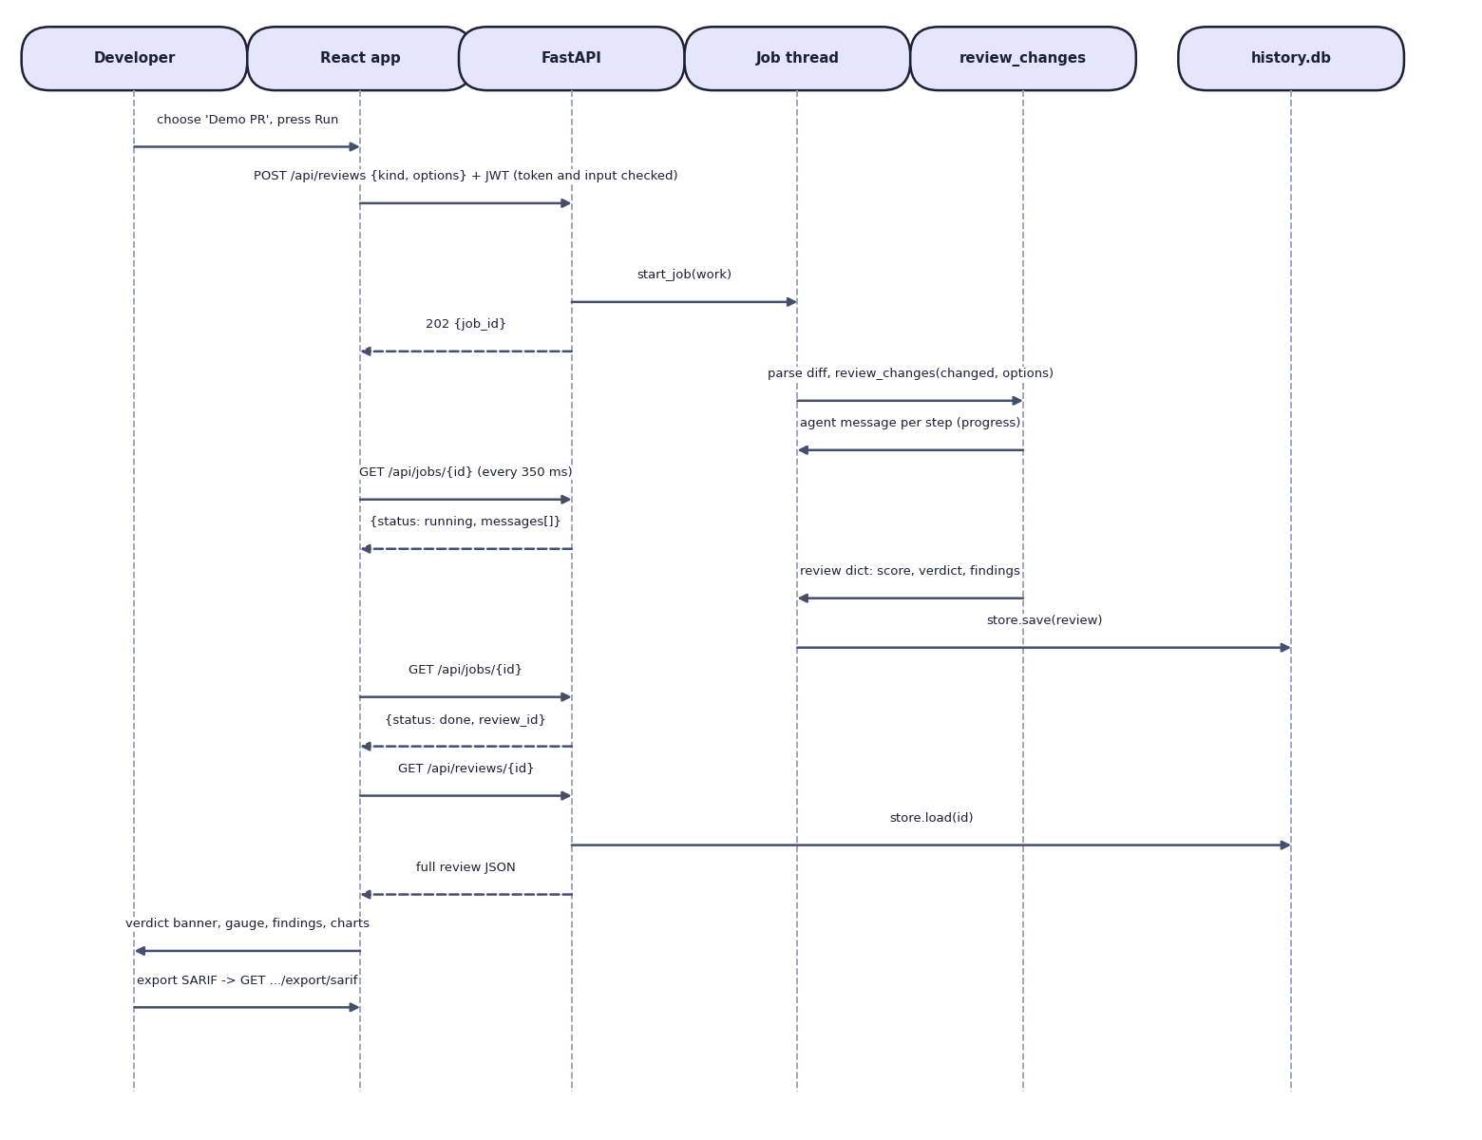
Fig. 5.7: Sequence diagram: running a review and opening the result
The participants are the developer, the React app, FastAPI, a job thread, review_changes and the history database. The app posts the request with the JWT; FastAPI checks the token and input, starts a job and answers 202 with a job identifier. The job thread runs review_changes, which reports one message per agent, while the app polls the job and receives running with the messages so far. When the review is saved the next poll returns done; the app loads the whole review and shows it, and the last arrow requests an export. The polling interval of the implemented hook is 350 ms.
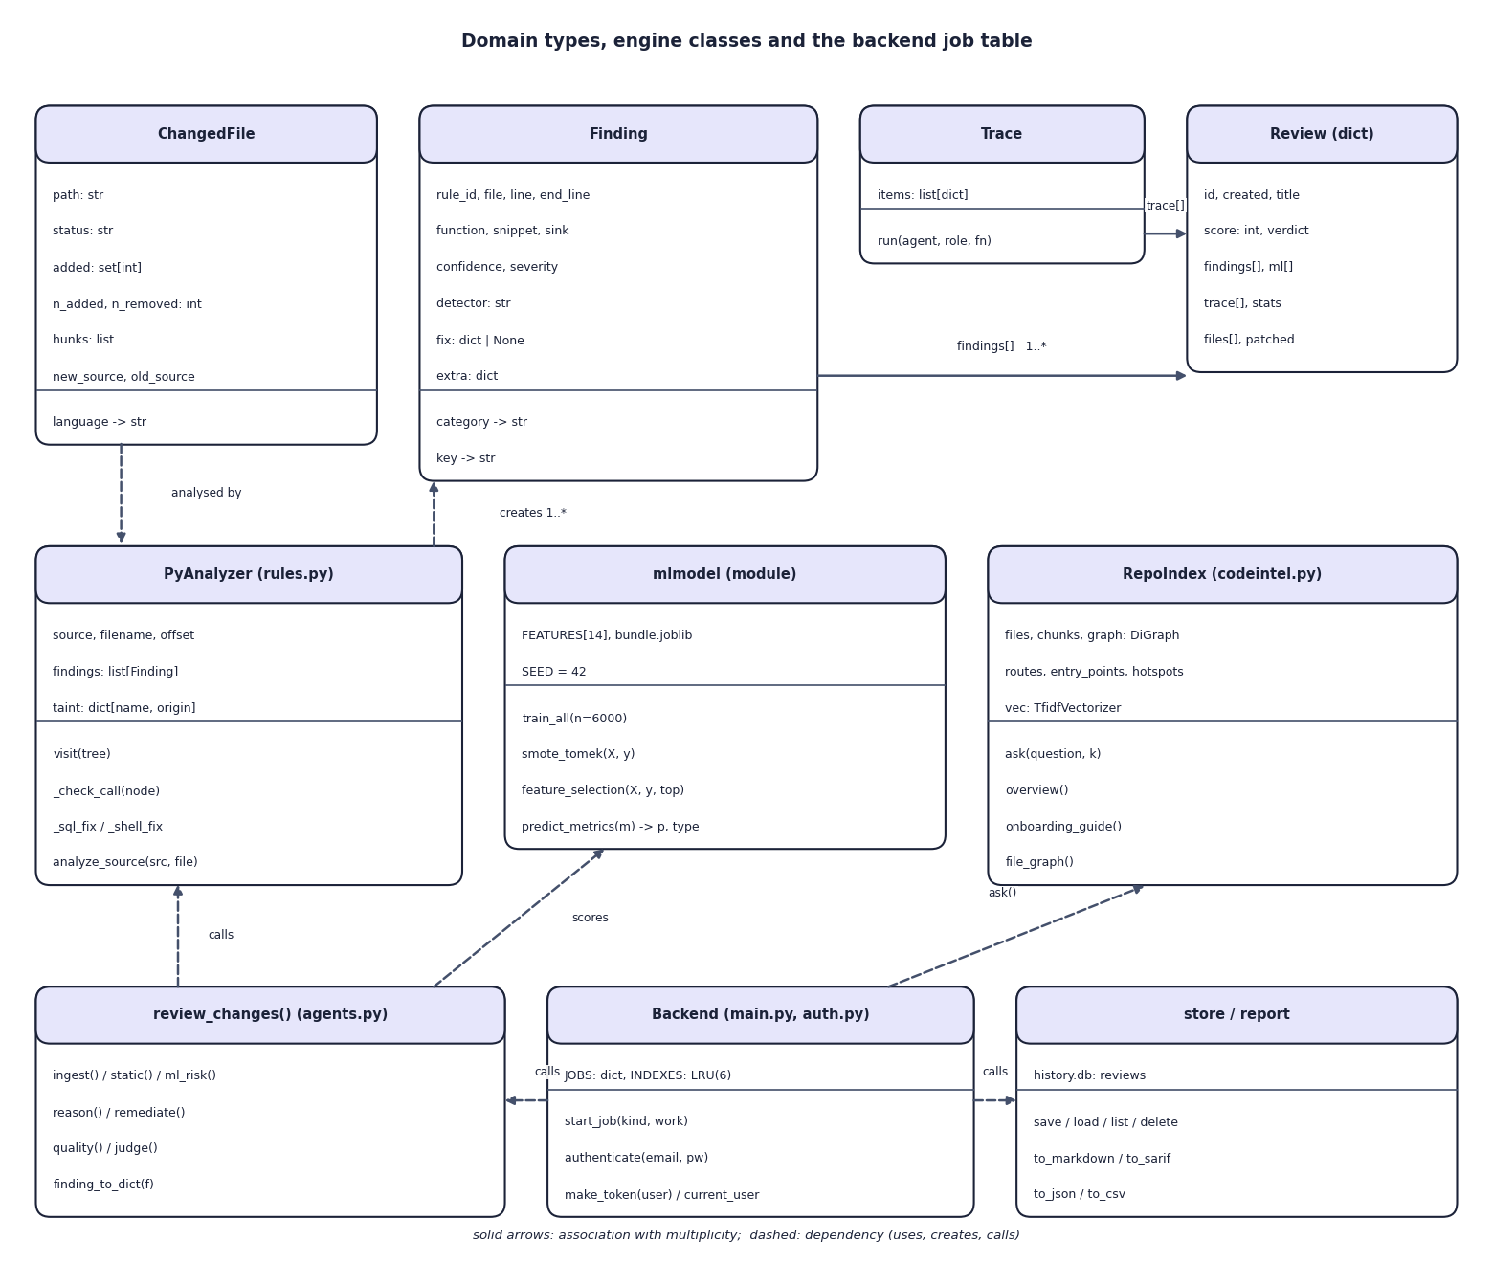
Fig. 5.8: UML class diagram
The upper row shows the domain types: ChangedFile, Finding (rule, location, confidence, severity, optional fix), Trace and the review record. The middle row shows PyAnalyzer, which walks the syntax tree and creates findings, the model module, and RepoIndex with its chunks, graph and TF-IDF matrix. The bottom row shows review_changes() with its agent functions, the backend objects (the job table and the table of six repository indexes) and the store and report functions. Dashed arrows are dependencies; 1..* records that a review contains many findings.

5.5 Database Design
Persistence uses SQLite through Python's standard library. Two files are used so that the account store, which belongs to the new web layer, is separate from the history store, which belongs to the original engine. A review is always read and written as a whole and is never queried field by field, so it is stored as one JSON document with a few indexed columns for the list view; this keeps the schema stable when the review structure grows.
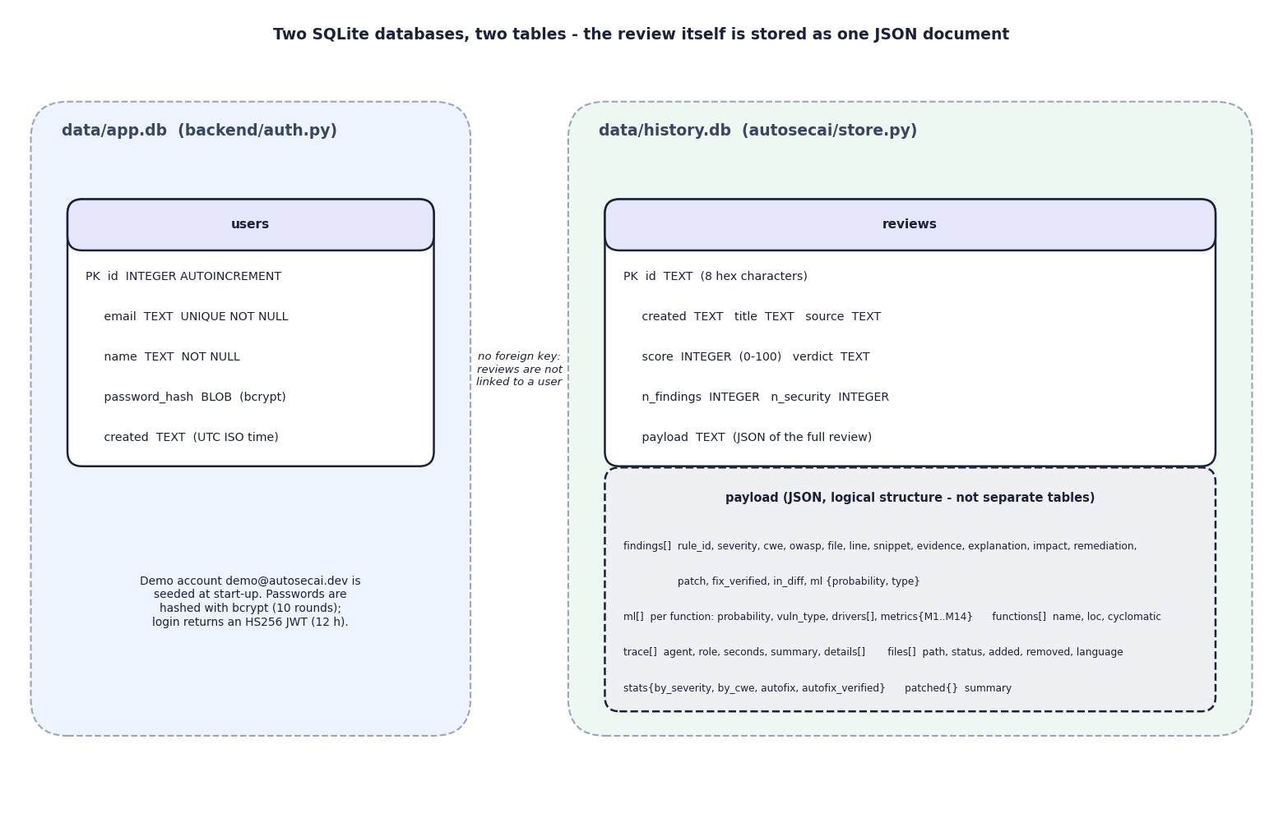
Fig. 5.9: Database design: two SQLite files
The file app.db holds one table, users (key, unique e-mail, name, bcrypt hash, creation time). The file history.db holds one table, reviews (eight-character identifier, creation time, title, source, score, verdict, two counters) and a payload column with the complete review as JSON. The lower box lists the logical parts of that payload (findings, ML rows, trace, files, statistics, patched files), which are not separate tables. The dotted note records a limitation: the tables are not linked, so a review has no user identifier and the history is shared by all accounts.
Table 5.1: Database tables and columns
File / table | Column | Type | Notes
app.db / users | id | INTEGER, primary key, auto-increment | Subject of the JWT
 | email | TEXT, UNIQUE, NOT NULL | Stored in lower case; format checked on registration
 | name | TEXT, NOT NULL | At least two characters
 | password_hash | BLOB, NOT NULL | bcrypt, 10 rounds; passwords cut at 72 bytes
 | created | TEXT, NOT NULL | UTC ISO time
history.db / reviews | id | TEXT, primary key | Eight hexadecimal characters
 | created, title, source | TEXT | Shown in the history table
 | score, verdict | INTEGER, TEXT | Score 0-100; APPROVE, REQUEST_CHANGES or BLOCK
 | n_findings, n_security | INTEGER | All findings; security findings inside the changed lines
 | payload | TEXT (JSON) | Findings, ML rows, trace, files, statistics, patched files, summary

The demo account is inserted at start-up if it does not exist. Deleting a review removes its row; there is no cascade because there is no relation. Two further stores exist in memory only: the job table (jobs older than one hour are dropped whenever a new job starts) and the table of repository indexes, which keeps the six most recently created indexes. Both disappear when the API process stops, which is acceptable because a job is short and an index can be rebuilt in milliseconds.

5.6 Module Design
The table lists the modules with their real size, counted as non-blank lines of the files in the repository.
Table 5.2: Modules of AutoSecAI (non-blank lines)
Module | File | Lines | Responsibility
Input handling | autosecai/diffutil.py | 201 | Unified-diff parser, before/after diff, zip and folder reader (up to 1,500 files of 800 KB), GitHub pull-request and archive download, fix application and patch generation
Static analysis | autosecai/rules.py | 577 | Python AST analyser with taint levels, 30 security rules, quality rules, regex rules for JavaScript, PHP and Java, fix generators for SQL and shell calls
Rule knowledge base | autosecai/knowledge.py | 265 | 43 entries (30 security, 12 quality, 1 ML-derived) with CWE, OWASP, severity, explanation, impact, exploit sketch, fix and safe example; weights
Metrics | autosecai/metrics.py | 218 | The 14 source-code metrics per function from the Python AST
Corpus generator | autosecai/dataset.py | 143 | Generates the labelled Python corpus (8 vulnerability types, hard negatives, label noise)
Model | autosecai/mlmodel.py | 234 | SMOTE and Tomek links, seven feature selectors, nine classifiers, type classifier, ablation, persistence and prediction
Agents | autosecai/agents.py | 330 | The seven-agent pipeline, risk score and verdict
Codebase intelligence | autosecai/codeintel.py | 394 | Chunking, TF-IDF, concept detection, import and call graph, question answering, overview and onboarding guide
Reports and history | autosecai/report.py, store.py | 91 | Markdown, SARIF 2.1.0, JSON and CSV exporters; SQLite history
Optional LLM | autosecai/llm.py | 24 | Thin client used only when a key is supplied
Sample data | autosecai/samples.py | 230 | Demo pull request, before/after pair and demo repository
REST API | backend/main.py | 414 | 7 public and 18 protected routes, job runner, repository indexes, uploads, exports
Accounts | backend/auth.py | 82 | Registration, login, bcrypt, JWT, demo account
Web application | frontend/src | 6,525 | 69 TypeScript files: ten pages, review components, lab tabs, charts, interface kit
Original UI | app.py, autosecai/ui.py | 785 | Streamlit front end (unchanged, not run in the final tests)
Tests | tests/ | 133 | Engine and API tests

The dependencies run in one direction. The web application depends on the API; the API depends on the engine; the engine modules depend on each other in a simple chain (diffutil and rules feed agents; metrics feed mlmodel; knowledge is read by rules and agents). The engine has no knowledge of the API, which is why the Streamlit page and the API can coexist.

5.7 User Interface Design
The web application has ten screens: the public landing page and the sign-in page, and, behind the sign-in, the overview, the new-review page, the review result, the codebase assistant, the Model Lab, the history, the settings and the about page, plus a friendly not-found page. A sidebar on wide screens and a drawer on phones give access to the sections, and a skip link lets keyboard users jump to the content.
The interface is built on a shared kit called Aurora Glass (translucent panels over a dark aurora background, with a light theme as well). Design decisions follow from the purpose of the product. The verdict is the first thing on a review page and uses both colour and a text label, so the meaning never depends on colour alone. Severities are shown as badges with their names. Every finding card expands to the explanation, impact, remediation, a safe pattern and, where one exists, a verified patch. Every asynchronous screen has a loading state, an empty state and an error state that says what failed and offers a retry; the 'API unreachable' case is covered by an automated test.
Four non-negotiable properties were applied to all screens: the theme (dark by default, light on request) persists across reloads; the reduced-motion setting of the operating system is honoured, and the animated pinned section of the landing page falls back to a plain list; every screen is laid out from 360 pixels upwards without horizontal scrolling (checked at 360 and 768 pixels in light and dark mode); and every control is reachable and operable with the keyboard, with a visible focus ring and Escape closing dialogs and the mobile drawer.
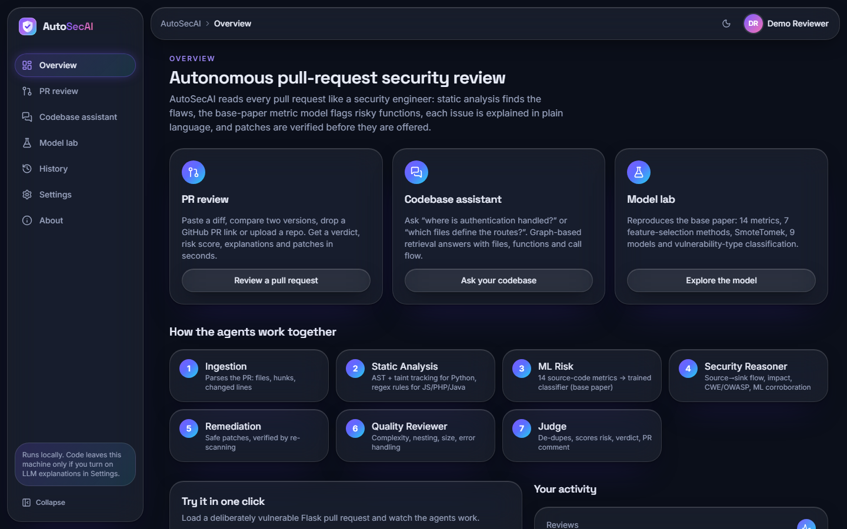  Fig. 5.10: Overview screen: three entry cards and the seven agents | 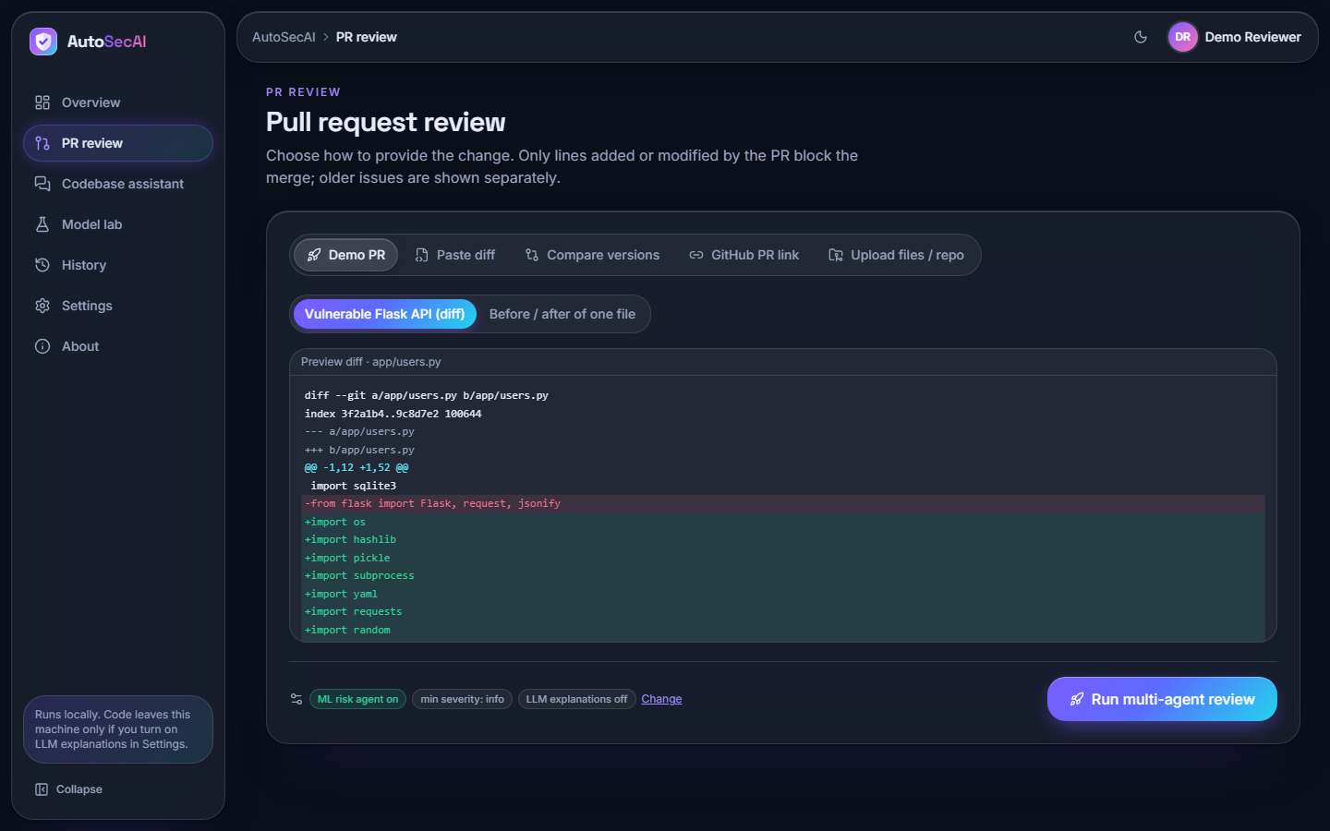  Fig. 5.11: New review screen with the five input modes

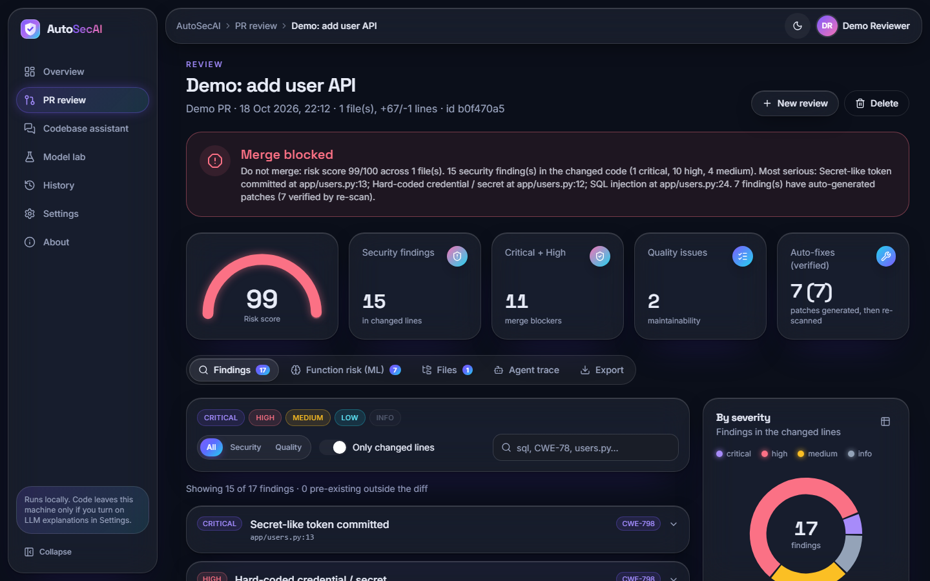  Fig. 5.12: Review result: verdict banner, gauge and four counters | 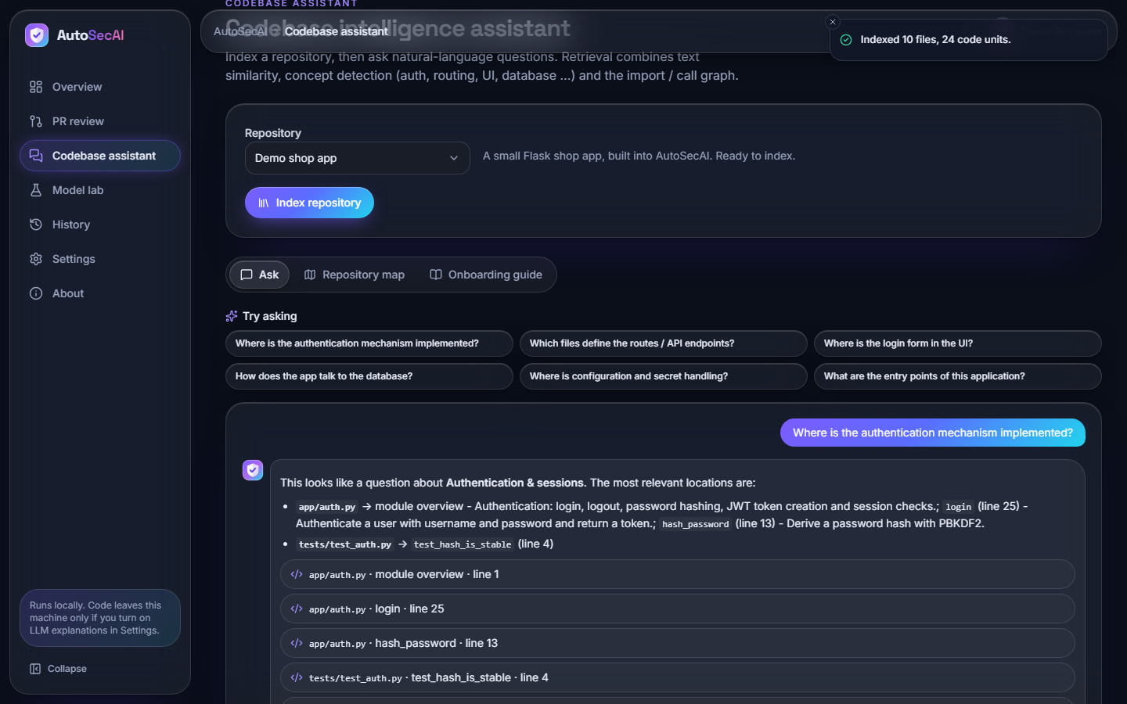  Fig. 5.13: Codebase assistant: suggested questions and a cited answer

The screens are shown in full size in the chapter on results and in the appendix of additional screens.

CHAPTER 6
METHODOLOGY AND SOFTWARE IMPLEMENTATION

6.1 Overall Methodology
AutoSecAI turns a code change into a reasoned review. The method has two parts. Preparation is done once, before the product is used: a labelled corpus of Python functions is generated, fourteen metrics are measured on it, features are selected, the classes are balanced, nine classifiers are trained and the best one is stored together with a report. Use happens for every pull request: the change is parsed, seven agents analyse it in sequence, and the result is a score, a verdict, explained findings and verified patches. A second use, the codebase assistant, indexes a repository and answers questions with cited locations.
The central idea comes from the base paper [1], which showed that a small set of source-code metrics predicts which functions are vulnerable. The paper applies the idea offline to C and C++ functions. This project applies it inside the pull-request workflow and combines it with two other kinds of evidence: an abstract-syntax-tree analyser with taint tracking, which names the exact line and the weakness class, and a rule knowledge base, which supplies the explanation, impact and fix. Each kind of evidence is weak alone, and the combination is evaluated later in this document.
Table 6.1: Pipeline of AutoSecAI
Step | Method | Output
1 Ingest | Unified-diff parser, before/after diff, zip or folder reader, GitHub pull-request download | List of changed files with hunks and added line numbers
2 Static analysis | Python AST, taint levels 0-3, 30 security rules, quality rules; regex rules for JavaScript, PHP and Java | Findings with rule, line, confidence, optional fix
3 ML risk | 14 metrics per function, Min-Max scaling, stored XGBoost model, type classifier | Probability, predicted type and top drivers per function
4 Reasoner | Knowledge-base lookup, source-to-sink description, corroboration with the model | Explanation, impact, remediation, CWE, OWASP
5 Remediation | Fix generators for SQL, shell and similar calls; apply to a copy; analyse again | Patch and a verified flag
6 Quality | Complexity, nesting, size, error handling, dead imports | Maintainability findings
7 Judge | De-duplication by file, line and CWE; weights; exponential score; verdict rule | Score 0-100, verdict, PR comment
8 Report | Markdown, SARIF 2.1.0, JSON, CSV, patched files; SQLite history | Exports and stored review

The seven agents are ordinary Python functions that append an entry (agent, role, seconds, summary, details) to a shared trace; none is a language model. An optional language-model call can rewrite the explanation of the six most serious findings; it was not measured.

6.2 Dataset
The metric model needs labelled functions. The base paper used 21,759 C and C++ functions from ten open-source projects, of which only 275 (1.26 %) were vulnerable, labelled from public vulnerability databases [1]. Those datasets are written in C and C++, are not distributed with the paper, and cannot be analysed by a Python pull-request tool. For this reason the project generates its own corpus of Python functions. This is the most important limitation of the learned component, and every result in this document must be read with it in mind: the model has been shown to learn the patterns the generator contains, not the patterns of real-world vulnerable code.
The generator (autosecai/dataset.py) produces 6,000 functions with a fixed seed. Each function starts as random benign logic whose complexity follows a heavy-tailed choice: it may contain no blocks at all or up to six, drawn from conditionals, loops, nested structures, try blocks, arithmetic, list comprehensions and index expressions. A vulnerable snippet of one of eight types is then inserted at a block boundary, so that the function stays syntactically valid. In 55 % of the non-vulnerable functions a look-alike safe snippet (a hard negative) is inserted instead: a parameterised query, a list-form subprocess call, ast.literal_eval, json.loads, yaml.safe_load, os.path.basename, an escaped HTML fragment, hashlib.sha256, secrets.token_hex or a password read from the environment. Half of the vulnerable snippets read their value directly from a request object, and half use a function parameter. Finally 1 % of the labels are flipped to imitate annotation noise.
Table 6.2: The eight vulnerability types of the generated corpus
Vulnerability type | Pattern inserted | Functions in the corpus
xss | HTML built from a value by f-string | 75
weak crypto | MD5 digest or predictable random value | 65
sql injection | query built by f-string, concatenation or % | 64
hardcoded secret | password literal passed to a connection | 63
deserialization | pickle, yaml.load or marshal on input | 61
code execution | eval or exec on input | 60
path traversal | open, send_file or remove on an unchecked path | 59
command injection | os.system, os.popen or shell=True with input | 54

Table 6.3: Dataset summary
Property | Value
Functions | 6,000 (seed 7)
Vulnerable | 501 (8.35 %), after 1 % label noise
Split | 75 % training (4,500) and 25 % test (1,500), stratified, seed 42
Test set | 125 vulnerable and 1,375 safe functions, never balanced
Balanced training set | 8,232 rows after SMOTE and 16 Tomek removals
Licence and provenance | Generated by the project's own code; no third-party data and no licence restriction

Two consequences follow. The analyser's rules and the generator were written by the same team around the same eight weakness classes, so the analyser's score on the corpus is optimistic for real code; and the headline model scores are an upper bound for production code, with no claim of equivalence with the base paper.

6.3 Data Preprocessing

6.3.1 Metric extraction
Every function is parsed with Python's ast module and fourteen metrics are measured on it. The metrics are the Python counterparts of the metrics of the base paper [1], which derived them from a code property graph of C and C++ functions. The first eleven keep the families and the numbering of the paper (complexity, size, variables, calls, parameters, index arithmetic in place of pointer arithmetic, input and output calls, nesting, loops and control dependency). Metrics M12 to M14 were added by this project, because injection flaws in Python are not memory flaws and are better indicated by risky calls, string-built call arguments and untrusted sources.
Table 6.4: The fourteen source-code metrics
Id | Metric | Meaning | Origin
M1 | Cyclomatic complexity | Independent paths (branches) through the function | paper family
M2 | Lines of code | Physical lines of the function body | paper family
M3 | Local variables | Distinct names assigned in the function | paper family
M4 | Call sites | Number of function/method calls (fan-out) | paper family
M5 | Parameters | Variables in the function's argument list (caller-argument metric) | paper family
M6 | Index arithmetic | Subscripts/slices computed with arithmetic (analogue of pointer arithmetic) | paper family
M7 | Vars in index arithmetic | Distinct variables used inside arithmetic subscripts | paper family
M8 | I/O & query calls | open/read/write/execute/send style calls | paper family
M9 | Nested control structures | Deepest nesting of if/for/while/try/with | paper family
M10 | Loops | for/while/comprehension loops | paper family
M11 | Max control dependency | Max number of guarding conditions on any statement | paper family
M12 | Risky API calls | eval/exec/os.system/subprocess/pickle/yaml.load, weak hash/PRNG ... | added by this project
M13 | String-built sinks | Call arguments or returned markup built by f-string/%/format/+ | added by this project
M14 | Untrusted/sensitive sources | request.*, input(), sys.argv, secret-named literals ... | added by this project

6.3.2 Scaling and balancing
Metric values have very different ranges (lines of code against a count of risky calls), so the selected metrics are scaled to the interval from 0 to 1 with Min-Max scaling fitted on the training data only. The training set is highly imbalanced, so the minority class is enlarged with SMOTE and the result is cleaned with Tomek links [15], [16], [17]. SMOTE draws a minority sample, picks one of its five nearest minority neighbours and creates a new sample on the line between them. A Tomek link is a pair of samples from different classes that are each other's nearest neighbour; the majority-class member of every such pair is removed. Both steps are implemented in the project (about thirty-five lines using scikit-learn's nearest-neighbour search), and they are applied to the training data only, so that the test set keeps its natural class ratio.
Listing: SMOTE as implemented in autosecai/mlmodel.py
def smote(X, y, k=5, seed=SEED):
"""Balance the minority class by interpolating between a sample and its k nearest neighbours."""
rng = np.random.default_rng(seed)
classes, counts = np.unique(y, return_counts=True)
minority, majority = classes[counts.argmin()], classes[counts.argmax()]
Xm = X[y == minority]
need = counts.max() - counts.min()
if need <= 0 or len(Xm) < 2:
return X, y
kk = min(k, len(Xm) - 1)
nn = NearestNeighbors(n_neighbors=kk + 1).fit(Xm)
idx = nn.kneighbors(Xm, return_distance=False)[:, 1:]
base = rng.integers(0, len(Xm), need)
neigh = idx[base, rng.integers(0, kk, need)]
gap = rng.random((need, 1))
synth = Xm[base] + gap * (Xm[neigh] - Xm[base])
return np.vstack([X, synth]), np.concatenate([y, np.full(need, minority)])

6.4 Algorithm Choice and Justification
Feature selection. Following the base paper, seven methods rank the metrics: absolute Pearson correlation with the label, the coefficients of a linear support-vector machine, Lasso coefficients, the chi-squared statistic, recursive feature elimination with logistic regression, recursive feature elimination with a random forest, and the variance threshold. Each method votes for its five best metrics; the metrics are sorted by votes and, for ties, by mean rank. The paper keeps the top five. This project instead validated the number of metrics k from 5 to 14 on a quarter of the training data and chose k = 13 (validation F1 0.786, against 0.566 for k = 5). The only metric dropped is the number of variables used in index arithmetic (M7), which received no vote.
Classifiers. Nine classifiers were trained, as in the paper: random forest, decision tree, logistic regression, support-vector machine with an RBF kernel, k-nearest neighbours, naive Bayes, gradient boosting, XGBoost [19] and a soft-voting ensemble of random forest, gradient boosting and logistic regression. The model with the best F1 on the held-out data, XGBoost (F1 0.851), is the one stored and used by the ML Risk agent; the random forest (F1 0.826, the winner of the paper) is also kept for the importance chart. F1 was chosen as the selection criterion because accuracy is meaningless when 91.7 % of the functions are safe, and a security tool needs a balance between missed flaws and false alarms.
Why a rule engine as well. A metric model can say that a function looks vulnerable, but not where, why or how to fix it. The AST and taint analyser tracks values from requests and parameters to dangerous calls, names the line and weakness class and can propose a patch. The two detectors fail differently (the measured comparison is given in the testing chapter), which is why the pipeline correlates both kinds of evidence.
Table 6.5: Consensus of the seven feature-selection methods (training data)
Metric | Votes (of 7) | Mean rank
n_strbuild_args | 7 | 3.71
n_sources | 6 | 3.43
n_danger | 6 | 3.86
n_vars | 4 | 4.29
loc | 3 | 7.14
n_io | 2 | 8.00
n_loops | 2 | 8.14
n_params | 1 | 8.57
max_ctrl_dep | 1 | 9.00
cyclomatic | 1 | 9.14
idx_arith | 1 | 10.14
max_nesting | 1 | 10.71
n_calls | 0 | 7.86
idx_vars | 0 | 11.00

6.5 Mathematical Formulation
This section states the formulas that the implementation uses. The notation is local to this document.

6.5.1 Cyclomatic complexity (metric M1)
Following McCabe [21], the complexity of a function is one plus the number of decision points: each if, conditional expression, while, for, exception handler and assertion adds one; each comprehension adds one plus the number of its filters; a boolean expression with n operands adds n - 1; each match case adds one.

6.5.2 SMOTE and Tomek links
For a minority sample x_i and one of its k = 5 nearest minority neighbours x_nn, a synthetic sample is x_new = x_i + u (x_nn - x_i), where u is drawn uniformly from [0, 1) [15]. The number of samples created is the difference between the sizes of the majority and the minority class. A pair (x_a, x_b) is a Tomek link if their classes differ and each is the other's nearest neighbour [16]; the majority member of the pair is deleted [17].

6.5.3 Evaluation measures
With TP, FP, FN and TN as the cells of the confusion matrix, precision P = TP / (TP + FP), recall R = TP / (TP + FN), accuracy = (TP + TN) / (TP + FP + FN + TN) and F1 = 2 P R / (P + R). The area under the ROC curve (AUC) is the probability that a random vulnerable function receives a higher score than a random safe one.

6.5.4 Risk score and verdict
Let the visible findings be f_1 ... f_n. Each has a severity weight s (critical 10, high 6, medium 3, low 1, info 0.2) and a confidence weight c (high 1.0, medium 0.7, low 0.4). Info-level quality findings are skipped. A finding outside the changed lines counts only 15 % of its weight. With w_i = s_i c_i m_i, where m_i is 1 inside the diff and 0.15 outside, the total is W = sum of w_i and the risk score is
score = round( 100 x (1 - exp(-W / 18)) )
The exponential form maps any amount of evidence onto 0-100 with diminishing returns: one medium-severity finding of medium confidence gives a score of 11, and the demo pull request, whose total weight is large, gives 99. The verdict is BLOCK if at least one security finding of high or critical severity with at least medium confidence lies in the changed lines, or if the score is 70 or more; REQUEST_CHANGES if a finding of medium or higher severity lies in the changed lines, or the score is 30 or more; and APPROVE otherwise.

6.5.5 Retrieval in the codebase assistant
Each function, class or window of a source file is a chunk. Names are split at underscores and capital letters, and chunks are represented by TF-IDF vectors over unigrams and bigrams with sublinear term frequency [22]. For a question q the score of chunk c is
score(c) = cos(q, c) + 0.30 x max concept affinity(c) / 2 + 0.5 [name(c) = identifier in q] + 0.1 [path(c) contains a long token of q]
then multiplied by 1.15 for function chunks and 1.05 for class chunks. The affinity of a chunk to each of eight concepts (authentication, routing, user interface, database, configuration, tests, security controls, entry points) is computed from keyword counts in the code and from matches in the path, capped at 2. For the five strongest chunks a personalised PageRank [23] is run on the import and call graph with damping 0.6 and the scores as the personalisation vector; its normalised value times 0.08 is added to every chunk. Chunks with a final score of at most 0.02 are discarded and the top k (default 6) are returned.

6.6 Model Architecture and Training
Training is a single function, train_all(), which takes 31.7 s on the development machine (Intel Core i5-12500, 12 threads, no GPU). It generates the corpus, splits it, selects features on the training part, balances it, fits the nine classifiers, evaluates them on the untouched test part, runs the ablation, trains the type classifier and writes the model bundle, the report and two CSV files. All random choices use fixed seeds. The hyper-parameters were not tuned with a grid search (the paper used one [1]); they are library defaults except where listed.
Table 6.6: Model configuration
Model | Configuration
Random forest | 300 trees, seed 42
Decision tree | maximum depth 12
Logistic regression | up to 2,000 iterations
SVM | RBF kernel, probability estimates on
k-nearest neighbours | k = 7
Naive Bayes | Gaussian
Gradient boosting | library defaults, seed 42
XGBoost | 200 trees, depth 5, learning rate 0.1, log-loss
Voting ensemble | soft vote of random forest (200 trees), gradient boosting and logistic regression
Type classifier | random forest, 400 trees, class-balanced, 14 metrics, trained on the vulnerable functions only

Table 6.7: Results of the nine classifiers on the 1,500 held-out functions
Model | Accuracy | Precision | Recall | F1 | AUC
Random Forest | 0.973 | 0.882 | 0.776 | 0.826 | 0.953
Decision Tree | 0.953 | 0.682 | 0.824 | 0.746 | 0.896
Logistic Regression | 0.879 | 0.401 | 0.920 | 0.558 | 0.945
SVM (RBF) | 0.933 | 0.563 | 0.856 | 0.679 | 0.929
KNN | 0.901 | 0.448 | 0.832 | 0.583 | 0.924
Naive Bayes | 0.877 | 0.397 | 0.920 | 0.554 | 0.936
Gradient Boosting | 0.949 | 0.650 | 0.832 | 0.730 | 0.937
XGBoost (stored) | 0.977 | 0.942 | 0.776 | 0.851 | 0.937
Voting Ensemble | 0.963 | 0.738 | 0.856 | 0.793 | 0.956

XGBoost gave the best F1 (0.851) through the highest precision (0.942), at the same recall as the random forest (0.776). Logistic regression and naive Bayes had the highest recall (0.920) but a precision near 0.40, which would flood a reviewer with false alarms.

6.6.1 Ablation, feature count and stability
Table 6.8: Ablation of the random forest
Random-forest configuration | Precision | Recall | F1
RF - all 14 metrics, no balancing | 0.933 | 0.776 | 0.847
RF - top-5 metrics + SmoteTomek (paper setting) | 0.643 | 0.648 | 0.645
RF - top-13 metrics + SmoteTomek (this system) | 0.882 | 0.776 | 0.826

All fourteen metrics without balancing gave the best F1 (0.847); the paper's top-five setting with SMOTE-Tomek gave only 0.645; the system's setting (top 13 with balancing) gave 0.826. Recall is the same (0.776) with and without balancing and balancing lowered precision, so on this corpus it did not help; but the configurations differ in the number of metrics as well, so the effects cannot be separated and no single-factor experiment was run. The sweep shows that the taint-oriented metrics matter: five metrics lower the validation F1 from 0.786 to 0.566.
To check that the result is not an accident of one random corpus, the Random Forest and XGBoost pipelines were repeated on five corpora generated with different seeds (k fixed at 13, same split rule). The first seed reproduces the stored report exactly.
Table 6.9: Five independently generated corpora
Corpus seed | Vulnerable | RF F1 | RF precision | RF recall | XGB F1 | XGB precision | XGB recall
7 | 501 | 0.826 | 0.882 | 0.776 | 0.851 | 0.942 | 0.776
11 | 493 | 0.800 | 0.860 | 0.748 | 0.842 | 0.949 | 0.756
23 | 545 | 0.818 | 0.910 | 0.743 | 0.840 | 0.953 | 0.750
41 | 517 | 0.818 | 0.856 | 0.783 | 0.840 | 0.895 | 0.791
59 | 484 | 0.809 | 0.875 | 0.752 | 0.836 | 0.929 | 0.760
Mean +/- sd |  | 0.814 +/- 0.010 |  |  | 0.842 +/- 0.006

The headline F1 of 0.851 for XGBoost is the best of the five seeds; the mean is 0.842 with a standard deviation of 0.006. For the random forest the headline 0.826 is also the best seed (mean 0.814 +/- 0.010). XGBoost ranks above the random forest on all five seeds, which supports the stored choice. The number of metrics was not re-selected per seed.
Risky API calls, untrusted sources and string-built sinks carry about 46 % of the importance; the paper's complexity metrics matter less for these injection-type flaws. The type classifier reaches an accuracy of 0.651 on 126 functions (macro F1 0.630): reliable for SQL injection, XSS, command injection, weak cryptography and hard-coded secrets (F1 0.77 to 0.88), unreliable for deserialization (0.21), path traversal (0.33) and code execution (0.38).

6.7 Application Architecture
The application has three tiers. The web tier is a single-page React application written in TypeScript and bundled with Vite. Pages are loaded lazily by route, server state is cached by TanStack Query, and an axios instance adds the bearer token to every request and redirects to the sign-in page on a 401. Long operations use a hook that starts a job, polls it every 350 ms and shows the agents' messages as they arrive. User settings (minimum severity, ML agent on or off, optional keys) live in the browser's local storage and are sent with each request; the server never stores them.
The API tier is a FastAPI application. Routes validate their input with Pydantic models, call the engine functions unchanged and return JSON; a helper replaces non-finite floating-point numbers, which JSON cannot carry. Reviews and the retraining run as jobs: start_job creates a record in the in-memory job table, runs the work in a daemon thread and stores either the result or a readable error. Repository indexes are kept in an ordered dictionary limited to six entries. The engine tier is the Python package; it has no knowledge of HTTP.
The trained model is loaded lazily and cached; if the artefacts are missing the first call trains them (about 32 s), and the Model Lab can retrain on request as a job.

6.8 Key Code Walkthroughs

6.8.1 Taint levels in the static analyser
The analyser assigns each expression a taint level: 0 for constants and sanitised values, 1 for a value built by string formatting, 2 for a value derived from a function parameter, and 3 for a value read from a request, the command line or standard input. The level of a compound expression is the highest level of its parts, and a call to a known sanitiser resets the level to 0. A sink such as cursor.execute is reported when its argument is string-built or its level is at least 2, and the confidence is high for level 3, medium for level 2 and low otherwise.

6.8.2 Verified fixes
A fix is a replacement of a source segment with a start position, an end position and new text. For SQL calls built by string formatting, the fixer flattens the expression into literal parts and embedded expressions, replaces each expression by a placeholder, and returns the same call with the values as a parameter tuple. The remediation agent applies the fix to a copy of the source, re-runs the analyser and keeps the patch only if a finding of the same rule no longer appears within one line of the original. On the demo pull request all seven generated patches passed this check.

6.8.3 Risk score and verdict

6.8.4 Background jobs
The job runner is deliberately small. A new job removes jobs older than one hour, registers a record and starts a daemon thread. The thread's exceptions are converted into a message, so the interface always receives either a result or a reason.

6.9 Implementation Decisions and Reasoning
The table lists the main decisions taken while building AutoSecAI, the reason for each and the price that was paid. Most of them follow one principle: every claim the tool makes about a pull request must come with evidence that a developer can check, and the tool must keep working on a laptop without any account or network.
Table 6.10: Implementation decisions
Decision | Why | Trade-off
Seven deterministic agents; a language model only rewrites text, and only if a key is supplied | Results are reproducible, testable and available offline; every finding carries a rule, a line, a CWE and a trace entry | Less flexible than a free-form reviewer; the optional language-model mode is not measured
Python ast with lightweight taint tracking instead of a full data-flow engine | About 1.23 ms per function, a source-to-sink explanation for every injection finding, and rewrites that can be re-scanned | Taint is followed inside one function and parameters are treated as tainted; flows across modules and unknown frameworks are missed
Regex rules for JavaScript, PHP and Java next to the Python engine | A pull request often touches several languages and a cheap check is better than silence | Higher false-positive and false-negative rates than the Python path
Python-AST adaptation of the base paper's 14 metrics, with M12-M14 added | The paper's code property graph is built for C; injection flaws in Python are better described by risky calls, string-built sinks and untrusted sources | Only M1-M11 mirror the paper; the added metrics are this project's own design
A generated corpus for the metric model | No labelled Python vulnerability data of suitable size was available, and the C datasets of the paper cannot be reused | Scores describe a generator, not real code; stated on every screen of the Model Lab
Own SMOTE and Tomek-link code (NumPy and scikit-learn only) | One dependency fewer and a transparent implementation that can be unit tested (test_smote_tomek_balances) | A simple version of the algorithms [15], [16], [17] that was not compared with a library
Production model chosen by held-out F1 (XGBoost), Random Forest kept for importances | XGBoost had the best F1 (0.851 against 0.826); Random Forest gives the importance chart of the base paper | Selection on the test set; the five-corpus study shows the ranking is stable but small differences are not significant
A patch is marked verified only if a re-scan no longer finds the same rule near the same line and the patched file still parses | A suggestion that does not remove the problem is worse than none | A re-scan proves the rule no longer fires, not that behaviour is preserved; the repository's own tests are not run
Risk score 100 x (1 - exp(-W / 18)); findings outside the diff count 15% | A bounded, saturating score; only lines changed by the pull request should block a merge | The constants were chosen by judgement, not fitted
Verdict from rules (a high or critical security finding in the diff blocks) as well as from the score | A single serious flaw must block the merge even when the score is moderate | Conservative: low-confidence high-severity findings do not block, but medium-confidence ones do
Reviews run as background threads polled by the browser | No broker to install; the interface shows each agent's message as it appears | The job table is in memory and is lost on restart; one process only
SQLite with one JSON document per review | A review is read and written as a whole; no migrations when a field is added | No queries inside findings and no owner column, so the history is shared by all accounts
A thin FastAPI layer over the unchanged engine; the Streamlit interface left in place | The engine and its ten tests were not touched; the API adds authentication, jobs and exports only | A second front end to maintain; the Streamlit version could not be run on the build machine
React 19 and TypeScript application from an interface kit (Aurora Glass) | Designed states for loading, empty and error cases, dark mode, reduced motion and keyboard use from the start; 22 scripted flows verify it | A larger dependency tree than the original interface
TF-IDF, concept words and an import / call graph for the codebase assistant | Works offline without downloading an embedding model; each answer lists why a location matched | Lexical: the expected file was first for 8 of 12 questions only
Local-first settings: the optional API key and token stay in the browser | Nothing leaves the machine unless the user turns the option on | Keys are visible to anyone with access to the browser profile

6.10 API Design
The API has 25 route handlers: 7 public and 18 that require a bearer token. Paths are grouped by resource under /api, request bodies are JSON (except uploads, which are multipart), and errors have the shape {"detail": "..."} with a readable message. A review is created by an asynchronous call that answers 202 with a job identifier, because it can take longer than a request should; all other calls are synchronous. The interactive documentation of FastAPI is available at /docs on port 8311.
Table 6.11: HTTP endpoints of AutoSecAI
Method | Path | Access | Purpose
GET | /api/health | public | Liveness and version
GET | /api/public/stats | public | Model statistics from the stored report, for the landing page
GET | /api/public/rules | public | Titles of the security weakness classes in the knowledge base
GET | /api/public/example | public | One real finding from the demo pull request (computed once, not saved)
POST | /api/auth/login | public | E-mail and password to token and user; 401 on a wrong password
POST | /api/auth/register | public | Create an account (201); 409 for a duplicate, 422 for invalid input
GET | /api/auth/demo | public | The seeded demo credentials
GET | /api/auth/me | JWT | The signed-in user
GET | /api/meta | JWT | Version, severities, the seven agents, the 14 metrics with safe-function means, suggested questions
GET | /api/samples | JWT | Demo diff, before and after versions, demo repository file list
POST | /api/reviews | JWT | Start a review (kinds demo-diff, demo-versions, diff, versions, github, folder); 202 with a job id
POST | /api/reviews/upload | JWT | Start a review from uploaded files or zips (multipart); 202
GET | /api/jobs/{id} | JWT | Status, live messages, result or error of a job
GET | /api/reviews | JWT | List stored reviews (limit 1-500)
GET | /api/reviews/{id} | JWT | One complete review; 404 if it does not exist
DELETE | /api/reviews/{id} | JWT | Delete a review
GET | /api/reviews/{id}/export/{fmt} | JWT | Download md, sarif, json or csv
GET | /api/reviews/{id}/patched | JWT | Download one automatically fixed file (full-file input only)
POST | /api/codebase/index | JWT | Index the demo shop, this project, a folder or a GitHub repository
POST | /api/codebase/index/upload | JWT | Index uploaded zips
GET | /api/codebase/{id} | JWT | Overview, onboarding guide and graph of a loaded index
POST | /api/codebase/{id}/ask | JWT | Answer a question with cited locations (k limited to 1-12)
GET | /api/lab/report | JWT | The stored model report
POST | /api/lab/analyze | JWT | Metrics, probability, type and security findings for pasted code
POST | /api/lab/retrain | JWT | Retrain all models as a job; 202

6.11 Security and Error Handling
Authentication. Passwords are hashed with bcrypt [28] (10 rounds, input limited to 72 bytes) and never stored or logged. A successful login returns a JSON Web Token [27] signed with HS256, valid for 12 hours; the signing key is the SHA-256 digest of the JWT_SECRET setting so that its length is always sufficient. Every route except the public ones depends on a function that validates the token and loads the user, and answers 401 with a specific message for a missing, expired or invalid token or a deleted account. Registration checks the name (two characters), the e-mail format and the password length (eight characters) and answers 409 for a duplicate address.
Input handling. Request bodies are validated by Pydantic models; invalid combinations (an empty diff, a folder that does not exist, a diff without files) answer 422 with an actionable message. A review is limited to 300 files; zip archives and folders are read up to 1,500 files of at most 800,000 bytes each; GitHub requests time out after 20 s (pull request) or 40 s (archive); repository questions ask for between 1 and 12 results; uploaded text is decoded with replacement characters so that binary content cannot raise an exception. The codebase index of the project itself excludes the front end, the documents, the scripts, the data folder and the environment file, so that secrets are never indexed. Cross-origin requests are allowed only from the two local front-end addresses.
Error surfacing. Failures inside a job (a bad GitHub link, a network error) are caught in the job thread and appear in the job record, from which the interface shows them with a retry option. Any other uncaught exception is converted by a global handler into a 500 response with the exception type and message. The interface has a distinct state for every case, including an unreachable API.
What is not protected. The history of reviews is not linked to users, so every account sees every review. Jobs and repository indexes are in memory and lost on restart. There is no rate limit other than the cost of bcrypt. The global error handler returns exception text, and the folder input reads any directory of the API host; both suit a local tool, not a server. The default JWT_SECRET is a placeholder, the demo credentials are published by a public endpoint by design, and tokens in local storage are exposed to any script injected into the page; the interface sanitises the Markdown it renders to reduce that risk.

6.12 Installation and Execution
The product runs on Windows with Python 3.11 and Node.js. The ports are fixed in the .env file: 8311 for the API and 5311 for the web application. The sequence below was used for the final tests.
Table 6.12: Installation and verification commands
Step | Command | Effect
1 | run.bat | Reads the ports, installs the Python requirements, installs the npm packages when frontend/node_modules is missing, opens two windows (API and web) and then the browser at port 5311
2 | Press 'Use the demo account' | Signs in as demo@autosecai.dev with the password Demo@1234, or create an account on the same page
3 | Overview, 'Run demo pull request review' | Runs the seven agents on the built-in vulnerable pull request and opens the review
4 | python -m pytest tests -q | 17 engine and API tests
5 | python scripts/smoke_test.py | 16 checks against the running API
6 | python scripts/ui_flows.py | 22 browser flows with Playwright (needs playwright install chromium)
7 | python scripts/capture_screens.py | Rewrites the screenshots in docs/screenshots
8 | cd frontend && npm run build | Type-checks and bundles the web application

To run the parts by hand: python -m backend starts the API and npm run dev inside frontend starts the web application, which proxies /api to the API. The first start trains the models if the artefacts are missing (about 30 s). Anthropic keys and GitHub tokens are optional and are entered on the settings page. The original Streamlit interface is still started with run_streamlit.bat but requires streamlit and plotly, which were not installed on the test machine and therefore were not tested.

CHAPTER 7
SYSTEM TESTING

7.1 Testing Strategy
AutoSecAI was checked at five levels: automated engine and API tests (17 tests), a scripted smoke test of the running API (16 checks), a scripted walk through the real interface in a browser (22 flows), the production build of the web application, and measured studies of the analysis itself: a comparison of the rule engine with the learned model, a retrieval check of the codebase assistant and timing measurements. The levels answer different questions. The unit and API tests ask whether the code behaves as designed, deterministically and without a network. The smoke test asks whether a running server answers correctly end to end. The browser flows ask whether a person can use every feature and whether every state, including errors, is shown. The studies ask how good the analysis is.
No test calls an external service: the language-model layer was never enabled, and GitHub was contacted only to confirm that an invalid link gives a readable error. The API tests use a temporary account database. All checks were run on 18 October 2026 on one Windows 11 machine (Intel Core i5-12500, 15.7 GB of memory, Python 3.11.9).
Table 7.1: Test levels and results
Level | Tool | Count | Result on 18 October 2026
Unit and engine tests | pytest, tests/test_core.py | 10 | passed
API tests | pytest and FastAPI TestClient, tests/test_api.py | 7 | passed (17 tests in about 10 s)
API smoke test | scripts/smoke_test.py against the running server | 16 | 16 of 16 passed
Browser flows | scripts/ui_flows.py, Playwright and Chrome | 22 | 22 of 22 passed, no console errors
Production build | npm run build (TypeScript strict check, Vite bundle) | 1 | passed
Layout check | all screens at 360 and 768 px, light and dark | 4 views per screen | no horizontal overflow

7.2 Unit Testing
The file tests/test_core.py holds 10 tests of the engine, one for each property that must never regress. They use no mocks: the analyser, the metric extractor, the diff parser and the trained model are the real ones.
Table 7.2: Engine tests
No. | Test | What it checks
1 | test_sqli_detected_and_safe_not | A string-built SQL call is reported as SQL injection; the parameterised form is not
2 | test_taint_from_request | A value read from a request and concatenated into a shell command is reported as command injection
3 | test_sanitizer_stops_taint | Converting the value with int() before use removes the command-injection finding
4 | test_autofix_parametrises_and_reparses | The generated fix parses as valid Python, contains a placeholder and the finding disappears when the fixed code is analysed again
5 | test_metrics_cyclomatic | A function with one if and one for has cyclomatic complexity 3 and nesting depth 2
6 | test_diff_parsing_and_review | The demo diff is parsed, the review verdict is BLOCK and at least one patch is verified
7 | test_before_after_marks_preexisting | In a before/after comparison, a newly added eval is marked as inside the change
8 | test_ml_scores_vulnerable_higher | The model gives a vulnerable-looking function a higher probability than a trivial one
9 | test_smote_tomek_balances | After SMOTE and Tomek links a 200 : 20 imbalance is reduced to a difference of fewer than 30 samples
10 | test_codebase_finds_auth | In the demo repository, 'where is authentication implemented?' ranks app/auth.py first, and the /auth/login route is found

Test 3 is the important negative case: a rule engine that reported every dangerous call regardless of data flow would flood reviewers with false alarms. Test 4 enforces the promise that a suggested fix is valid Python and removes its finding.

7.3 Integration Testing
The file tests/test_api.py holds 7 tests that run the whole stack from the HTTP layer down to the engine and the database, using FastAPI's test client. A fresh temporary account database is created for each run.
Table 7.3: API tests
No. | Test | What it checks
1 | test_protected_routes_need_a_token | Listing reviews without a token and with an invalid token both answer 401
2 | test_demo_account_signs_in_and_bad_password_does_not | The seeded demo account can sign in; a wrong password answers 401
3 | test_register_validates_and_rejects_duplicates | A valid registration answers 201; the same e-mail again 409; a malformed e-mail 422; a short password 422
4 | test_demo_review_blocks_and_is_saved | A demo review runs as a job, finishes with the verdict BLOCK, contains seven trace entries and a SQL-injection finding, exports valid SARIF 2.1.0, and can be deleted (then 404)
5 | test_review_input_is_validated | An empty diff, text that is not a diff and a missing folder each answer 422
6 | test_codebase_index_and_ask | The demo repository is indexed, the graph is not empty and a question returns hits
7 | test_lab_analyze | Pasted code with a string-built query yields a SQL-injection finding; code that does not parse answers 422

7.3.1 Smoke test of the running server
The script scripts/smoke_test.py sends real HTTP requests to the running API and passed all 16 checks: health; public statistics; the landing example and rule list; authentication required; bad login rejected; demo login and /me; registration and duplicate; metadata and samples; the demo diff review as a job; the compare-versions review; review input validation; a GitHub link that cannot be fetched produces a readable error; history and the four exports; deleting a review; codebase indexing and a question; and the Model Lab report and analysis.
The web application is checked by npm run build, which runs the TypeScript compiler in strict mode over all sources and then the Vite production build with route-level code splitting. The build completed without type errors.

7.4 Functional Testing
Functional testing was automated with Playwright: a script drives a real Chrome browser through the application with the real API behind it and asserts what the user sees. The 22 flows below cover every input mode, every export, every state of the history, the codebase assistant, the Model Lab, the settings and the failure paths. All flows passed on 18 October 2026, and the browser console stayed free of errors during the run.
Table 7.4: Browser flows of scripts/ui_flows.py
No. | Flow | What is asserted
1 | Protected route redirects to sign-in | Opening the history while signed out leads to the sign-in page
2 | Wrong password | A readable error alert is shown
3 | Registration | A new account is created and the app opens with the user's name
4 | Sign out | Returns to sign-in and the app is blocked again
5 | Demo review, filters, search | Findings are counted, the search narrows them, an empty search shows the empty state, reset restores them, a card expands to show 'How to fix'
6 | Exports | Markdown, SARIF, JSON and CSV downloads each start and contain data
7 | Compare two versions | The SQL injection is found and a fixed file is offered
8 | Typed diff and diff file upload | Both inputs produce a review
9 | Bad diff and bad GitHub link | Readable errors are shown instead of a failure
10 | File and zip upload | A full scan runs on uploaded sources
11 | Local folder | A folder path is scanned
12 | ML, Files and Agent trace tabs | All tabs render real data
13 | History | Open, search, delete with confirmation and cancel with Escape
14 | Codebase: demo repository | Index, suggested question, typed question, map and onboarding guide
15 | Codebase: this project, zip, bad folder | The project indexes itself, a zip is indexed, a missing folder gives a readable error
16 | Model Lab | Every tab renders; 'Try it' analyses pasted code; retraining asks for confirmation first
17 | Settings persistence | Choices survive a reload and change the review options
18 | Theme | The chosen theme survives a reload
19 | Keyboard | A skip link appears on the first Tab, the focus ring is visible, and the mobile drawer closes with Escape
20 | Reduced motion | The landing page and the app render, and the pinned animated section falls back to a plain list
21 | API unreachable | Each page says what failed and offers a retry
22 | Unknown route | A friendly not-found page is shown

The twenty-six screen captures at 1440 by 900 pixels were taken with real data while the capture script also collected console errors, failed requests and 4xx or 5xx responses; none occurred.

7.5 Security Testing
Because AutoSecAI is itself a security tool, its own access control was tested with the same care as its analysis. The following behaviours are covered by automated checks.
Table 7.5: Security checks
Behaviour | Check | Result
Routes need a token | Listing reviews without a token, and with a forged token (API test 1, smoke test) | 401
Wrong password | API test 2, smoke test and browser flow 2 | 401 with a readable message
Duplicate account | API test 3 and smoke test | 409
Invalid registration data | Malformed e-mail, short password (API test 3) | 422
Protected pages in the browser | Browser flows 1 and 4: unauthenticated visits redirect to sign-in, also after sign-out | redirect
Hostile input to the analyser | Pasted text that is not Python, not a diff, or a missing folder (API tests 5 and 7, flow 9, 15) | 422, no crash
Sanitised rendering | Finding text and Markdown are rendered through a sanitiser (code review of the components; flows 5 and 12 render the data) | reviewed, not attacked

No penetration test, fuzzing campaign or dependency-vulnerability audit was performed. The known weaknesses of the design (a shared history, an unauthenticated demo-credentials endpoint, a development secret in the shipped settings, tokens in local storage, no rate limiting) are listed in the chapter on methodology and were not fixed, because the product is intended as a local tool.

7.6 Validation and Edge Cases
Validation asks whether the analysis is right, not only whether the code runs. Three studies were run on the project's own data.

7.6.1 Rule engine against the learned model
On the 1,500 held-out functions (125 vulnerable), the AST and taint analyser (security findings of medium severity or higher), the stored XGBoost model, and their combinations were scored against the corpus labels.
Table 7.6: Rule engine and ML model on the same 1,500 functions
Detector | Precision | Recall | F1 | TP | FP | FN
Rule engine | 0.926 | 0.704 | 0.800 | 88 | 7 | 37
ML model (XGBoost) | 0.942 | 0.776 | 0.851 | 97 | 6 | 28
Either detector flags (OR) | 0.902 | 0.880 | 0.891 | 110 | 12 | 15
Both flag (AND) | 0.987 | 0.600 | 0.746 | 75 | 1 | 50

The detectors are complementary. The rules are precise (0.926) but miss 37 of 125 vulnerable functions; the model finds more (recall 0.776); flagging when either fires raises recall to 0.880 and F1 to 0.891 at the price of 12 instead of 6 false alarms. The corpus caveat applies: generator and rules were written by the same team and about 1 % of the labels are wrong, so these figures describe the corpus, not real code.

7.6.2 Codebase assistant on the demo repository
Twelve hand-written questions on the ten-file demo repository each name the file that should rank first. It ranked first for 8 of 12 questions and within the first three files for 11 of 12; indexing took 14.1 ms and an answer a median of 2.2 ms. The misses were questions that mix topics (orders and database, route decorator, front end), and looking up a user by name did not return the database module. This is a small check, not a benchmark.
Table 7.7: Retrieval check on the demo repository
Question | Expected file | Ranked files (first three) | Rank
Where is the authentication mechanism implemented? | app/auth.py | app/auth.py, tests/test_auth.py | 1
Which function hashes the password? | app/auth.py | app/auth.py, tests/test_auth.py, templates/login.html | 1
Where is the login route? | app/auth.py | app/auth.py, app/routes.py, templates/login.html | 1
How does the app connect to the database? | app/db.py | app/db.py, app/config.py | 1
Where are database queries for orders written? | app/db.py | app/routes.py, app/db.py, static/app.js | 2
Which file defines the API routes for orders and the profile? | app/routes.py | app/routes.py, app/auth.py, app/main.py | 1
What decorator protects routes from anonymous users? | app/auth.py | app/routes.py, app/auth.py | 2
Where does the front end fetch the orders? | static/app.js | app/routes.py, static/app.js, app/db.py | 2
Which template holds the sign in form? | templates/login.html | templates/login.html, templates/index.html, app/auth.py | 1
Where are the unit tests? | tests/test_auth.py | tests/test_auth.py, app/auth.py | 1
How is the user looked up by name? | app/db.py | app/auth.py, tests/test_auth.py | not found
What clears the session on logout? | app/auth.py | app/auth.py | 1

7.6.3 Edge cases
The browser flows and API tests cover the following edge cases: an empty diff, text that is not a diff, a diff without files, a before/after pair where the issue was already present (reported as outside the change), a file that is not valid Python (reported by the Model Lab as 422), a missing folder, an invalid zip, an unreachable API, an unknown route, a GitHub link that cannot be fetched, a duplicate account and a deleted review. A whole-file fix is offered only when a full file was supplied, and the export tab says so when it is not.

7.7 Performance Testing
Timings were measured on an otherwise idle machine. The engine-only review of the built-in demo pull request (one file, 67 added lines, seven functions) was repeated 20 times after a warm-up run: the median was 0.375 s, the mean 0.391 s, the 95th percentile 0.471 s and the range 0.347 to 0.517 s. The review found 17 issues and scored 99 of 100, with the verdict BLOCK; all seven generated patches were verified.
Table 7.8: Median time per agent on the demo pull request
Agent | Median time (ms)
Ingestion Agent | 0.0
Static Analysis Agent | 8.0
ML Risk Agent | 301.5
Security Reasoner | 0.0
Remediation Agent | 62.5
Quality Reviewer | 0.0
Judge Agent | 0.0

The ML Risk agent dominates, because it scores each function with the stored model; the remediation agent, which re-runs the analyser for each patch, is second; the static analysis itself takes about 8 ms for the whole file.
The table below gives the latency of the HTTP endpoints against the running API on localhost with a single client.
Table 7.9: HTTP latency measured on localhost
Endpoint | Runs | Median (ms) | 95th percentile (ms)
GET /api/health | 30 | 1.2 | 2.5
POST /api/auth/login (bcrypt) | 15 | 60.1 | 75.3
GET /api/meta | 30 | 2.7 | 3.8
GET /api/reviews | 30 | 3.2 | 4.2
GET /api/public/stats | 30 | 1.7 | 2.4
GET /api/lab/report | 30 | 6.2 | 7.3
POST /api/lab/analyze | 30 | 5.2 | 6.4
POST /api/reviews demo-diff -> done (polled 50 ms) | 10 | 435.5 | 901.0
POST /api/codebase/index demo | 1 | 38.8 | -
POST /api/codebase/{id}/ask | 20 | 4.8 | 5.6

Login takes about 60 ms because bcrypt is deliberately slow. A complete review through the job interface took a median of 435.5 ms including the 50 ms polling of the test. Training the nine models takes about 31.7 s and the retraining job about 27 s through the API. Memory use, concurrent users and large repositories were not measured.

7.8 User Acceptance Testing
No user study was carried out: no outside developer used AutoSecAI, so there are no usability scores or task times, and none are claimed. Instead the four developers walked through every screen with real data, exercised each input mode, and repeated the flows a new user meets first (demo sign-in, the one-click review, reading a finding, exporting, asking the codebase assistant, the Model Lab) until they worked without explanation. The twenty-two scripted browser flows encode that walk-through.
The acceptance criteria came from the project objectives: a change can be supplied in several ways, changed files and lines are identified, each finding is explained and located, a verified fix is offered where one can be generated, a verdict and report are produced, and a repository can be questioned. Each was met on the demo data. Whether the output helps developers on their own pull requests remains open.

7.9 Limits of the Testing Done
The tests establish that the system works as designed on the data used. They do not establish how well it performs on real software, and the following limits should be kept in mind when reading the results.
- Synthetic evaluation data. The model scores and the comparison of the rule engine with the model come from a generated corpus. They are not evidence of performance on real vulnerable code.
- No real pull-request benchmark. Objective six of the project asked for precision against manually reviewed pull requests. No labelled set of real pull requests was available, so this was not measured; the only demonstration is the built-in vulnerable pull request, which was written for the purpose.
- No comparison with other tools. The analyser was not compared with existing scanners such as Bandit, Semgrep or CodeQL.
- GitHub was not exercised with a real pull request. Only the error path of an invalid link was tested, because the tests avoid the network.
- The language-model layer was never run. No key was available, so the optional explanation and answer rewriting is untested and unmeasured.
- Small retrieval check. Twelve questions on a ten-file repository, written by the developers.
- No load, concurrency or soak test. Timings are for one client on one machine; memory use was not measured.
- No usability study and no security audit beyond the checks listed above.
- One machine, one browser. Everything ran on Windows 11 with Chrome; other browsers and systems were not tested, and the Streamlit interface was not run.

CHAPTER 8
RESULTS AND OUTPUT SCREENS

8.1 Output Screens
Every screen below is a real capture of AutoSecAI running with real data on 18 October 2026: the built-in vulnerable pull request was reviewed through the interface, the demo repository was indexed, and the Model Lab shows the trained report. The captures are 1440 by 900 pixels unless stated, were taken with a scripted browser (scripts/capture_screens.py) and were checked for console errors and failed requests; none was found. The numbers visible in the screens are the same numbers that appear in the tables of this chapter.
Fig. 8.1: Overview page | Fig. 8.2: New review: Demo PR input

Overview page. The page after signing in as Demo Reviewer: the heading "Autonomous pull-request security review", cards for PR review, Codebase assistant and Model lab, and the strip "How the agents work together" with the seven numbered agents from Ingestion to Judge.
New review: Demo PR input. The five input modes (Demo PR, Paste diff, Compare versions, GitHub PR link, Upload files / repo), the sample "Vulnerable Flask API (diff)" with a preview of the diff of app/users.py, the setting chips (ML risk agent on, min severity info, LLM explanations off) and the run button.
Fig. 8.3: Review result: verdict, gauge and key figures | 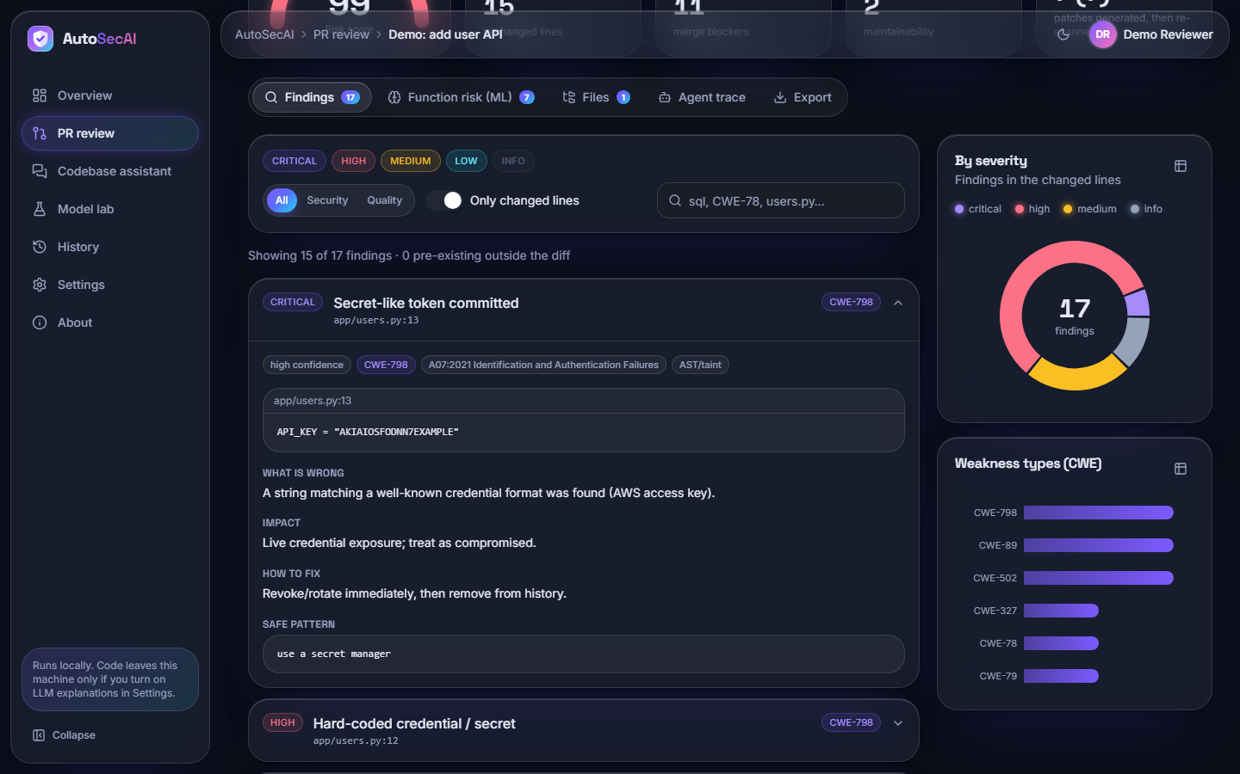  Fig. 8.4: Findings tab with the first finding opened

Review result: verdict, gauge and key figures. The red banner "Merge blocked" ("risk score 99/100 ... 15 security finding(s) ... 1 critical, 10 high, 4 medium"), the gauge at 99, and the tiles 15 security findings, 11 merge blockers, 2 quality issues and 7 (7) verified auto-fixes; tabs Findings 17, Function risk 7, Files 1.
Findings tab with the first finding opened. "Secret-like token committed" (CRITICAL, CWE-798, app/users.py:13) expanded: chips (high confidence, OWASP A07:2021, AST/taint), the quoted line, What is wrong, Impact, How to fix and Safe pattern. On the right, the severity donut (17 findings) and the CWE bar chart; the filters include "Only changed lines".
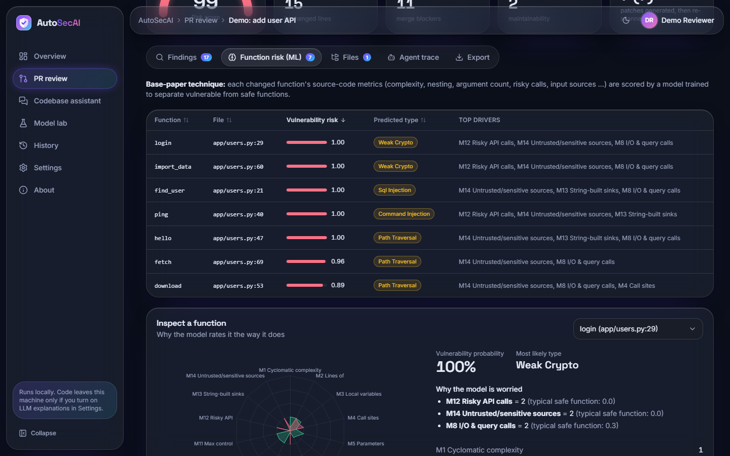  Fig. 8.5: Function risk (ML) tab | 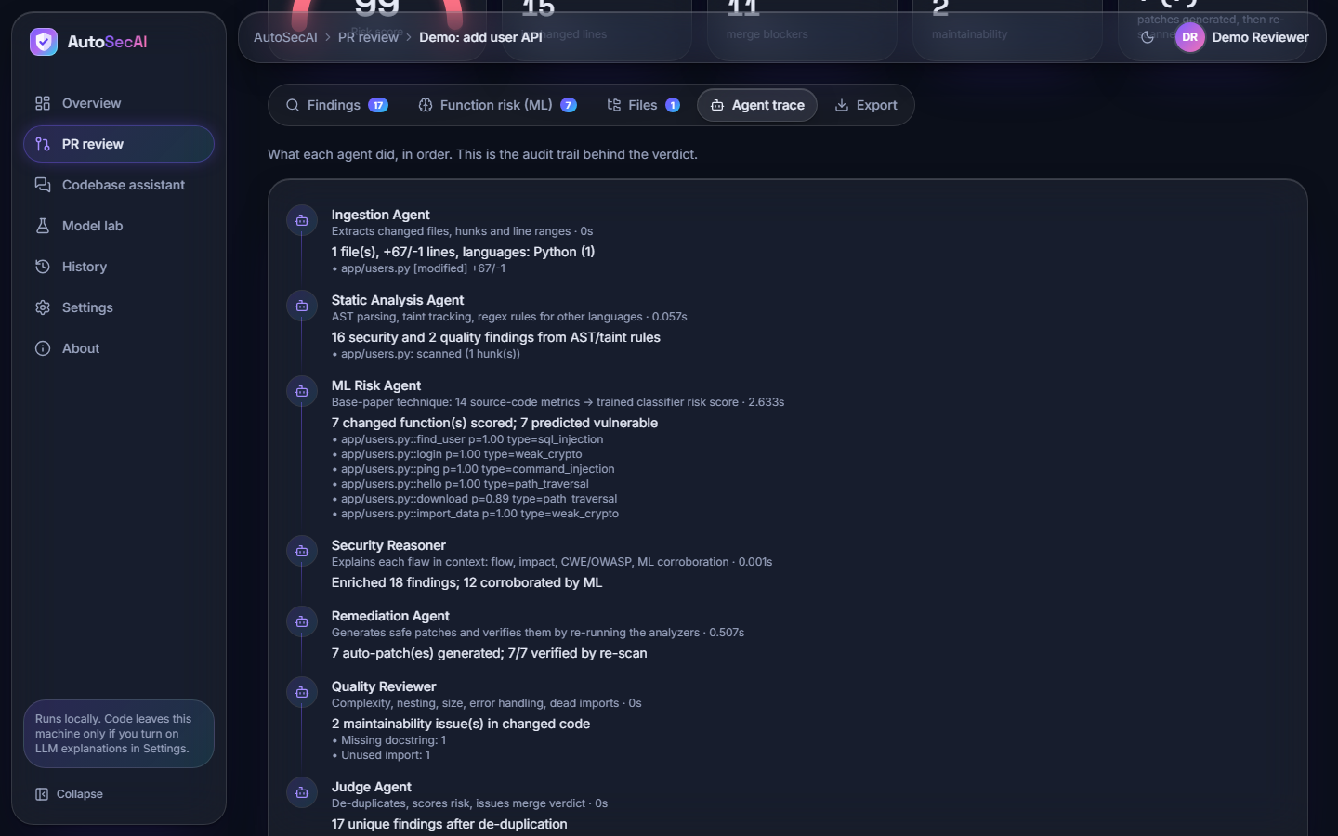  Fig. 8.6: Agent trace tab

Function risk (ML) tab. The seven changed functions ranked by risk (login, import_data, find_user, ping, hello 1.00; fetch 0.96; download 0.89) with predicted type and top drivers. "Inspect a function" shows login: radar chart, probability 100% and drivers M12 = 2, M14 = 2, M8 = 2 against safe values 0.0, 0.0, 0.3.
Agent trace tab. The audit trail of the seven agents: static analysis "16 security and 2 quality findings" (0.011 s); ML Risk "7 changed function(s) scored; 7 predicted vulnerable" (0.321 s); Reasoner "12 corroborated by ML"; Remediation "7/7 verified by re-scan" (0.059 s); Judge "17 unique findings after de-duplication".
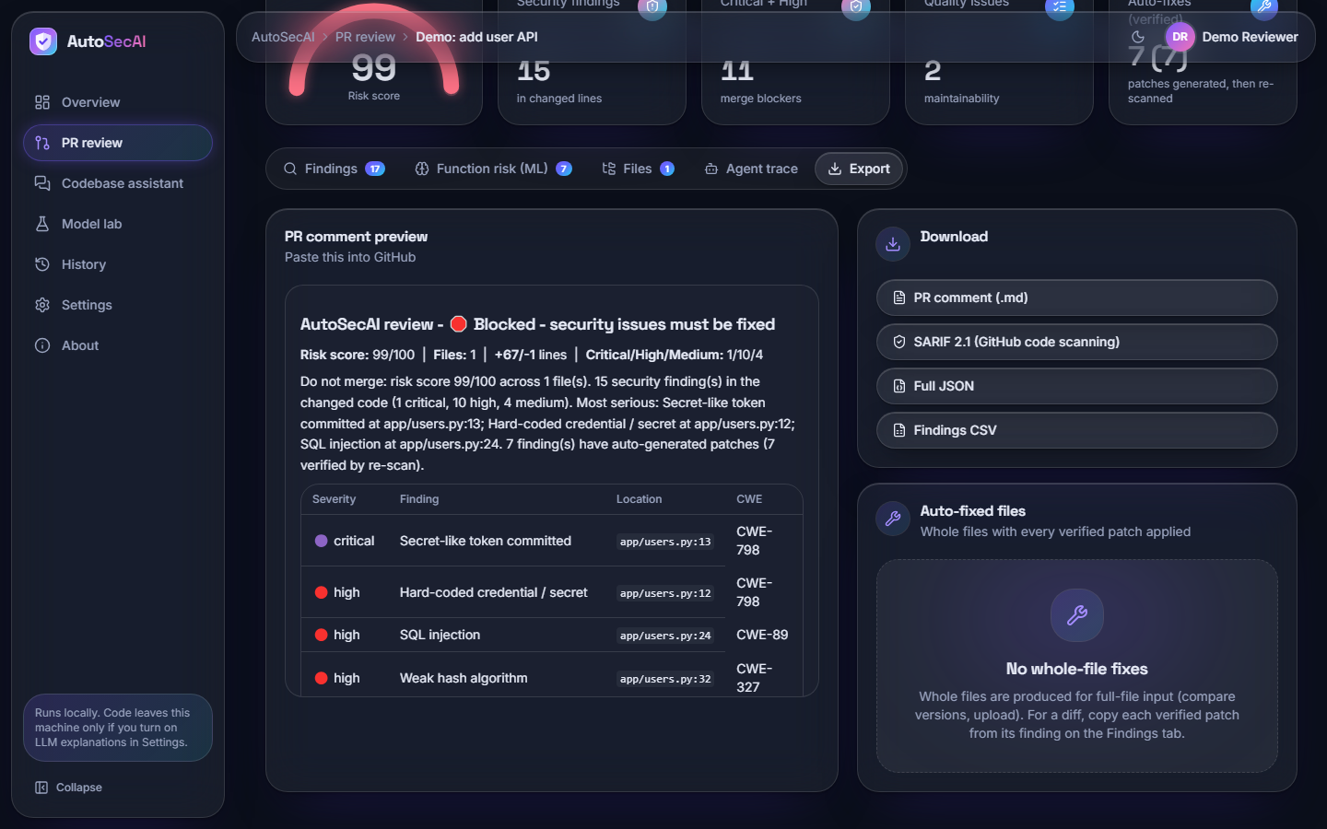  Fig. 8.7: Export tab | Fig. 8.8: Codebase assistant: question and cited answer

Export tab. The PR comment preview ("Blocked - security issues must be fixed", risk 99/100, Critical/High/Medium 1/10/4, a table of findings), the downloads PR comment (.md), SARIF 2.1, Full JSON and Findings CSV, and the card stating "No whole-file fixes" because the input was a diff.
Codebase assistant: question and cited answer. After the toast "Indexed 10 files, 24 code units", the question "Where is the authentication mechanism implemented?" is answered with app/auth.py (login, line 25; hash_password, line 13) and tests/test_auth.py (line 4), followed by four evidence rows.
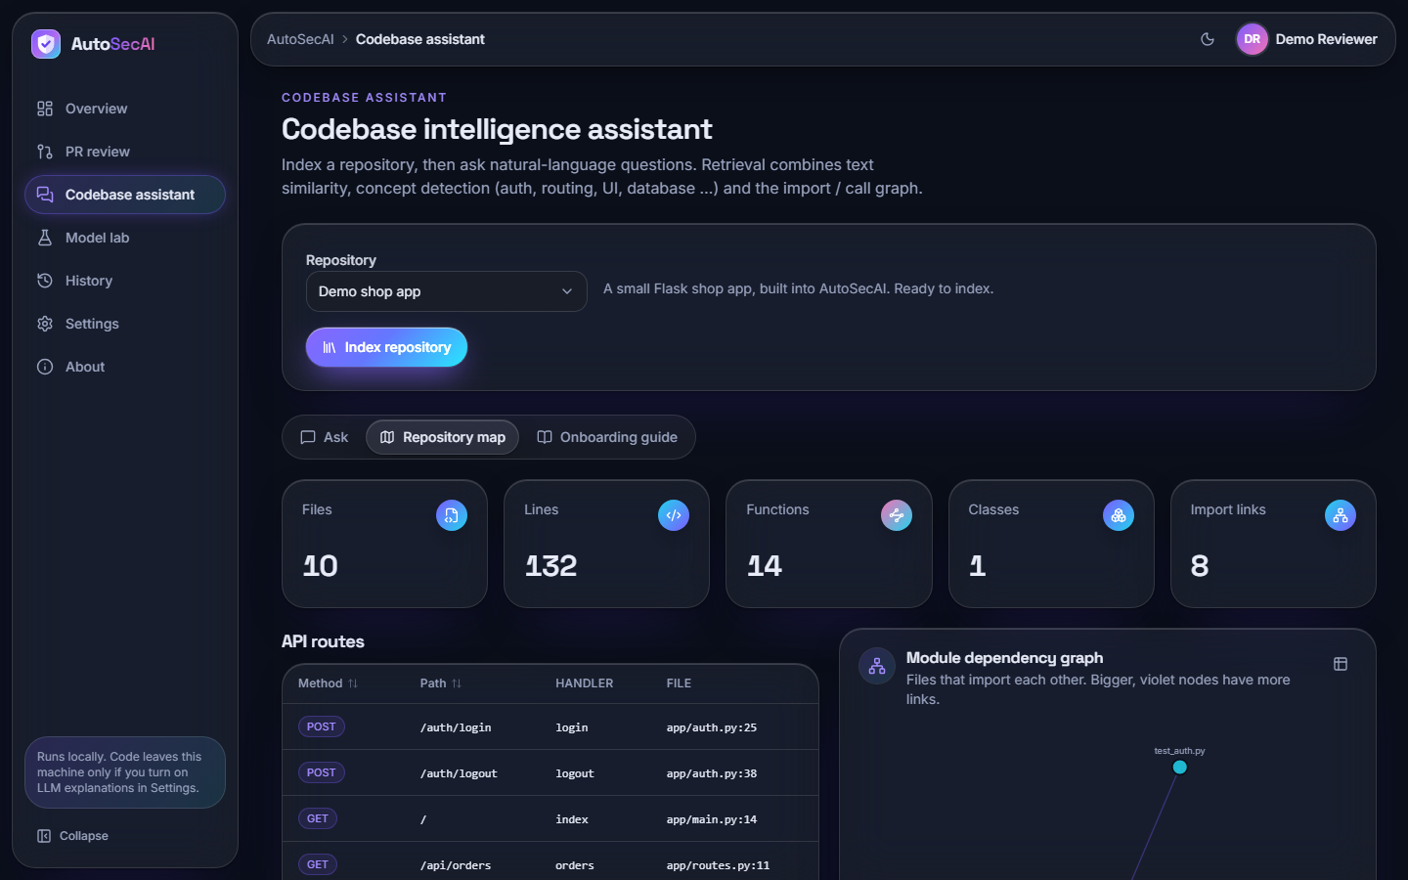  Fig. 8.9: Codebase assistant: repository map | 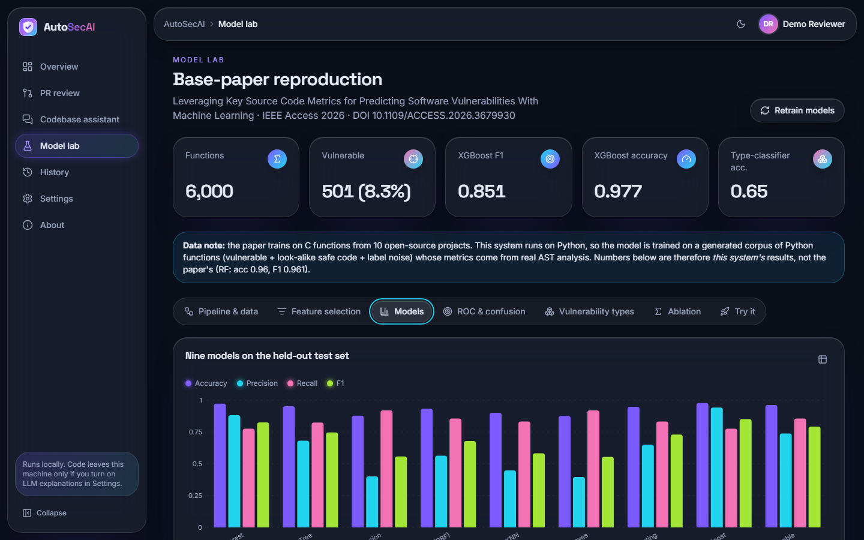  Fig. 8.10: Model Lab: nine models

Codebase assistant: repository map. Tiles for Files 10, Lines 132, Functions 14, Classes 1 and Import links 8; the table of API routes (POST /auth/login at app/auth.py:25, GET /api/orders at app/routes.py:11, and more); and the start of the module dependency graph.
Model Lab: nine models. The key figures (6,000 functions; 501 vulnerable; XGBoost F1 0.851, accuracy 0.977; type accuracy 0.65), the data note that the paper used C functions while this system uses a generated Python corpus, and grouped bars of accuracy, precision, recall and F1 for the nine models.
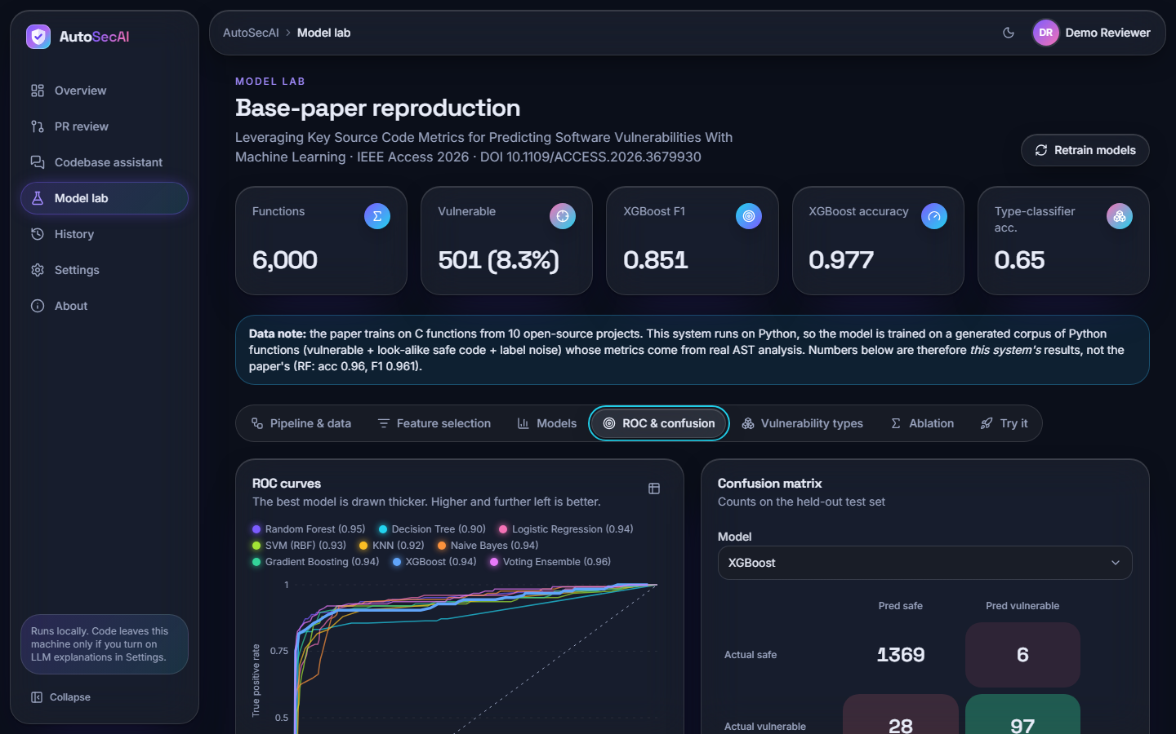  Fig. 8.11: Model Lab: ROC curves and confusion matrix | 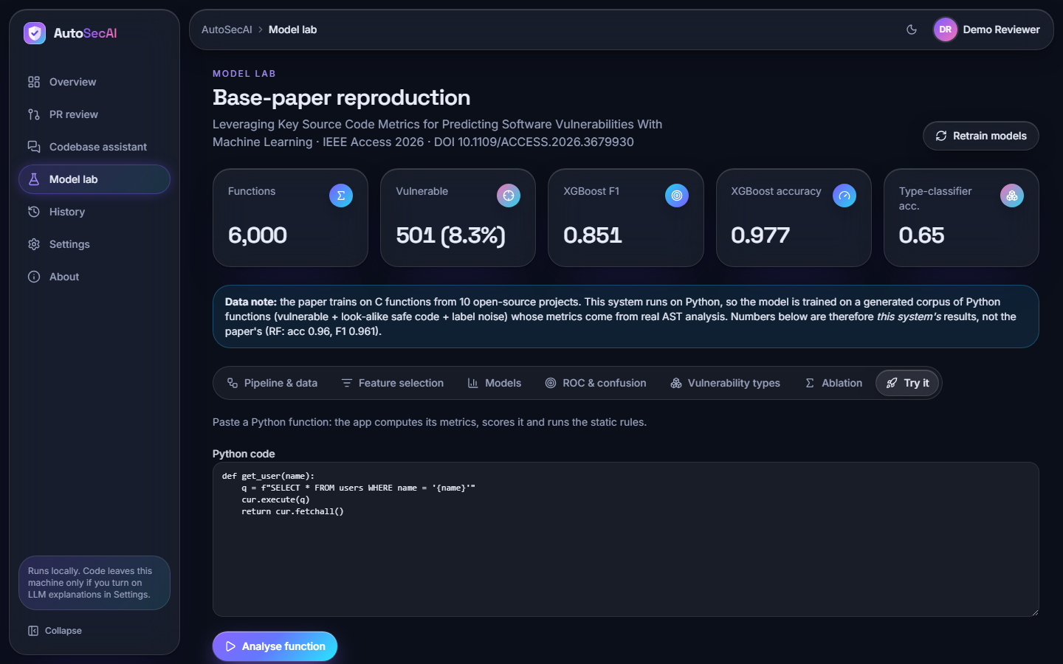  Fig. 8.12: Model Lab: Try it

Model Lab: ROC curves and confusion matrix. ROC curves of the nine models with AUC in the legend (0.90 for Decision Tree to 0.96 for the Voting Ensemble) and the XGBoost confusion matrix: 1369 safe correctly passed, 6 false alarms, 28 vulnerable functions missed, 97 found.
Model Lab: Try it. A pasted function, get_user(name), that builds its query with an f-string, and the button "Analyse function"; the result lies below the visible area. The model gives probability 0.006 while the static rule SQLI fires at line 3 (see the sample outputs).
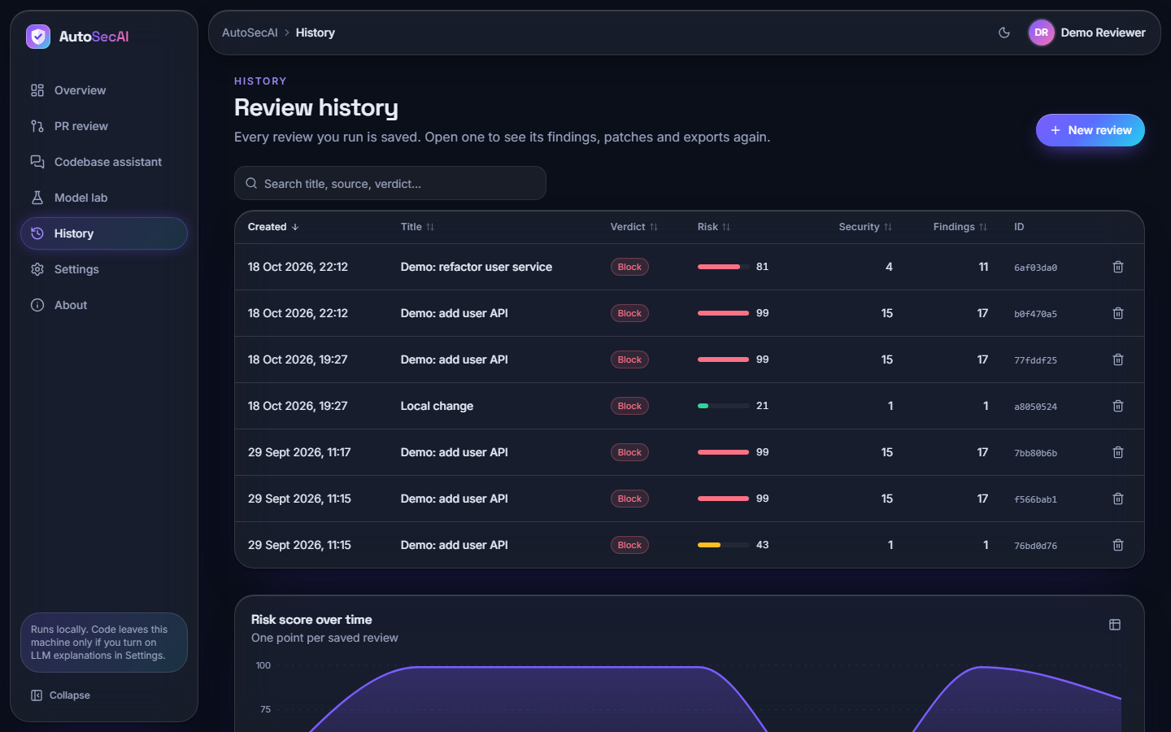
Fig. 8.13: History

History. Five saved reviews with verdict, risk, security findings and ID: two Block verdicts of 18 October 2026 (risk 81 and 99) and three of 29 September (99, 99, 43), with a delete button per row, a search box and the start of the chart "Risk score over time".

8.2 Model Performance
AutoSecAI contains one trained component, the metric model that scores each changed function; the static rules, the agents and the retrieval are deterministic code. This section reports the evaluation of that model and of the rule engine. All figures were produced by the shipped code (autosecai/mlmodel.py, scripts/measure_facts.py) on one machine (Intel Core i5-12500, 15.7 GB RAM, no GPU). The corpus is generated: 6,000 Python functions, of which 501 (8.35%) are vulnerable, split 75 / 25 into 4,500 training and 1,500 test functions (125 vulnerable, 1,375 safe). After SMOTE and Tomek-link cleaning the training set held 8,232 rows (16 Tomek removals); the test set was never balanced. The results therefore describe how well the metric model separates the generated vulnerable patterns from the generated safe look-alikes, not how it would perform on real repositories.
Table 8.1: Headline model results (generated Python corpus, 1,500 held-out functions)
Measure | Result
Best model by F1 (XGBoost): accuracy / precision / recall | 0.977 / 0.942 / 0.776
XGBoost: F1 and area under the ROC curve | 0.851 and 0.937
Random Forest (the base paper's choice): F1 and AUC | 0.826 and 0.953
Metrics kept after validation (best k of 5 to 14) | 13 of 14 (validation F1 0.786)
Vulnerability-type classifier, accuracy / macro F1 | 0.651 / 0.630 (126 test functions, 8 types)
XGBoost F1 over five independent corpora | mean 0.842 +/- 0.006 (minimum 0.836)
Rule engine alone, precision / recall / F1 | 0.926 / 0.704 / 0.800
Rule engine or ML model, F1 | 0.891 (recall 0.880)
Training time of the full nine-model pipeline | 31.7 s

8.2.1 Nine classifiers
Table 8.2: Nine classifiers on the held-out test set
Model | Accuracy | Precision | Recall | F1 | AUC
Random Forest | 0.973 | 0.882 | 0.776 | 0.826 | 0.953
Decision Tree | 0.953 | 0.682 | 0.824 | 0.746 | 0.896
Logistic Regression | 0.879 | 0.401 | 0.920 | 0.558 | 0.945
SVM (RBF) | 0.933 | 0.563 | 0.856 | 0.679 | 0.929
KNN | 0.901 | 0.448 | 0.832 | 0.583 | 0.924
Naive Bayes | 0.877 | 0.397 | 0.920 | 0.554 | 0.936
Gradient Boosting | 0.949 | 0.650 | 0.832 | 0.730 | 0.937
XGBoost (best F1) | 0.977 | 0.942 | 0.776 | 0.851 | 0.937
Voting Ensemble | 0.963 | 0.738 | 0.856 | 0.793 | 0.956

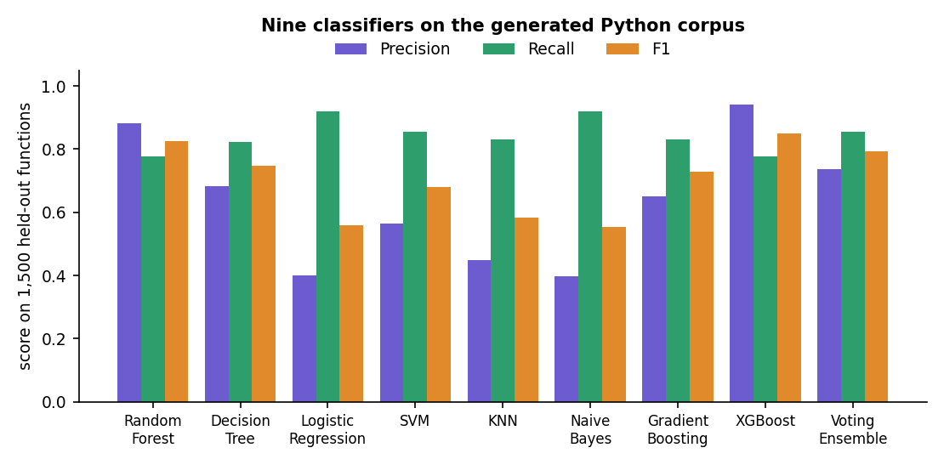
Fig. 8.14: Precision, recall and F1 of the nine classifiers
XGBoost gave the best F1 (0.851) and the highest precision (0.942); it raised six false alarms on 1,375 safe functions. Logistic Regression and Naive Bayes found the most vulnerable functions (recall 0.920 each) but flagged 172 and 175 safe functions, so their precision was only 0.401 and 0.397. Random Forest, the winner of the base paper [1], reached F1 0.826 and the highest AUC of the single models (0.953); the soft-voting ensemble had the highest AUC overall (0.956). The model that AutoSecAI stores and uses inside the pull-request pipeline is XGBoost, chosen by F1 on the test set.

8.2.2 Confusion matrices and ROC curves
Table 8.3: Confusion matrices of four models (rows: truth, 1,375 safe and 125 vulnerable)
Model | True negative | False positive | False negative | True positive
XGBoost | 1,369 | 6 | 28 | 97
Random Forest | 1,362 | 13 | 28 | 97
Voting Ensemble | 1,337 | 38 | 18 | 107
Logistic Regression | 1,203 | 172 | 10 | 115

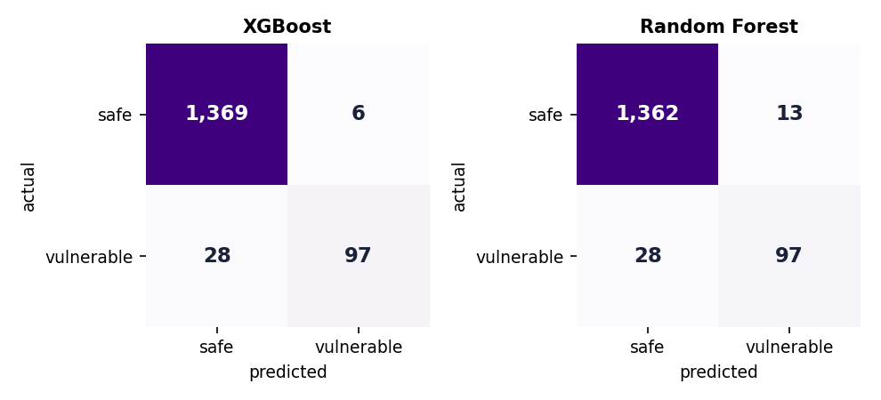  Fig. 8.15: Confusion matrices of XGBoost and Random Forest | 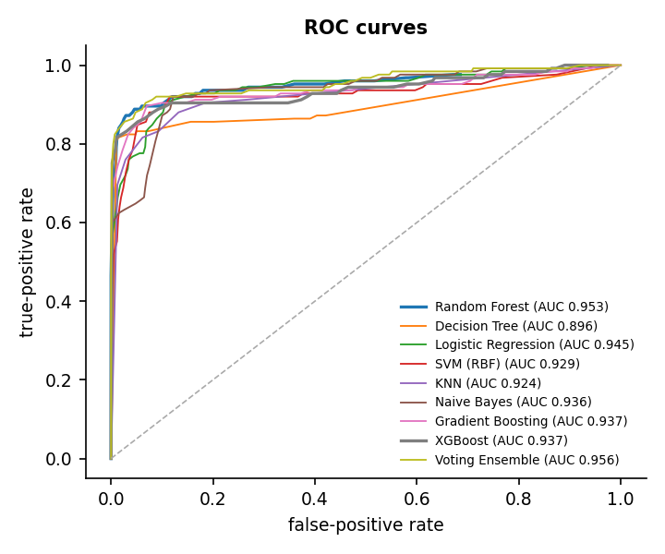  Fig. 8.16: ROC curves of the nine classifiers

The two best models missed the same number of vulnerable functions (28 of 125) and differ in false alarms: 6 for XGBoost and 13 for Random Forest. The ROC curves of all nine models rise steeply and lie close together at the top left, which is why the AUC values range only from 0.896 to 0.956; the models differ more in where they place the decision threshold than in how well they rank the functions.

8.2.3 Which metrics drive the score
Table 8.4: The six most important of the 13 selected metrics
Metric | Random Forest importance
M12 Risky API calls | 0.174
M14 Untrusted/sensitive sources | 0.147
M13 String-built sinks | 0.143
M2 Lines of code | 0.074
M5 Parameters | 0.070
M4 Call sites | 0.067

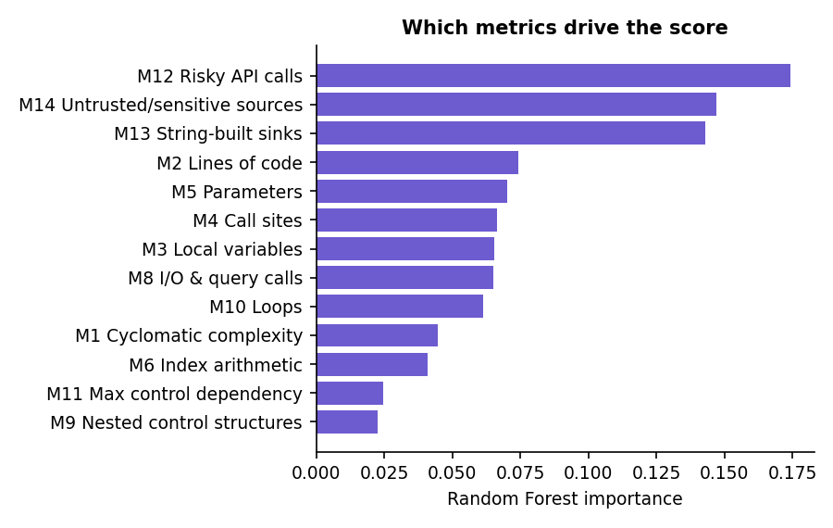  Fig. 8.17: Random Forest importance of the 13 selected metrics | 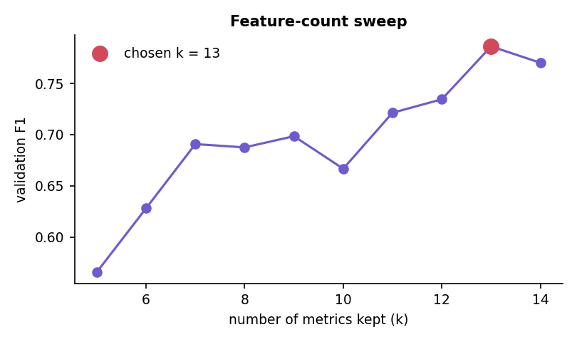  Fig. 8.18: Validation F1 against the number of metrics kept

The three metrics added by this project to the base paper's families, M12 (risky API calls), M13 (string-built sinks) and M14 (untrusted or sensitive sources), carry 46.4% of the total importance, and they were the top three of the seven-method consensus. The base paper reports M5, M6, M1, M9 and M11 as the most important metrics for C code [1]; on Python injection patterns the order is different, which is expected because the flaws differ (memory errors there, injection here). The feature-count sweep supports the same point: with only five metrics (the paper's setting) the validation F1 was 0.566, with thirteen it was 0.786, and with all fourteen 0.770.

8.2.4 Ablation
Table 8.5: Ablation of balancing and feature count
Configuration (Random Forest) | Precision | Recall | F1
RF - all 14 metrics, no balancing | 0.933 | 0.776 | 0.847
RF - top-5 metrics + SmoteTomek (paper setting) | 0.643 | 0.648 | 0.645
RF - top-13 metrics + SmoteTomek (this system) | 0.882 | 0.776 | 0.826

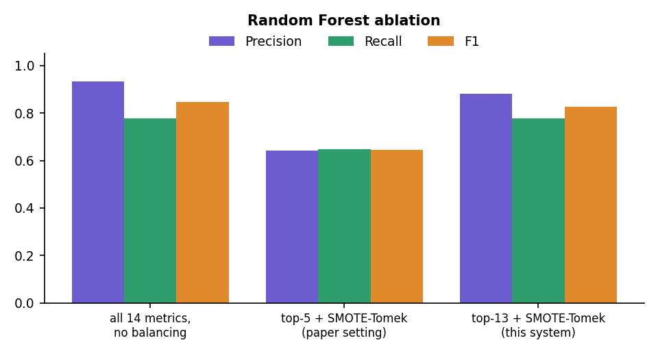
Fig. 8.19: Ablation: precision, recall and F1 of three Random Forest configurations
The ablation shows two things and hides a third. Keeping only the paper's five metrics was clearly worse (F1 0.645) than keeping thirteen (0.826). Balancing with SMOTE-Tomek did not raise recall on this corpus (0.776 with and without it); it lowered precision from 0.933 to 0.882. The two comparisons are confounded, however: the unbalanced baseline uses all fourteen metrics and the balanced system uses thirteen, so the effect of balancing alone was not isolated, and no single-factor experiment was run. The honest reading is that the extra taint metrics matter and that balancing was not shown to help here.

8.2.5 Vulnerability types
Table 8.6: Vulnerability-type classifier (accuracy 0.651)
Type | Precision | Recall | F1 | Test functions
code execution | 0.353 | 0.400 | 0.375 | 15
command injection | 0.846 | 0.786 | 0.815 | 14
deserialization | 0.214 | 0.200 | 0.207 | 15
hardcoded secret | 0.682 | 0.938 | 0.789 | 16
path traversal | 0.444 | 0.267 | 0.333 | 15
sql injection | 0.875 | 0.875 | 0.875 | 16
weak crypto | 0.800 | 0.750 | 0.774 | 16
xss | 0.850 | 0.895 | 0.872 | 19

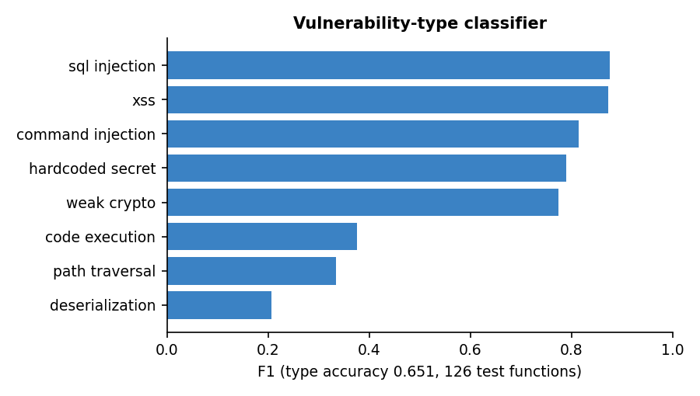
Fig. 8.20: F1 of the vulnerability-type classifier by type
SQL injection (0.875), XSS (0.872), command injection (0.815), hard-coded secrets (0.789) and weak cryptography (0.774) are separated well; deserialization (0.207), path traversal (0.333) and code execution (0.375) are not, because their metric signatures (one risky call fed by one source) overlap with the injection types. This is why the product reports the exact weakness from the static rules and uses the model's type only as a hint.

8.2.6 Stability over five corpora
Table 8.7: Models retrained on five independently generated corpora (k fixed at 13)
Corpus seed | Vulnerable | RF F1 | RF precision | RF recall | XGB F1 | XGB precision | XGB recall
7 | 501 | 0.826 | 0.882 | 0.776 | 0.851 | 0.942 | 0.776
11 | 493 | 0.800 | 0.860 | 0.748 | 0.842 | 0.949 | 0.756
23 | 545 | 0.818 | 0.910 | 0.743 | 0.840 | 0.953 | 0.750
41 | 517 | 0.818 | 0.856 | 0.783 | 0.840 | 0.895 | 0.791
59 | 484 | 0.809 | 0.875 | 0.752 | 0.836 | 0.929 | 0.760

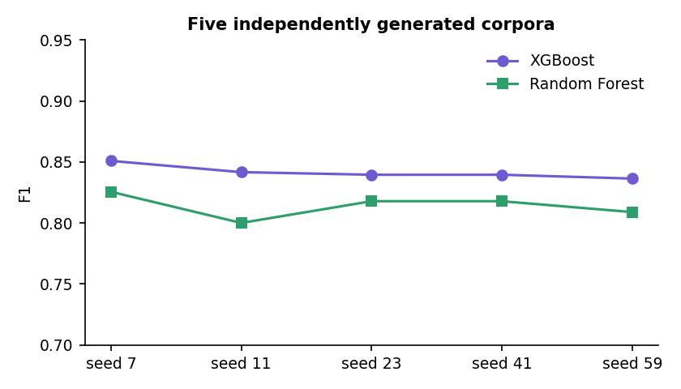
Fig. 8.21: F1 of XGBoost and Random Forest on five generated corpora
The stored report is the first of the five runs (seed 7, reproduced exactly by the study). Across the five corpora XGBoost reached an F1 of 0.842 +/- 0.006 and Random Forest 0.814 +/- 0.010; the headline 0.851 is therefore the best of five, not the typical value, and XGBoost was ahead of Random Forest on every corpus. The spread is small relative to the difference between configurations, so the ranking of the models is stable on this generator. The number of metrics was not re-selected for each corpus.

8.2.7 Rule engine and metric model compared
Table 8.8: Rule engine and metric model on the same held-out functions
Detector (1,500 held-out functions) | Precision | Recall | F1 | TP | FP | FN
AST/taint rule engine (security, medium or higher) | 0.926 | 0.704 | 0.800 | 88 | 7 | 37
Metric model (XGBoost) | 0.942 | 0.776 | 0.851 | 97 | 6 | 28
Either flags (OR) | 0.902 | 0.880 | 0.891 | 110 | 12 | 15
Both flag (AND) | 0.987 | 0.600 | 0.746 | 75 | 1 | 50

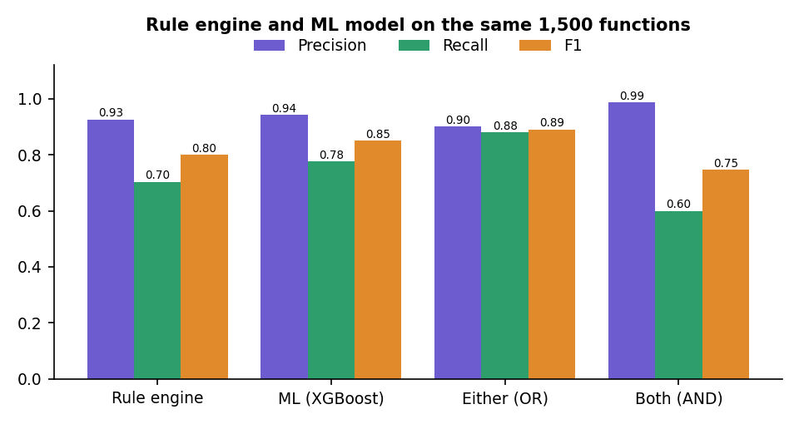
Fig. 8.22: Precision, recall and F1 of the rule engine, the metric model and their combinations
On the same 1,500 functions the rule engine (about 1.23 ms per function) reached a precision of 0.926 and a recall of 0.704; the metric model a precision of 0.942 and a recall of 0.776. The two detectors miss different functions: flagging a function when either of them does lifts recall to 0.880 and F1 to 0.891, while requiring both gives a precision of 0.987 with a recall of 0.600. This is the quantitative argument for corroboration: the Security Reasoner marks a finding "corroborated by ML" when the model also rates the function as vulnerable, and the Judge treats such findings as stronger evidence. The caveat is large: the corpus generator and the rules were written by the same team around the same eight patterns, so the rule-engine figures are optimistic for real code, and about 1% of the labels are deliberately wrong, so no detector can reach 1.0.

8.3 Product-Level Results

8.3.1 The demonstration pull request
The built-in pull request adds 67 lines (one line removed) to app/users.py and deliberately contains many flaws. The review produced a risk score of 99 / 100 and the verdict BLOCK, with 17 unique findings: 1 critical, 10 high, 4 medium and 2 informational; 15 are security findings and 2 are quality findings. All 7 changed functions were scored by the metric model and all 7 were flagged. Seven auto-patches were generated and 7 of 7 passed the re-scan, that is, the patched source no longer triggers the same rule. Eight security findings received no patch (the two hard-coded secrets, the string-concatenated SQL query in login, the cross-site scripting return, the path traversal, the pickle load, the predictable random token and the request to a user-supplied URL), because the rule engine has a fix template only for the cases it can rewrite safely.
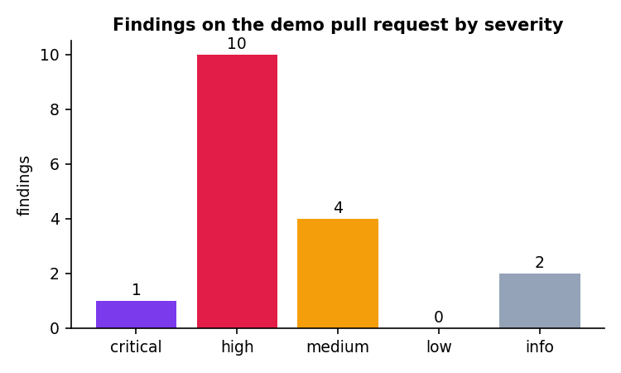
Fig. 8.23: Findings of the demonstration pull request by severity

8.3.2 Review time
Table 8.9: Median time per agent over 20 runs of the demonstration review (engine only)
Agent | Median time
Ingestion Agent | 0.0 ms
Static Analysis Agent | 8.0 ms
ML Risk Agent | 301.5 ms
Security Reasoner | 0.0 ms
Remediation Agent | 62.5 ms
Quality Reviewer | 0.0 ms
Judge Agent | 0.0 ms
Whole review | 375 ms

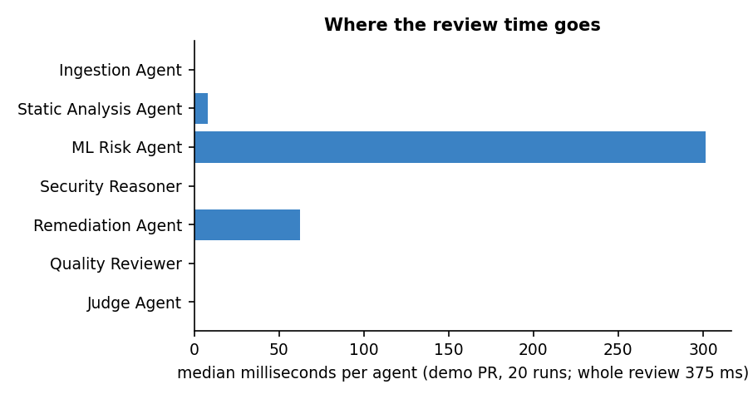
Fig. 8.24: Median time per agent
A whole review took a median of 375 ms (mean 391 ms, fastest 347 ms, 95th percentile 471 ms, slowest 517 ms). The ML Risk Agent accounts for about 80% of the time, because it computes fourteen metrics and runs the model for every changed function; the Remediation Agent, which re-scans every patched file, accounts for about 17%, and the static analysis needs only 8 ms. The measurements were made on an otherwise idle machine; absolute values shift between runs, and no larger pull request was timed.

8.3.3 HTTP interface
Table 8.10: Latency of the HTTP API on localhost (one client)
Endpoint | Runs | Median | 95th percentile
GET /api/health | 30 | 1.2 ms | 2.5 ms
POST /api/auth/login (bcrypt) | 15 | 60.1 ms | 75.3 ms
GET /api/meta | 30 | 2.7 ms | 3.8 ms
GET /api/reviews | 30 | 3.2 ms | 4.2 ms
GET /api/public/stats | 30 | 1.7 ms | 2.4 ms
GET /api/lab/report | 30 | 6.2 ms | 7.3 ms
POST /api/lab/analyze | 30 | 5.2 ms | 6.4 ms
POST /api/reviews demo-diff -> done (polled 50 ms) | 10 | 435.5 ms | max 901.0 ms
POST /api/codebase/index demo | 1 | 38.8 ms (single run) | -
POST /api/codebase/{id}/ask | 20 | 4.8 ms | 5.6 ms

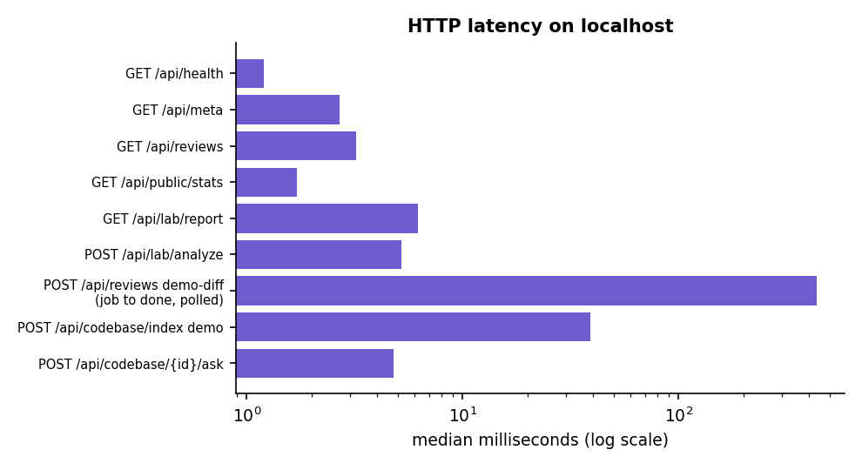
Fig. 8.25: Median latency of the API endpoints (logarithmic axis)
Read-only endpoints answered in a few milliseconds. Login took about 60.1 ms because bcrypt is deliberately slow, and a demonstration review submitted as a job and polled every 50 ms was complete after a median of 436 ms. The web application polls every 350 ms,so the user sees each agent's message as it appears. No concurrency or load test was run.

8.3.4 Codebase assistant
The assistant was evaluated on the built-in demo shop (10 files) with 12 questions written by hand before the run, each with the file that should come first. The expected file was ranked first for 8 of 12 questions and within the first three files for 11 of 12. Building the index took 14.1 ms and answering a question a median of 2.2 ms in the engine. This is a small, hand-made check on one tiny repository, not a benchmark.
Table 8.11: Retrieval check on the demo repository
Question | Expected file | Files returned (first three) | Rank
Where is the authentication mechanism implemented? | app/auth.py | app/auth.py, tests/test_auth.py | 1
Which function hashes the password? | app/auth.py | app/auth.py, tests/test_auth.py, templates/login.html | 1
Where is the login route? | app/auth.py | app/auth.py, app/routes.py, templates/login.html | 1
How does the app connect to the database? | app/db.py | app/db.py, app/config.py | 1
Where are database queries for orders written? | app/db.py | app/routes.py, app/db.py, static/app.js | 2
Which file defines the API routes for orders and the profile? | app/routes.py | app/routes.py, app/auth.py, app/main.py | 1
What decorator protects routes from anonymous users? | app/auth.py | app/routes.py, app/auth.py | 2
Where does the front end fetch the orders? | static/app.js | app/routes.py, static/app.js, app/db.py | 2
Which template holds the sign in form? | templates/login.html | templates/login.html, templates/index.html, app/auth.py | 1
Where are the unit tests? | tests/test_auth.py | tests/test_auth.py, app/auth.py | 1
How is the user looked up by name? | app/db.py | app/auth.py, tests/test_auth.py | not returned
What clears the session on logout? | app/auth.py | app/auth.py | 1

8.3.5 Automated checks
Table 8.12: Automated checks run on 18 October 2026
Check | Result
Unit and API tests (pytest tests) | 17 passed (10 engine tests, 7 API tests)
API smoke test against the running server | 16 of 16 checks passed
Browser flows (scripted, real browser) | 22 flows passed, 0 console errors
Production build of the web application (type check and bundle) | Passes
Screens captured for this report | 26 screenshots, console clean, no HTTP error responses
Horizontal overflow at 360 px and 768 px, light and dark | None found on any screen

8.4 Comparison with the Base Paper
The base paper [1] trains classifiers on 21,759 functions of ten open-source C and C++ projects, of which only 275 (1.26%) are vulnerable, and reports a Random Forest with accuracy 0.96, precision 0.948, recall 0.974 and F1 0.961. AutoSecAI reproduces the pipeline on a generated corpus of Python functions and obtains an F1 of 0.851 for XGBoost and 0.826 for Random Forest. The two sets of figures are not comparable. The language, the origin and the class balance of the data, the way the metrics are extracted and the labels (real CVE and NVD records against injected patterns with 1% noise) all differ, and the generated corpus was designed together with the rules that are also evaluated here. No claim is made that AutoSecAI is more or less accurate than the paper; the figure that is comparable is the structure of the evidence, which the table below sets side by side.
Table 8.13: AutoSecAI and the base paper
Aspect | Base paper [1] | AutoSecAI
Data | 21,759 C/C++ functions, 275 vulnerable, ten real projects | 6,000 generated Python functions, 501 vulnerable (8.35%)
Metric extraction | Code property graph from a fuzzy parser; 14 metrics | Python ast and control-flow analogues; 14 metrics, M1-M11 mirror the paper, M12-M14 added
Feature selection | Several methods, top five kept (M5, M6, M1, M9, M11) | Seven methods with vote and rank consensus; k validated, 13 kept; top five are M13, M14, M12, M3, M2
Balancing | SmoteTomek (balanced set of 21,474) | Own SMOTE and Tomek-link implementation (8,232 rows)
Best model | Random Forest, F1 0.961 | XGBoost, F1 0.851 (Random Forest 0.826); five-corpus mean 0.842 +/- 0.006
Use of the model | Offline classification of functions | Scores every changed function inside a pull request, corroborates static findings, ranks risk
Beyond the model | None | Static rules with CWE and OWASP mapping, explanations, verified patches, SARIF export, codebase assistant
Weakness types | Eight types of C vulnerability | Eight Python-oriented types (accuracy 0.651); exact CWE from the 30 security rules
Evidence of real-world accuracy | Ten real projects | None: no real or labelled pull requests were available

The Sphinx study of LLM-driven review [2] addresses the same activity from a different side: it generates review comments with a trained language model and evaluates them with a checklist-based benchmark. AutoSecAI trains no language model; its findings come from deterministic analysis and the optional language-model layer only rewrites the text. The two works measure different things (coverage of review points against detection of vulnerable functions), so only the approach can be compared: Sphinx is a learned reviewer evaluated on comment quality, AutoSecAI an analyser whose findings carry evidence, a patch and a re-scan. The lesson taken from [2] is the value of an explicit checklist of verification points, which the Agent trace and the PR comment mirror in a simple form.

8.5 Sample Inputs and Outputs
The first sample is the built-in pull request. A part of its diff is shown below, followed by the findings that the review returned for it, in the order of severity (the line numbers refer to the new file).
Listing: Excerpt of the demonstration diff (added lines of app/users.py)
@app.route("/user")
def find_user():
name = request.args.get("name")
cur = get_db().cursor()
cur.execute(f"SELECT id, email FROM users WHERE name = '{name}'")
return jsonify(cur.fetchall())

@app.route("/ping")
def ping():
host = request.args.get("host", "127.0.0.1")
os.system(f"ping -c 1 {host}")
return "done"

@app.route("/import", methods=["POST"])
def import_data():
blob = request.data
obj = pickle.loads(blob)
cfg = yaml.load(request.form["config"])
calc = eval(request.args.get("expr"))
return jsonify(obj=str(obj), cfg=cfg, calc=calc)

Table 8.14: Findings returned for the demonstration pull request (risk 99, BLOCK)
Rule | Line | Severity | CWE | Finding | Verified patch
GENERIC_SECRET | 13 | critical | CWE-798 | Secret-like token committed | no
HARDCODED_SECRET | 12 | high | CWE-798 | Hard-coded credential / secret | no
SQLI | 24 | high | CWE-89 | SQL injection (find_user) | yes
WEAK_HASH | 32 | high | CWE-327 | Weak hash algorithm (md5) | yes
SQLI | 34 | high | CWE-89 | SQL injection by concatenation (login) | no
CMDI | 42 | high | CWE-78 | OS command injection (ping) | yes
XSS | 49 | high | CWE-79 | Cross-site scripting (hello) | no
PATH | 55 | high | CWE-22 | Path traversal (download) | no
DESER | 62 | high | CWE-502 | Unsafe deserialization (pickle) | no
YAML_LOAD | 63 | high | CWE-502 | yaml.load without SafeLoader | yes
EVAL | 64 | high | CWE-95 | Dynamic code evaluation (eval) | yes
WEAK_RANDOM | 35 | medium | CWE-338 | Predictable random for a secret | no
TLS_VERIFY | 71 | medium | CWE-295 | TLS certificate verification disabled | yes
SSRF | 71 | medium | CWE-918 | Server-side request forgery | no
DEBUG_ON | 75 | medium | CWE-489 | Debug mode enabled | yes
Q_UNUSED_IMPORT | 5 | info | - | Unused import | -
Q_NO_DOCSTRING | 29 | info | - | Missing docstring | -

For the SQL injection in find_user the Remediation Agent produced the following patch, applied it to a copy of the file and re-ran the analyser; the rule no longer fired, so the patch was marked as verified. The Security Reasoner described the flow as attacker-controlled input entering the function, reaching cur.execute without sanitisation, and executing with attacker data, and it added that the independent metric model also rated find_user as vulnerable (probability 1.00, drivers M14 untrusted sources and M13 string-built sinks).
Listing: Verified patch for the SQL injection at line 24
--- a/app/users.py
+++ b/app/users.py
@@ -22,5 +22,5 @@
name = request.args.get("name")
cur = get_db().cursor()
- cur.execute(f"SELECT id, email FROM users WHERE name = '{name}'")
+ cur.execute("SELECT id, email FROM users WHERE name = ?", (name,))
return jsonify(cur.fetchall())

Table 8.15: Further sample inputs and outputs (run on 18 October 2026)
Input | Output
Model Lab, Try it: get_user(name) builds q = f"SELECT ... '{name}'" and calls cur.execute(q) | Metric model: probability 0.006, no type (below the 0.5 threshold), driver M8 I/O & query calls. Static rules: SQLI, line 3, high. The two detectors disagree; the rule is right.
Codebase question: "Where is the authentication mechanism implemented?" (demo shop) | Intent "Authentication & sessions"; app/auth.py (module overview, login line 25, hash_password line 13) and tests/test_auth.py (test_hash_is_stable, line 4). Correct file ranked first.
Compare versions: the before / after sample of one file | Review "Demo: refactor user service": risk 81, verdict BLOCK, 4 security findings and 11 findings in total (visible in the history screen). Findings that were already in the old version are shown separately as pre-existing.
Paste a diff that is not a diff | The API answers 422 with a readable message and no job is started.
GitHub PR link that does not exist | The job ends with a readable error (tested); a real pull request was not fetched in this project.

8.6 Success and Failure Analysis

8.6.1 Where it works
- All 7 vulnerable functions of the demonstration pull request were flagged, and every security finding has a CWE, an explanation, the quoted line and a remediation text.
- 7 of 7 generated patches passed the re-scan (parameterised queries, argument lists instead of shell strings, safe_load and similar rewrites).
- The rule engine raised only 7 false alarms and the model 6 on 1,375 safe look-alikes, and together they found 110 of the 125 vulnerable functions.
- Input errors, expired tokens and failed jobs produce readable messages instead of stack traces, and every screen ran in the scripted browser flows without console errors.

8.6.2 Where it fails or is weak
Table 8.16: Failure and weakness analysis
Observation | Cause | Effect and handling
The rule engine missed 37 of 125 vulnerable test functions and the metric model 28 | Rules cover patterns they know; the model sees only counts of metrics; about 1% of the generated labels are wrong on purpose | Both are reported; the combination misses 15. Real recall on real code is unknown
get_user (query built in a variable, then executed) gets probability 0.006 from the model | The f-string is assigned to q first, so the call argument is a plain name and the string-built-sink metric stays 0 | The rule SQLI still fires at line 3; this is why the product never relies on the model alone
The predicted type of three of the seven demo functions disagrees with the rules (hello XSS shown as path traversal; import_data shown as weak crypto; fetch SSRF shown as path traversal). Deserialization, path traversal and code execution have type F1 of only 0.21, 0.33 and 0.38 | Accuracy of the type classifier is 0.651; metric signatures overlap; SSRF is not one of its eight types | Finding cards use the exact rule and CWE; the model's type is only a hint and decides no verdict
Eight of the 15 security findings of the demonstration have no patch | The engine rewrites only cases whose safe form it can derive; secrets, XSS and path traversal need design decisions | The finding still carries a remediation text and a safe example
Retrieval put the expected file second or lower for four of twelve questions ("How is the user looked up by name?" does not return app/db.py) | Scoring by text similarity, concept words and graph links is ambiguous when a question shares few words with the code | Evidence rows list several files with reasons; the check is small
The review history of all accounts is one list | The reviews table has no user column | Documented as a limitation; the interface does not separate users' reviews

8.7 Limits of the Results
- Generated data. The model was trained and tested on 6,000 generated Python functions; its F1 of 0.851 does not show how it performs on real repositories, and the rule evaluation is optimistic because the rules and the generator were written by the same team.
- Best of five. The headline XGBoost F1 is the best of five corpora (mean 0.842 +/- 0.006); the number of metrics was not re-selected for each corpus and the ablation is confounded.
- No real labelled pull requests. Precision and recall of the whole system on real pull requests were not measured, and no comparison with Bandit, Semgrep or CodeQL was run.
- Untested paths. The optional language-model mode (no API key) and the fetch of a real GitHub pull request (only the error path) were not tested; the retrieval check covers one small repository.
- One machine, no user study. All timings come from one desktop computer; no load test was run and no developer rated the findings or the answers.

8.8 Objectives Against Outcomes
The six objectives are those stated in the objectives document of the batch. The outcome column says plainly whether each was achieved, achieved in part or not measured.
Table 8.17: Objectives against outcomes
Objective | Outcome | Evidence
1. Extract changed files and diff context automatically when a pull request is opened | Achieved on demand; not on opening | Diffs, two file versions, GitHub links, files, zip files and folders are parsed into changed files, hunks and line ranges (Ingestion Agent). There is no webhook: the user starts the review. Real GitHub fetching was not tested beyond the error path.
2. Compute source-code metrics for changed files and use them to rank vulnerability likelihood | Achieved | 14 metrics per function; nine models; XGBoost F1 0.851 (best of five corpora) on generated data; all 7 functions of the demonstration ranked 0.89 to 1.00.
3. Perform AST-based static analysis to detect injection, access-control and validation flaws | Achieved for injection and validation; access control only partly | 30 security rules with taint tracking in Python (SQL, command, code, path, template, XSS, SSRF, deserialization, secrets, TLS, JWT, CSRF) and regex rules for three more languages; rule engine precision 0.926 on the generated corpus. Missing object-level authorisation (IDOR) is not detected.
4. Deploy multiple LLM agents covering security, code quality and maintainability | Achieved in part | Seven cooperating agents (ingestion, static analysis, ML risk, security reasoner, remediation, quality reviewer, judge) run and are traced. They are deterministic programs; a language model only rewrites explanations when a key is supplied, and that mode was not measured.
5. Retrieve related code from the repository so that review comments reflect the wider codebase | Achieved in part | The codebase assistant retrieves related code (expected file first for 8 of 12 questions). It is a separate feature: the review comments of a pull request do not yet pull in related repository code.
6. Post consolidated review comments and evaluate precision against manually reviewed pull requests | Comment achieved; evaluation not achieved | A consolidated comment is generated and can be copied or exported (Markdown, SARIF, JSON, CSV); it is not posted to GitHub automatically. No manually reviewed pull requests were available, so precision on them was not measured; precision was measured only on the generated corpus (rules 0.926, model 0.942).

CHAPTER 9
CONCLUSION

9.1 Summary of the Work
This project built AutoSecAI, an analyser that reviews a pull request for security flaws and code-quality problems and explains what it found. A change can be supplied as a diff, two versions of a file, a GitHub link or uploaded files. Seven cooperating agents then parse it, apply abstract-syntax-tree and taint rules, score every changed function with the metric model of the base paper [1], explain each finding with its weakness class, impact and source-to-sink flow, propose a patch that is re-scanned to check that it works, summarise maintainability, and issue a risk score and a verdict. A codebase assistant answers natural-language questions about a repository, and a Model Lab reproduces the base-paper pipeline on Python. The tool is a FastAPI service with a React interface, 17 automated tests and a demonstration account.
On a generated corpus of 6,000 Python functions the metric model (XGBoost) reached an F1 of 0.851 (mean 0.842 +/- 0.006 over five corpora), the rule engine 0.800 and the two together 0.891. The built-in vulnerable pull request was reviewed in a median of 375 ms and blocked with a risk score of 99, and the codebase assistant ranked the expected file first for 8 of 12 questions. These results come from generated data and a small repository; no real labelled pull requests were available.

9.2 Objectives Achieved
Of the six objectives, the first three were achieved with the limits noted in the results chapter: diff context is extracted on request, not by a webhook; metrics rank the changed functions; and 30 security rules detect injection and validation flaws but not missing object-level authorisation. The objective of deploying LLM agents is met only in part, because the agents are deterministic programs with an optional language-model layer, and related repository code is retrieved by the codebase assistant but not yet fed into the review comments. A consolidated comment is generated and exported, but not posted to GitHub, and precision against manually reviewed pull requests was not evaluated, because no such set was available.

9.3 Key Findings
1. Two detectors are better than one. On 1,500 held-out functions the rule engine found 88 of 125 vulnerable functions and the model 97; together they found 110 (F1 0.891).
2. Taint-oriented metrics carry the signal. The three metrics added for Python injection (M12, M13, M14) hold 46.4% of the importance; keeping only five metrics gave a validation F1 of 0.566, keeping thirteen 0.786.
3. The headline is the best case. XGBoost reached 0.851 on the stored corpus but 0.842 +/- 0.006 on average over five; Random Forest averaged 0.814 +/- 0.010.
4. Balancing was not shown to help. Recall was identical with and without SMOTE-Tomek and precision fell; because the feature count also differed, the effect of balancing alone remains unmeasured.
5. The model cannot be trusted alone. It gave a probability of 0.006 to a plain SQL-injection function that builds its query in a variable, which the rule SQLI flagged; the type classifier reached only 0.651 accuracy.
6. Fast, but patches need judgement. A review took a median of 375 ms; seven of the 15 security findings of the demonstration received a verified patch and the other eight were left to the developer.

9.4 Practical Applications
- Teams that review pull requests can run the tool before a human reviewer, read the verdict and the findings, and paste the generated comment or upload the SARIF file to code scanning [26].
- Junior developers can index an unfamiliar repository and ask where authentication, routes or the database layer are handled, and read the generated onboarding guide.
- Security trainers can use the demonstration pull request and the explanations, with their CWE [25] and OWASP [24] mapping, to teach the common injection flaws.
- Students of machine learning for software engineering can use the Model Lab to see the effect of feature selection, balancing and model choice on a documented generator.
- Maintainers of small projects without a security team can run the checks locally, because nothing leaves the machine unless the optional language-model layer is switched on.

9.5 Known Limitations
- The metric model was trained and tested on generated Python functions; its scores are a prioritisation signal and the figures do not transfer to real repositories. The rule-engine figures are optimistic, and no comparison with Bandit, Semgrep or CodeQL was run.
- Deep analysis covers Python only; JavaScript, PHP and Java have regex rules, and missing authorisation checks are not detected. Whole-file fixes exist only for full-file input.
- The optional language-model mode and the real GitHub pull-request fetch were not measured; the job table is in memory and the history is shared by all accounts.
- The retrieval check used 12 questions on one small repository, and no load test or user study was carried out. No numeric comparison with the base paper is possible.

CHAPTER 10
FUTURE SCOPE

10.1 Improvements
- Collect a labelled set of real pull requests and measure precision, recall and the false-alarm rate of the whole system on it, next to Bandit, Semgrep and CodeQL.
- Replace the generated corpus with real Python functions labelled from public vulnerability records, retrain, and report both results.
- Re-select the number of metrics for every corpus and run a single-factor experiment for balancing.
- Follow taint across function and module boundaries, add checks for missing authorisation, and add a per-user owner column to the review history.

10.2 Additional Features
- A GitHub App or webhook that reviews a pull request when it is opened and posts the consolidated comment and the suggested patches back.
- Feeding the codebase assistant's retrieval into the review, so that a finding can mention the callers and related code of the changed function.
- Running the project's own test suite against a patch before it is marked verified.
- More languages with real parsers (JavaScript and TypeScript first), a baseline file for known findings, and a dependency-vulnerability check.

10.3 Scalability and Deployment
- Move the job table to a queue with a worker process, so that reviews survive a restart and several can run in parallel.
- Replace SQLite with a server database, store the findings in tables, and add user and team ownership with role-based access.
- Serve over HTTPS with a generated signing secret instead of the development default, add rate limiting, and complete a security review of the service itself.
- Package the service as containers with a production build of the interface, measure load and concurrency (not tested here), and run the 17 tests, the smoke test and the 22 browser flows in continuous integration.

10.4 Further Research
- Compare the metric model with learned detectors of the kind listed in the batch survey, such as hybrid CNN-LSTM [3] and code-language-model approaches [6], on the same real labelled set.
- Study whether a checklist-based evaluation of review comments, as proposed in [2], can be applied to the explanations that AutoSecAI generates, and how a language model should be trained or prompted to meet it.
- Learn the weights of the risk score and the verdict rule from developers' decisions, and calibrate the model probability before combining it with the rule evidence.
- Investigate metrics that capture taint across functions, and whether M12-M14 generalise to other languages.

REFERENCES
[1] B. K. E. Abbasi and A. Shameli-Sendi, "Leveraging key source code metrics for predicting software vulnerabilities with machine learning," IEEE Access, vol. 14, pp. 52610-52625, 2026, doi: 10.1109/ACCESS.2026.3679930.
[2] D. Zhang, S. Zhang, Z. Jin, J. Luo, S. Fu and E. Nallipogu, "Sphinx: Benchmarking and modeling for LLM-driven pull request review," arXiv:2601.04252, Jan. 2026.
[3] "Enhancing software security with CNN-LSTM hybrid model: Vulnerability detection," 2025 (listed in the batch literature survey; not independently retrieved).
[4] "Real-time AI code security auditing: Automated vulnerability detection and remediation through meta-experimental analysis," 2025 (listed in the batch literature survey; not independently retrieved).
[5] "Improving software security: A multi-modal framework for vulnerability detection using code simplification and meta-learning," 2025 (listed in the batch literature survey; not independently retrieved).
[6] "Advancing software security: DcodeBERT for automatic vulnerability detection and repair," 2024 (listed in the batch literature survey; not independently retrieved).
[7] H. Shahriar and M. Zulkernine, "Mitigating program security vulnerabilities: Approaches and challenges," ACM Comput. Surv., vol. 44, no. 3, pp. 1-46, Jun. 2012.
[8] Y. Shin and L. Williams, "Can traditional fault prediction models be used for vulnerability prediction?" Empirical Softw. Eng., vol. 18, no. 1, pp. 25-59, Feb. 2013.
[9] B. Chernis and R. Verma, "Machine learning methods for software vulnerability detection," in Proc. 4th ACM Int. Workshop Secur. Privacy Anal., Mar. 2018, pp. 31-39.
[10] F. Yamaguchi, M. Lottmann and K. Rieck, "Generalized vulnerability extrapolation using abstract syntax trees," in Proc. 28th Annu. Comput. Secur. Appl. Conf., Dec. 2012, pp. 359-368.
[11] R. Russell et al., "Automated vulnerability detection in source code using deep representation learning," in Proc. 17th IEEE Int. Conf. Mach. Learn. Appl. (ICMLA), Dec. 2018, pp. 757-762.
[12] Z. Li, D. Zou, S. Xu, X. Ou, H. Jin, S. Wang, Z. Deng and Y. Zhong, "VulDeePecker: A deep learning-based system for vulnerability detection," arXiv:1801.01681, 2018.
[13] L. Wartschinski, Y. Noller, T. Vogel, T. Kehrer and L. Grunske, "VUDENC: Vulnerability detection with deep learning on a natural codebase for Python," Inf. Softw. Technol., vol. 144, Art. no. 106809, Apr. 2022.
[14] H. Hanif, M. H. N. Md Nasir, M. F. Ab Razak, A. Firdaus and N. B. Anuar, "The rise of software vulnerability: Taxonomy of software vulnerabilities detection and machine learning approaches," J. Netw. Comput. Appl., vol. 179, Art. no. 103009, Apr. 2021.
[15] N. V. Chawla, K. W. Bowyer, L. O. Hall and W. P. Kegelmeyer, "SMOTE: Synthetic minority over-sampling technique," J. Artif. Intell. Res., vol. 16, pp. 321-357, 2002.
[16] I. Tomek, "Two modifications of CNN," IEEE Trans. Syst., Man, Cybern., vol. SMC-6, no. 11, pp. 769-772, Nov. 1976.
[17] G. E. A. P. A. Batista, R. C. Prati and M. C. Monard, "A study of the behavior of several methods for balancing machine learning training data," ACM SIGKDD Explor. Newsl., vol. 6, no. 1, pp. 20-29, 2004.
[18] L. Breiman, "Random forests," Mach. Learn., vol. 45, no. 1, pp. 5-32, 2001.
[19] T. Chen and C. Guestrin, "XGBoost: A scalable tree boosting system," in Proc. 22nd ACM SIGKDD Int. Conf. Knowl. Discovery Data Mining, 2016, pp. 785-794.
[20] F. Pedregosa et al., "Scikit-learn: Machine learning in Python," J. Mach. Learn. Res., vol. 12, pp. 2825-2830, 2011.
[21] T. J. McCabe, "A complexity measure," IEEE Trans. Softw. Eng., vol. SE-2, no. 4, pp. 308-320, Dec. 1976.
[22] G. Salton and C. Buckley, "Term-weighting approaches in automatic text retrieval," Inf. Process. Manage., vol. 24, no. 5, pp. 513-523, 1988.
[23] L. Page, S. Brin, R. Motwani and T. Winograd, "The PageRank citation ranking: Bringing order to the web," Stanford InfoLab, Stanford, CA, USA, Tech. Rep. 1999-66, 1999.
[24] OWASP Foundation, "OWASP Top 10:2021," 2021. [Online]. Available: https://owasp.org/Top10/
[25] MITRE Corporation, "Common Weakness Enumeration (CWE)." [Online]. Available: https://cwe.mitre.org/
[26] OASIS, "Static Analysis Results Interchange Format (SARIF) Version 2.1.0," OASIS Standard, Mar. 2020.
[27] M. Jones, J. Bradley and N. Sakimura, "JSON Web Token (JWT)," IETF RFC 7519, May 2015.
[28] N. Provos and D. Mazieres, "A future-adaptable password scheme," in Proc. USENIX Annu. Tech. Conf., 1999, pp. 81-91.

APPENDIX A
IMPORTANT CODE
The listings below are extracted from the source files when this report is built, so they match the code that produced the results. Only the parts that carry the main ideas are shown; each listing names its file.

A.1 Risk Score and Verdict (Judge Agent)
After de-duplication the Judge Agent applies the minimum-severity filter, weights each finding by severity and confidence, counts findings outside the changed lines at 15%, turns the sum into a bounded score and applies the verdict rule.
Listing: Scoring and verdict in review_changes(), autosecai/agents.py
floor = SEVERITY_ORDER[min_severity]
visible = [f for f in findings if SEVERITY_ORDER[f.severity] >= floor]
weight = 0.0
for f in visible:
if f.category != "security" and f.severity in ("info",):
continue
w = SEVERITY_WEIGHT[f.severity] * CONF_WEIGHT[f.confidence]
weight += w if f.extra.get("in_diff") else w * 0.15
score = round(100 * (1 - math.exp(-weight / 18)))
blockers = [f for f in visible if f.extra.get("in_diff") and f.category == "security"
and SEVERITY_ORDER[f.severity] >= 3 and f.confidence in ("high", "medium")]
mediums = [f for f in visible if f.extra.get("in_diff") and SEVERITY_ORDER[f.severity] >= 2]
if blockers or score >= 70:
verdict = "BLOCK"
elif mediums or score >= 30:
verdict = "REQUEST_CHANGES"
else:
verdict = "APPROVE"

A.2 Patch Verification (Remediation Agent)
A patch is applied to a copy of the source and the analyser is run again; the patch counts as verified only when the same rule no longer fires near the same line and the patched Python file still parses.
Listing: Verification by re-scan in review_changes(), autosecai/agents.py
new, ok = apply_fixes(base, [fx])
f.extra["patch"] = make_patch(path, base, new, 2) if ok else ""
f.extra["fix_note"] = fx.get("note", "")
verified["total"] += 1
if ok:
fs2, _ = analyze_source(new, path)
still = any(x.rule_id == f.rule_id and abs(x.line - f.line) <= 1 for x in fs2)
try:
ast.parse(new) if path.endswith(".py") else None
parses = True
except SyntaxError:
parses = False
f.extra["fix_verified"] = (not still) and parses
verified["ok"] += int(f.extra["fix_verified"])

A.3 Taint Level of an Expression
Each name is given a level: 0 for constants and sanitised values, 1 for strings built from other values, 2 for function parameters and 3 for direct request input. The level of an expression is the highest level of its parts.
Listing: _level_of() in PyAnalyzer, autosecai/rules.py
def _level_of(self, node, env, params) -> int:
if node is None:
return 0
if isinstance(node, ast.Constant):
return 0
if isinstance(node, ast.Name):
return env.get(node.id, 2 if node.id in params else 0)
if is_source_expr(node):
return 3
if isinstance(node, ast.Call):
d = dotted(node.func)
if d in SANITIZERS or d.rsplit(".", 1)[-1] in ("escape", "quote", "basename", "secure_filename"):
return 0
lv = max([self._level_of(a, env, params) for a in node.args] +
[self._level_of(k.value, env, params) for k in node.keywords] +
[self._level_of(node.func.value, env, params) if isinstance(node.func, ast.Attribute) else 0])
return lv
if isinstance(node, (ast.JoinedStr, ast.BinOp, ast.Attribute, ast.Subscript, ast.Tuple, ast.List, ast.IfExp,
ast.FormattedValue, ast.Dict, ast.Set, ast.Starred, ast.BoolOp, ast.UnaryOp)):
lv = max((self._level_of(c, env, params) for c in ast.iter_child_nodes(node)
if not isinstance(c, (ast.operator, ast.Load, ast.Store, ast.cmpop, ast.boolop, ast.unaryop))),
default=0)
if is_string_built(node):
lv = max(lv, 1)
return lv
return 0

A.4 SQL Injection Rule
Listing: SQL injection check in PyAnalyzer._check_call(), autosecai/rules.py
# --- SQL injection
if last in SQL_SINKS and isinstance(call.func, ast.Attribute) or d in ("text",):
if arg0 is not None and not isinstance(arg0, ast.Constant) and (built0 or lv0 >= 2):
if is_string_built(arg0) or lv0 >= 1:
fix = None
new = sql_parametrize(call) if is_string_built(arg0) else None
if new:
fix = self._seg_fix(call, new, "Parameterised the query; placeholders use `?` (sqlite). "
"Use `%s` for psycopg2/MySQL drivers.")
self._add("SQLI", call, qual, self._conf(max(lv0, 1)), self._tainted_desc(arg0, env, params),
d, fix=fix)
return

A.5 SMOTE and Tomek Links
Listing: smote() in autosecai/mlmodel.py
def smote(X, y, k=5, seed=SEED):
"""Balance the minority class by interpolating between a sample and its k nearest neighbours."""
rng = np.random.default_rng(seed)
classes, counts = np.unique(y, return_counts=True)
minority, majority = classes[counts.argmin()], classes[counts.argmax()]
Xm = X[y == minority]
need = counts.max() - counts.min()
if need <= 0 or len(Xm) < 2:
return X, y
kk = min(k, len(Xm) - 1)
nn = NearestNeighbors(n_neighbors=kk + 1).fit(Xm)
idx = nn.kneighbors(Xm, return_distance=False)[:, 1:]
base = rng.integers(0, len(Xm), need)
neigh = idx[base, rng.integers(0, kk, need)]
gap = rng.random((need, 1))
synth = Xm[base] + gap * (Xm[neigh] - Xm[base])
return np.vstack([X, synth]), np.concatenate([y, np.full(need, minority)])

Listing: tomek_clean() in autosecai/mlmodel.py
def tomek_clean(X, y):
"""Remove Tomek links: mutual nearest neighbours that belong to different classes (drop the majority one)."""
nn = NearestNeighbors(n_neighbors=2).fit(X)
nbr = nn.kneighbors(X, return_distance=False)[:, 1]
majority = np.bincount(y).argmax()
drop = set()
for i, j in enumerate(nbr):
if nbr[j] == i and y[i] != y[j] and i < j:
drop.add(i if y[i] == majority else j)
keep = np.array([i for i in range(len(y)) if i not in drop])
return X[keep], y[keep], len(drop)

A.6 Scoring One Function with the Metric Model
Listing: predict_metrics() in autosecai/mlmodel.py
def predict_metrics(m: dict) -> dict:
"""Score one function's metric dict -> probability, predicted type, and the metrics driving the score."""
b = load_bundle()
feats = b["features"]
x = np.array([[m[f] for f in feats]], dtype=float)
p = float(b["model"].predict_proba(b["scaler"].transform(pd.DataFrame(x, columns=feats)))[0, 1])
stats = b["safe_stats"]
contrib = []
for f in feats:
sd = stats["std"][f] or 1.0
z = (m[f] - stats["mean"][f]) / sd
contrib.append((f, float(b["importance"][f] * max(z, 0)), float(m[f]), float(stats["mean"][f])))
contrib.sort(key=lambda t: -t[1])
vtype = None
if p >= 0.5:
row = pd.DataFrame([[m[f] for f in b["all_features"]]], columns=b["all_features"])
proba = b["type_clf"].predict_proba(row)[0]
vtype = str(b["type_clf"].classes_[int(proba.argmax())])
return dict(probability=p, vuln_type=vtype,
drivers=[dict(feature=FEATURE_LABEL[f], contribution=c, value=v, safe_mean=mu)
for f, c, v, mu in contrib[:3] if c > 0])

A.7 Codebase Retrieval
A question is scored by TF-IDF similarity, a bonus for the detected concept (authentication, routes, database ...) and bonuses for exact identifier and path matches; personalised PageRank over the import and call graph then adds a small boost to neighbours of the strongest matches.
Listing: Scoring in RepoIndex.ask(), autosecai/codeintel.py
intents = self.detect_intent(question)
toks = [t for t in re.findall(r"[A-Za-z0-9_]+", question) if t.lower() not in STOP]
expanded = " ".join(split_ident(t) for t in toks)
qv = self.vec.transform([expanded or question])
sim = (self.matrix @ qv.T).toarray().ravel()
score = sim.copy()
if intents:
cols = [list(CONCEPTS).index(i) for i in intents]
score += 0.30 * self.concept_scores[:, cols].max(axis=1) / 2.0
# exact identifier / path mentions
for t in toks:
tl = t.lower()
for i, c in enumerate(self.chunks):
if tl == c["name"].split(".")[-1].lower():
score[i] += 0.5
elif len(tl) > 3 and tl in c["file"].lower():
score[i] += 0.1
# prefer function chunks over whole-file chunks when both present
for i, c in enumerate(self.chunks):
if c["kind"] == "function":
score[i] *= 1.15
elif c["kind"] == "class":
score[i] *= 1.05
top = list(np.argsort(-score)[: max(k * 2, 8)])

A.8 Review Storage
Listing: autosecai/store.py
"""SQLite persistence of review history."""
from __future__ import annotations

import json
import sqlite3
from pathlib import Path

DB = Path(__file__).resolve().parent.parent / "data" / "history.db"

def _conn():
DB.parent.mkdir(exist_ok=True)
c = sqlite3.connect(DB)
c.execute("""CREATE TABLE IF NOT EXISTS reviews(
id TEXT PRIMARY KEY, created TEXT, title TEXT, source TEXT, score INTEGER, verdict TEXT,
n_findings INTEGER, n_security INTEGER, payload TEXT)""")
return c

def save(review: dict):
sec = sum(1 for f in review["findings"] if f["category"] == "security" and f["in_diff"])
with _conn() as c:
c.execute("INSERT OR REPLACE INTO reviews VALUES (?,?,?,?,?,?,?,?,?)",
(review["id"], review["created"], review["title"], review["source"], review["score"], review["verdict"],
len(review["findings"]), sec, json.dumps(review, default=str)))

def list_reviews(limit=100) -> list[dict]:
with _conn() as c:
rows = c.execute("SELECT id,created,title,source,score,verdict,n_findings,n_security FROM reviews "
"ORDER BY created DESC LIMIT ?", (limit,)).fetchall()
keys = ["id", "created", "title", "source", "score", "verdict", "findings", "security"]
return [dict(zip(keys, r)) for r in rows]

def load(review_id: str) -> dict | None:
with _conn() as c:
r = c.execute("SELECT payload FROM reviews WHERE id=?", (review_id,)).fetchone()
return json.loads(r[0]) if r else None

def delete(review_id: str):
with _conn() as c:
c.execute("DELETE FROM reviews WHERE id=?", (review_id,))

A.9 Background Jobs
Listing: start_job() in backend/main.py
def start_job(kind: str, work) -> str:
"""Run `work(tick)` in a thread; the UI polls /api/jobs/{id} for the agent messages and the result."""
now = time.time()
for k in [k for k, j in JOBS.items() if now - j["started"] > 3600]:
JOBS.pop(k, None)
job = dict(id=uuid.uuid4().hex[:12], kind=kind, status="running", messages=[], result=None, error=None, started=now,
seconds=None)
JOBS[job["id"]] = job

def run():
try:
job["result"] = work(job["messages"].append)
job["status"] = "done"
except HTTPException as e:
job["error"], job["status"] = str(e.detail), "error"
except Exception as e: # network / parsing errors surface as readable messages
job["error"], job["status"] = f"{type(e).__name__}: {e}", "error"
job["seconds"] = round(time.time() - now, 2)

threading.Thread(target=run, daemon=True).start()
return job["id"]

A.10 Passwords and Tokens
Listing: Password hashing and token functions in backend/auth.py
def _hash(password: str) -> bytes:
return bcrypt.hashpw(password.encode()[:72], bcrypt.gensalt(rounds=10))

def make_token(user: dict) -> str:
now = int(time.time())
return jwt.encode({"sub": str(user["id"]), "iat": now, "exp": now + TOKEN_HOURS * 3600}, SECRET, algorithm="HS256")

def current_user(cred: HTTPAuthorizationCredentials | None = Depends(bearer)) -> dict:
if cred is None:
raise HTTPException(401, "Sign in to continue.")
try:
data = jwt.decode(cred.credentials, SECRET, algorithms=["HS256"])
except jwt.ExpiredSignatureError:
raise HTTPException(401, "Your session has expired. Sign in again.")
except jwt.InvalidTokenError:
raise HTTPException(401, "Your session is not valid. Sign in again.")
with _conn() as c:
row = c.execute("SELECT * FROM users WHERE id=?", (int(data["sub"]),)).fetchone()
if not row:
raise HTTPException(401, "This account no longer exists. Sign in again.")
return _public(row)

A.11 SARIF Export
Listing: to_sarif() in autosecai/report.py
def to_sarif(r: dict) -> str:
rules, seen = [], set()
results = []
for f in r["findings"]:
if f["rule_id"] not in seen:
seen.add(f["rule_id"])
rules.append({"id": f["rule_id"], "name": f["title"], "shortDescription": {"text": f["title"]},
"helpUri": f"https://cwe.mitre.org/data/definitions/{f['cwe'].split('-')[-1]}.html" if f["cwe"] else "",
"properties": {"tags": [t for t in (f["cwe"], f["owasp"], f["category"]) if t]}})
level = {"critical": "error", "high": "error", "medium": "warning", "low": "note", "info": "note"}[f["severity"]]
results.append({"ruleId": f["rule_id"], "level": level, "message": {"text": f"{f['title']}: {f['explanation']}"},
"locations": [{"physicalLocation": {"artifactLocation": {"uri": f["file"]},
"region": {"startLine": f["line"], "endLine": f["end_line"]}}}]})
doc = {"version": "2.1.0", "$schema": "https://json.schemastore.org/sarif-2.1.0.json",
"runs": [{"tool": {"driver": {"name": "AutoSecAI", "version": "2.0.0", "rules": rules}}, "results": results}]}
return json.dumps(doc, indent=2)

APPENDIX B
INSTALLATION AND USER GUIDE

B.1 Installation Guide
AutoSecAI runs on Windows 10 or 11 with Python 3.11 and Node.js. The ports are fixed in the file .env: 8311 for the API and 5311 for the web application.
1. Install Python 3.11 (with python on the PATH) and Node.js.
2. Open the project folder (8.ProjectCode) and double-click run.bat. It reads the ports from .env, installs the Python packages from requirements.txt and, when frontend/node_modules is missing, the web packages; it then starts the API and the web application in two windows and opens http://localhost:5311.
3. On the first start the models are trained (about 30 seconds) if autosecai/artifacts/ is missing; the demonstration account is created automatically.
4. Press "Use the demo account" on the sign-in page, or sign in with demo@autosecai.dev and Demo@1234, or create your own account (password of at least 8 characters).
5. To stop, close the two windows. The data (data/app.db, data/history.db) stays in the project folder.
To start the two servers by hand, run the commands below in two terminals.
Listing: Manual start
pip install -r requirements.txt
python -m backend # API on http://127.0.0.1:8311 (documentation at /docs)
cd frontend
npm install
npm run dev # web app on http://localhost:5311

Listing: Checks
python -m pytest tests -q # 17 tests: engine and API
python scripts/smoke_test.py # 16 API checks (API running)
pip install playwright && playwright install chromium
python scripts/ui_flows.py # 22 browser flows
python scripts/capture_screens.py # rewrites docs/screenshots
cd frontend && npm run build # production build

Optional settings (Settings page): an Anthropic API key switches on language-model explanations; a GitHub token raises the rate limit and allows private repositories. Without them everything runs offline. The original Streamlit interface still starts with run_streamlit.bat when streamlit and plotly are installed.

B.2 User Guide
Table B.1: User guide
Task | How
Sign in | Use the demo account button, or enter an e-mail and password; "Create account" registers a new user
Review the demonstration pull request | Overview, then "Run demo pull request review" (or PR review, tab Demo PR, button "Run multi-agent review"); each agent's message appears while it works
Review your own change | PR review, then Paste diff (or drop a .diff / .patch file), Compare versions (old and new text of one file), GitHub PR link, or Upload files / repo (files, a zip or a local folder)
Read the result | The banner gives the verdict and the risk score; the Findings tab lists findings with filters (severity, security or quality, only changed lines, search) and expandable cards with explanation, impact, flow, remediation, safe example and the verified patch
See which functions the model distrusts | Function risk (ML) tab: probability, type and drivers per function; "Inspect a function" shows the radar chart against typical safe functions
Check what each agent did | Agent trace tab: the seven agents, their time and their summary
Export | Export tab: PR comment (.md), SARIF 2.1, full JSON, findings CSV, and whole fixed files when the input was a full file
Ask about a repository | Codebase assistant: choose the demo shop, this project, a zip, a folder or a GitHub URL, press Index repository, then ask or pick a suggested question; the Repository map and Onboarding guide tabs summarise the code
Study or try the model | Model Lab: pipeline, feature selection, models, ROC and confusion, vulnerability types, ablation; "Try it" scores a pasted function; "Retrain models" rebuilds the report in about half a minute
Look at earlier reviews | History: search, open or delete a review; the chart shows the risk score over time
Change the settings | Settings: ML risk agent on or off, minimum severity, optional API key and GitHub token, theme (Light, Dark, System); settings are kept in the browser

AutoSecAI supports a reviewer; it does not replace one. A finding is a lead with evidence, and the decision to merge stays with the people responsible for the code.

APPENDIX C
ADDITIONAL SCREENS
Additional captures of the running application (18 October 2026). The main screens are shown in the chapter on results and output screens.
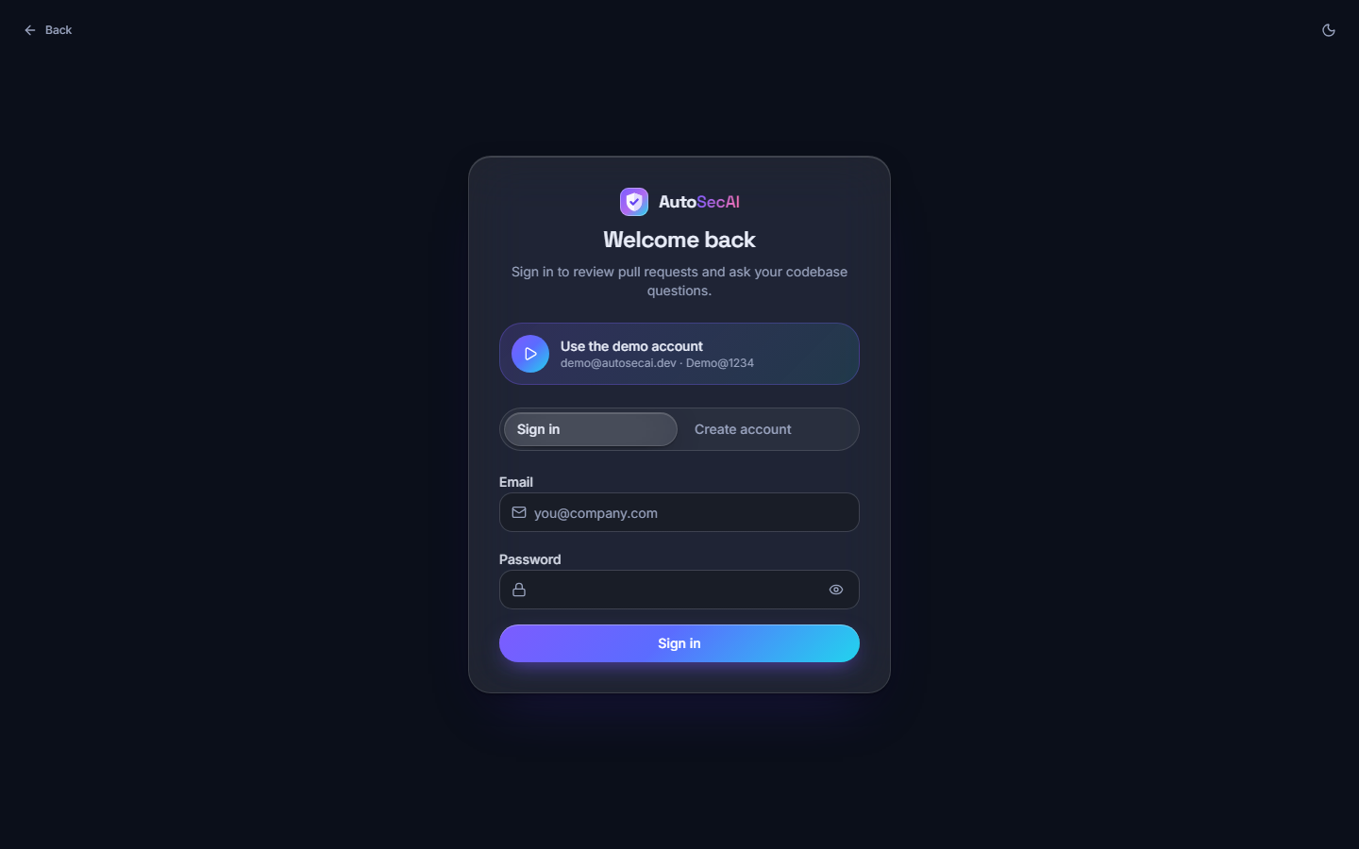  Fig. C.1: Sign in | 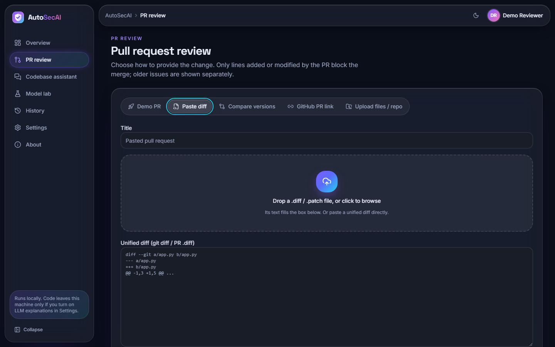  Fig. C.2: New review: Paste diff

Sign in. The sign-in card with the "Use the demo account" shortcut, the Sign in / Create account switch, the e-mail and password fields and the Sign in button.
New review: Paste diff. The Paste diff tab: title field, the drop zone for a .diff or .patch file and the text area for a unified diff. The cyan ring is the keyboard focus.
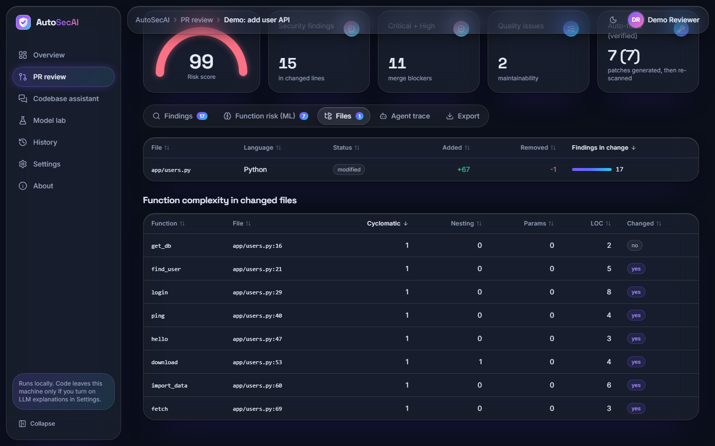  Fig. C.3: Files tab | 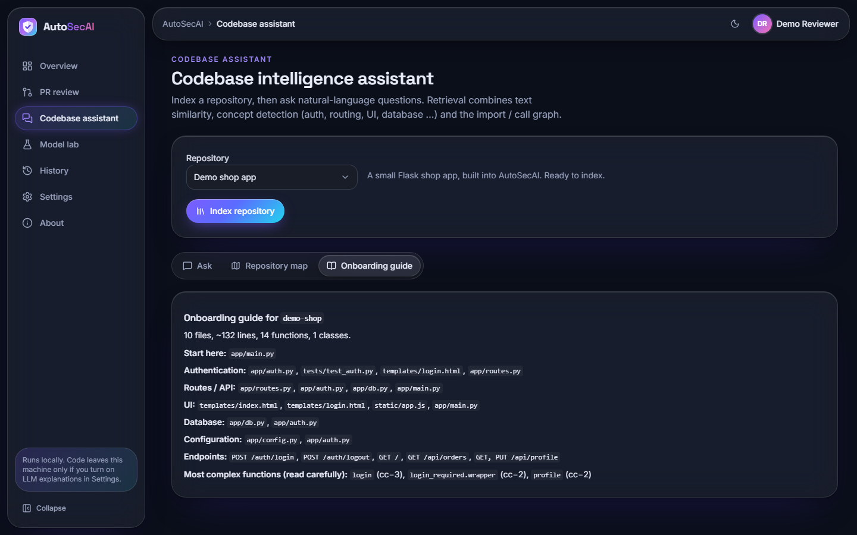  Fig. C.4: Codebase assistant: onboarding guide

Files tab. The changed file app/users.py (Python, +67 / -1, 17 findings) and the complexity table of its eight functions: cyclomatic complexity 1 each, nesting 1 only for download.
Codebase assistant: onboarding guide. The generated guide for demo-shop (10 files, about 132 lines, 14 functions): where to start, the files for authentication, routes, UI, database and configuration, the endpoints and the most complex functions (login, cc=3).
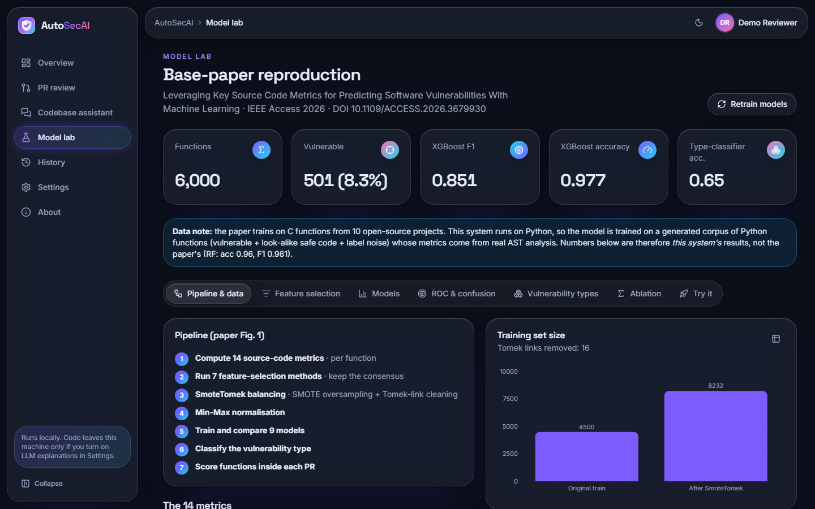  Fig. C.5: Model Lab: pipeline and data | 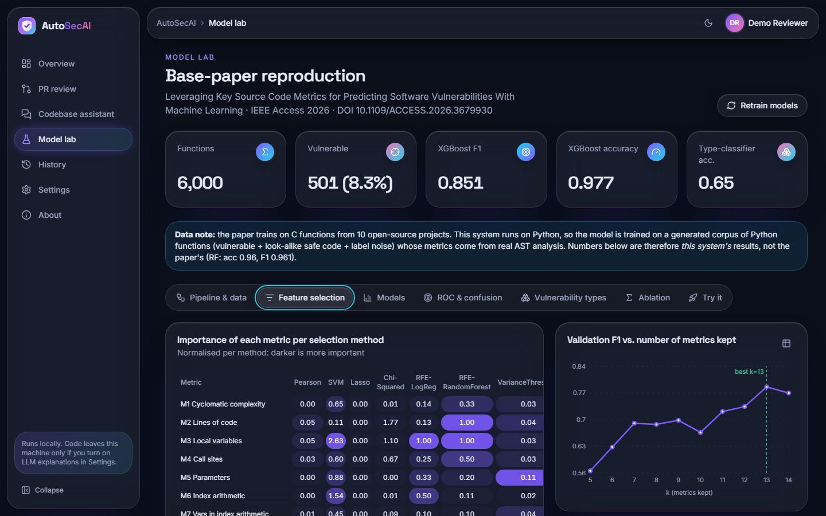  Fig. C.6: Model Lab: feature selection

Model Lab: pipeline and data. The seven pipeline steps and the chart "Training set size" (4500 original, 8232 after SmoteTomek; 16 Tomek links removed), under the tiles for 6,000 functions, 501 vulnerable (8.3 %), XGBoost F1 0.851 and accuracy 0.977.
Model Lab: feature selection. The importance heat table for the seven selection methods and the chart "Validation F1 vs. number of metrics kept", rising from about 0.57 at k = 5 to 0.79 at k = 13 (best) and 0.77 at k = 14.
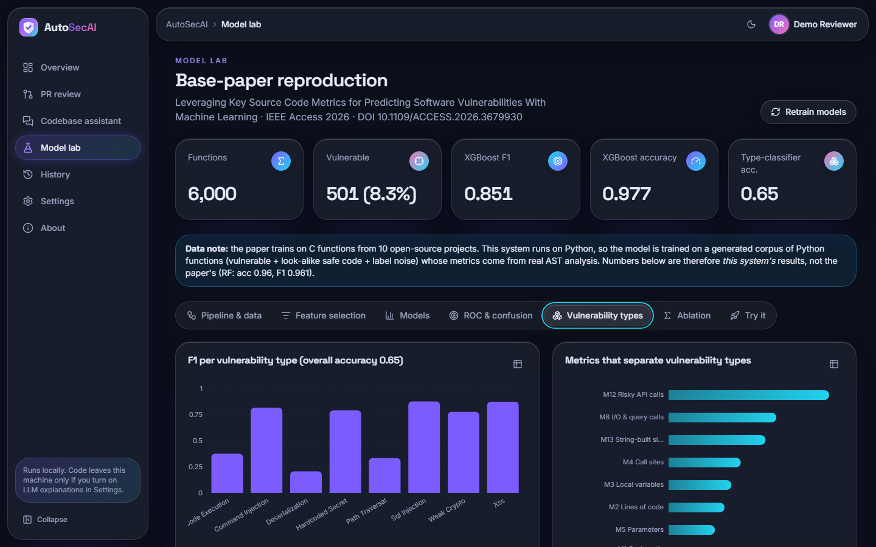  Fig. C.7: Model Lab: vulnerability types | 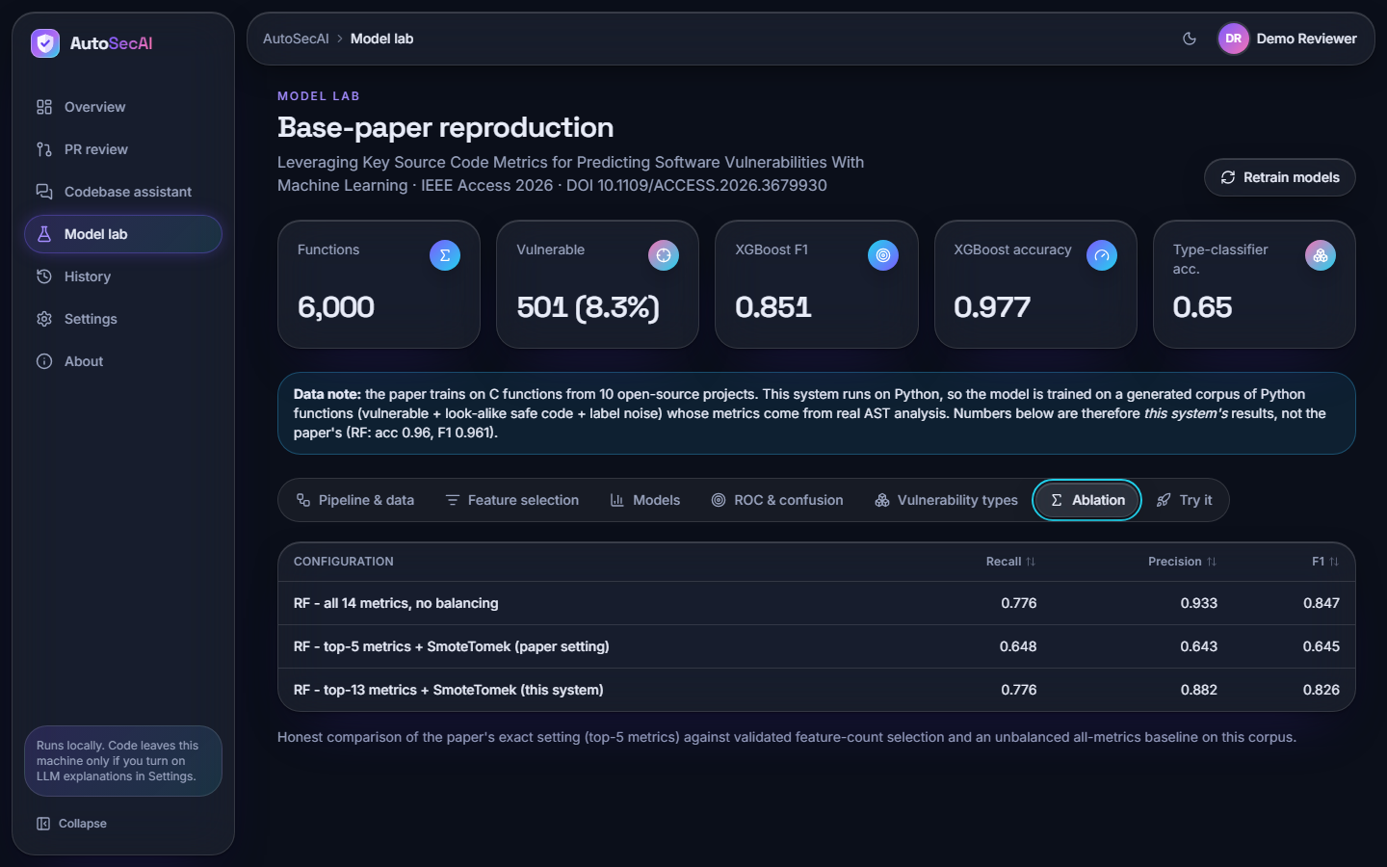  Fig. C.8: Model Lab: ablation

Model Lab: vulnerability types. F1 per vulnerability type (overall accuracy 0.65) and the metrics that separate the types, led by M12 Risky API calls, M8 I/O & query calls and M13 String-built sinks.
Model Lab: ablation. Recall / precision / F1 of three Random Forest configurations: all 14 metrics unbalanced 0.776 / 0.933 / 0.847; top-5 with SmoteTomek 0.648 / 0.643 / 0.645; top-13 with SmoteTomek 0.776 / 0.882 / 0.826.
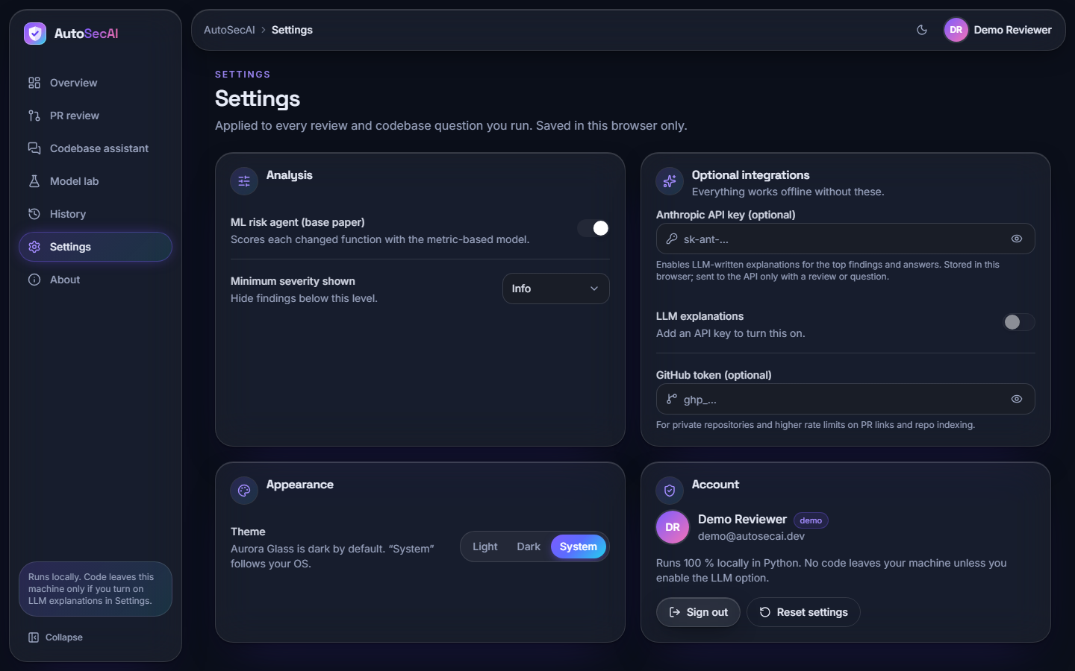  Fig. C.9: Settings | 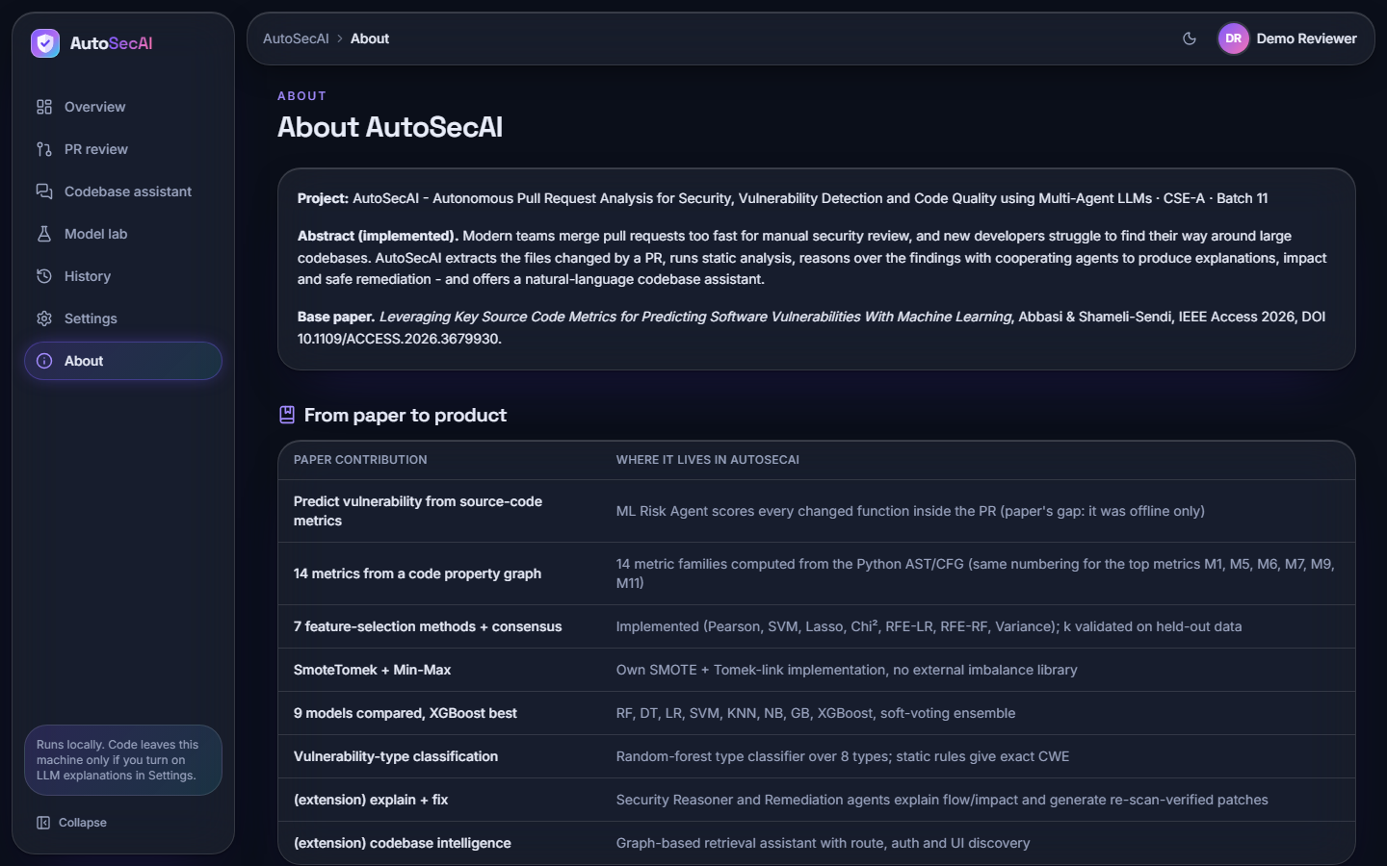  Fig. C.10: About

Settings. Switches for the ML risk agent and minimum severity, the optional API key (LLM explanations stay off until a key is added) and GitHub token, the theme (Light, Dark, System) and the account card; settings are saved in this browser only.
About. The abstract, the base paper reference and the table "From paper to product", which maps each contribution of the paper to where it lives in AutoSecAI and marks the two extensions (explanation with fixes, codebase intelligence).
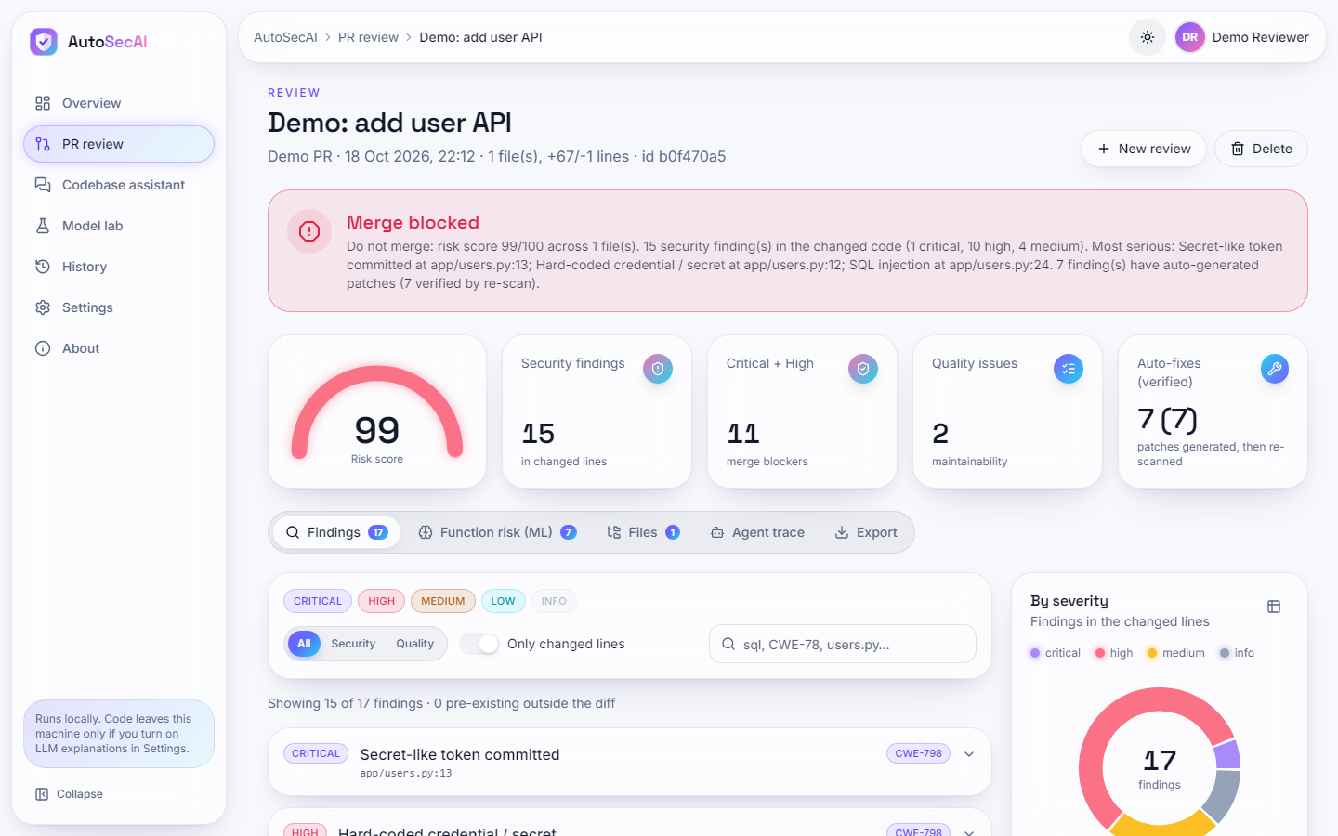
Fig. C.11: Review result in light mode

Review result in light mode. The verdict screen in the light theme: banner, gauge 99, tiles, tabs, filters, finding list and severity donut; the theme button shows the sun icon.
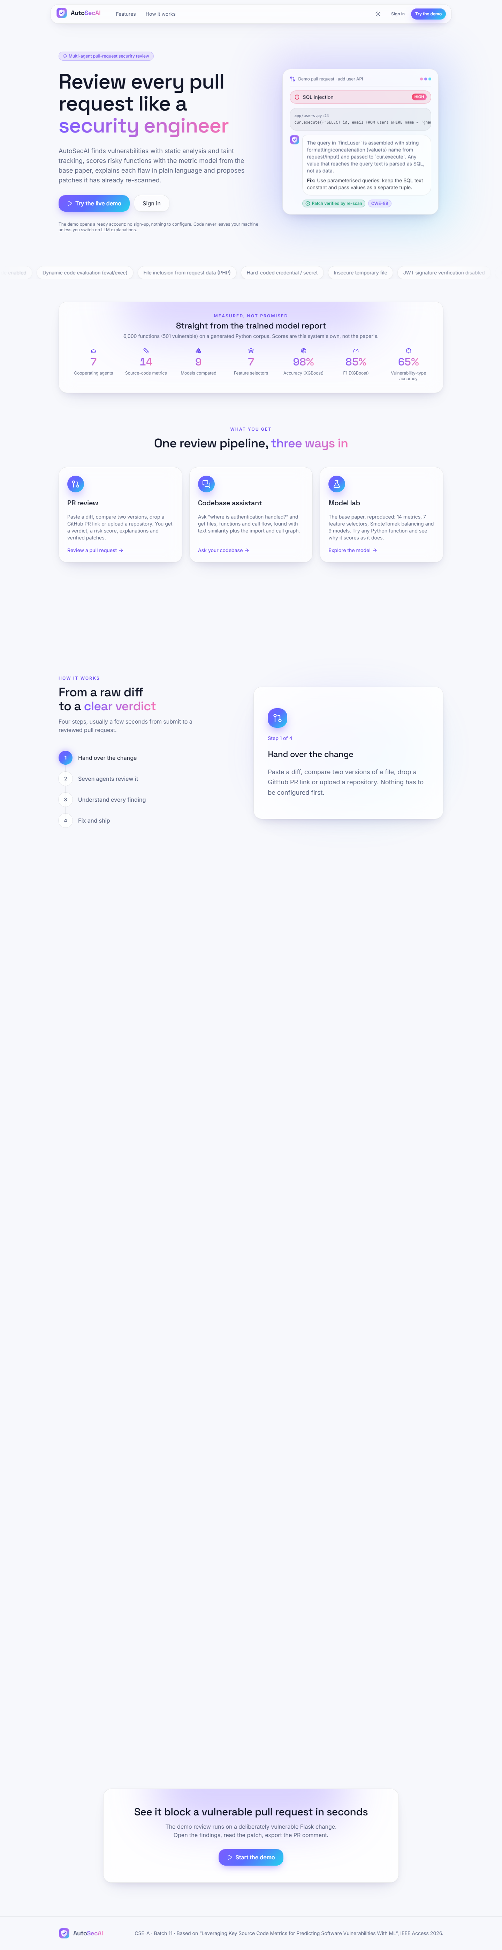  Fig. C.12: Landing page, light theme (full page) | 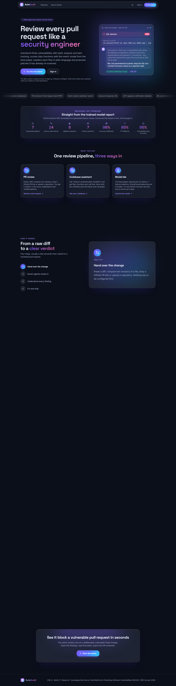  Fig. C.13: Landing page, dark theme (full page)

Landing page, light theme (full page). The public page: headline, a live example finding (SQL injection, CWE-89, "Patch verified by re-scan"), the block "Straight from the trained model report" (7 agents, 14 metrics, 9 models, 7 selectors, 98% accuracy, 85% F1, 65% type accuracy), the three entry points and the call to action.
Landing page, dark theme (full page). The same page in the dark theme, the default look of the Aurora Glass interface kit.

